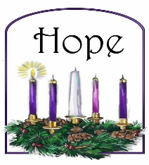
New Life At Calvary
The First Sunday
of Advent
November 30, 2025



Prelude: Kerry Holland

Welcome/Opening Prayer:

Selection: “You Brought Me Through This”

Advent Candle Lighting: Kamilah Williams & Kalilah Williams-Daniel

Scripture: Susan Gillespie
OT: Isaiah 7:14
NT: Luke 1:26-38

Offering:

Special Music: “Blessed Assurance”
Gwen Coats

Message: Counting Every Blessing:
“The Blessing of Advent” Pastor Kellie

Selection: “Grateful”

Announcements:

Benediction:

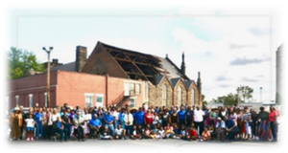
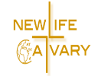

Church Purpose
In Response to God’s love, Our purpose is to love others, Teach the Word of God, and Reach the world for Christ. Therefore, as a Covenant Partner, I will be a part of a small group bible fellowship to grow in Christ. I will serve in the ministry with my gifts and talents. I will do my part in faithfully giving my tithes and offerings to keep the ministry of Jesus Christ alive in the World. I will love all those who enter our doors and accept them in our midst.
You Brought Me Through This
Song by Rev. Timothy Wright
(LEAD)
You Brought Me Through This
You Brought Me Through That
Lord I'm So Grateful To You (2X)
(CHOIR)
You Brought Me Through This
You Brought Me Through That
Lord I'm Grateful To You (2x)
(LEAD)
You Made A Way Out Of No Way
I’m So Grateful To You
You Opened Doors That Were Closed In My Face
Lord I’m So Grateful To You
(CHOIR)
You Brought Me Through This
You Brought Me Through That
Lord I'm Grateful To You (2x)

LEAD
You Made A Way Out Of No Way
I’m So Grateful To You
You Opened Doors That Were Closed In My Face
Lord I’m So Grateful To You
(CHOIR)
You Brought Me Through This
You Brought Me Through That
Lord I'm Grateful To You (2 X)
Sopranos:
You Brought Me Through This
You Brought Me Through That
Lord I'm Grateful To You
Altos:
You Brought Me Through This
You Brought Me Through That
Lord I'm Grateful To You
Tenors:
You Brought Me Through This
You Brought Me Through That
Lord I'm Grateful To You
All:
You Brought Me Through This
You Brought Me Through That
Lord I'm Grateful To You
(Special)
(Lead)...I'm So Grateful
(Choir)I’m So Grateful
(Lead) I'm So Grateful Yeah
(Choir) I”M So Grateful Yeah
(Lead) I'm So Grateful
(Choir) I'm So Grateful
(Lead) Do Do Do Do Do Do Do Do Do Do Do
(Choir) Do Do Do Do Do Do Do Do Do Do Do
(Lead) Do Do Do Do Do Do Do Do Do Do Do
(Choir) Do Do Do Do Do Do Do Do Do Do Do
(Lead) Do Do Do Do Do Do Do Do
(Choir) Do Do Do Do Do Do Do Do
(Lead) Do Do Do Do Do Do Do Do
(Choir) Do Do Do Do Do Do Do Do
(Lead)...I'm So Grateful
(Choir)I’m So Grateful
(Lead) I'm So Grateful Yeah
(Choir) I”M So Grateful Yeah
(Lead) I'm So Grateful
(Choir) I'm So Grateful
(Lead) Do Do Do Do Do Do Do Do Do Do Do
(Choir) Do Do Do Do Do Do Do Do Do Do Do
(Lead) Do Do Do Do Do Do Do Do Do Do Do
(Choir) Do Do Do Do Do Do Do Do Do Do Do
(Lead) Do Do Do Do Do Do Do Do
(Choir) Do Do Do Do Do Do Do Do
(Lead) Do Do Do Do Do Do Do Do
(Choir) Do Do Do Do Do Do Do Do
(Choir)
Lord I’m Grateful
Lord I’m Grateful
Lord I’m Grateful To You

Advent Candle lighting Liturgy

First Sunday in Advent
(Kamilah Williams & Kalilah Williams-Daniels)

Reader: "The people who walked in darkness have seen a great light; those who lived in a land of deep darkness -- on them light has shined... For a child has been born for us, a son given to us; authority rests upon his shoulders; and he is named Wonderful Counselor, Mighty God, Everlasting Father, Prince of Peace." (Isaiah 9:2, 6)

Reader: Today we remember the prophets of old, who demanded to be heard, who dared to speak of a child to come, unexpected liberator of the people, vulnerable incarnation of the Holiest of Holies, a new name for God.

People: Today we give thanks for the prophets among us, who bring to us surprising new visions of hope, who challenge us to think outside the box, who show us a future we never anticipated.

Reader: On this first Sunday of Advent, we light this candle as a symbol of the prophets who renew our faith and remind us of what may be.

(Light a purple candle)

“Light the Advent Candle”
Light the Advent candle, one: Now the waiting has begun; We have started on our way, Time to think of Christmas Day.
Candle, candle, burning bright, shining in the cold winter night; Candle, candle, burning bright, fill our hearts with Christmas light.

Grateful by Hezekiah Walker
I am
Grateful for the things
That you have done
Yes, I’m grateful for the
Victories we’ve won
I could go on and on and on
About the works
Because I’m grateful, grateful, so grateful
Just to praise you Lord
Flowing from my heart
Are the issues of my heart
Is Gratefulness

I am
Grateful for the things
That you have done
Yes, I’m grateful for the
Victories we’ve won
I could go on and on and on
About the works
Because I’m grateful, grateful, so grateful
Just to praise you Lord
Flowing from my heart
Are the issues of my heart
Is Gratefulness

Grateful, Grateful, Grateful, Grateful,
Grateful, Grateful Grateful

Grateful, Grateful, Grateful, Grateful
Gratefulness is flowing from my heart.

Announcements
Attention: Please refrain from walking during these times: Prayer, Soloist, Scripture and Sermon. Thank you.

If you would like to donate a poinsettia in honor/memory of a love one. Sign-up forms are in the foyer. The donations are $8.00 per poinsettia. Names will be listed in the Christmas Bulletin. Thanks

Thank you, to this past Tuesday’s cleaning crew: Helen Britt, Barbara Lowry, Renee Pride, and Lenny Gray. Christmas Decoration Ruby Turner. We appreciate the time that you spent helping with the upkeep of our church.

We would like to extend our heartfelt thanks to all the volunteers who helped serve over 100 meals at our special Thanksgiving Hot Meal dinner. Whether you contributed by checking our guests in, donating, shopping, singing, setting up, cooking, serving, or cleaning up, your efforts are sincerely appreciated. The meal featured traditional Thanksgiving dishes, along with special items provided by The River of Life Church. The evening included singing, personal testimonies, fellowship, and plenty of delicious food. We could not have accomplished this without your support. Once again, thank you!

Christmas Shopping at New Life At Calvary:
The Women's Guild Christmas Event, today
Sunday, December 7th from 11:30am-2:30pm in the gym. All proceeds will go to the New Life At Calvary Building On Faith Restoration Campaign. Other vendors will also be available. Support our small business owners at New Life At Calvary this holiday season.

Cleaning Help Volunteers
Greetings NLAC Family, we need your help! After the sudden and tragic loss of our staff member, Reginald Woods, we are missing a part of our cleaning staff. While our Personnel Committee works on hiring a new custodian, we are setting up a Volunteer Clean-Up Day on Tuesdays from 10:00 am – 12:00 pm.

We are asking for just 2 hours a week to help with cleaning and sanitizing our restrooms, kitchen, fellowship hall, and gym. Tasks will include sweeping, mopping, cleaning tables and chairs, dusting, and washing windows.
Our first clean-up day will be on Tuesday, September 23, 2025. We hope you can join us in keeping God’s house clean!

Repast Committee
We are forming a Repast Committee to assist with meals after funerals. Members of this committee will help ensure that food is prepared or provided, families are served with care, and clean-up/set-up runs smoothly.

This committee will be activated in the event of a loss where the repast meal is hosted at NLAC.
If you are interested in serving, please sign the sign-up sheet in the foyer. Meeting dates will be announced soon.

Hospitality Committee
The Hospitality Committee is returning! The role of this committee is to provide refreshments on Sundays after service. Responsibilities include making coffee, putting out refreshments, and handling set-up and clean-up. If you are already serving in this role or would like to join, please sign the sign-up sheet in the foyer. Meetings will be announced soon so we can stay organized and ready to serve.

Birthdays The Week of November 30, 2025

Sarah L. Williams Dec 1st
Billie Brown Dec. 2nd
Rev. Joseph Banaci Dec. 5th
Jai′Dah Kee Dec.5th

Advent Readers:
November 30th : Kamilah Williams & Kalilah Williams-Daniels
December 7th : Janet Orgen, Andrea Billups & Sharon Thomas
December 14th : Glenn & Shannon Hendrix
December 21st :

Scripture Readers Nov,/Dec. 2025
Susan Gillespie 30th
Sharon Thomas Dec. 7th
Hazel Hicks Dec. 14th
Trinity Sullivan Dec. 21st
Scholarship Sunday Dec. 28th

Special Offering
1st Sunday – Deacon’s Offerings
2nd Sunday – Prison Ministry
3rd Sunday – Rotolu Orphanage Nigeria
4th Sunday – Two Cents A Meal
5th Sunday – Above & Beyond

Sermon Series November, 2025
11/2/25: “The Blessing of Salvation”
11/9/25: “The Blessing of Relationship”
11/16/25: “The Blessing of Provision”
11/23/25: “The Blessing of Hope”
11/30/25: “The Blessing of Advent”

What Is Advent?
History and Meaning

Advent is the season of reflective preparation for Christ's Nativity at Christmas and Christ's expected return in the Second Coming. It starts Sunday, December 3rd and ends Sunday, December 24th, Christmas Eve. Some people may know that the Advent season focuses on expectation and think it serves as an anticipation of Christ’s birth in the season leading up to Christmas. This is part of the story, but there’s more to Advent.

The word “Advent” is derived from the Latin word adventus, meaning “coming.” By the 6th century, Roman Christians had tied Advent to the coming of Christ. But the “coming” they had in mind was not Christ’s first coming in the manger in Bethlehem, but his second coming in the clouds as the judge of the world.

GIVING OPTIONS
www.NLAC.tv Website Giving:

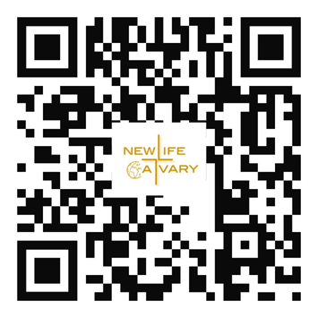

If you have Cash App you can send your offer to $2NLAC
Prayer for Hope
Heavenly Father,
When the days feel heavy and the path ahead seems unclear,
remind me that Your light still shines in the shadows.
Plant in my heart the seed of hope that grows even in dry seasons.
Help me trust that every trial has its purpose,
and that Your plans for me are filled with goodness and peace.
Lift my eyes above my fears,
and let my spirit rest in the promise that I am never alone.
May hope be my anchor,
and Your love my constant guide.
Amen





Go into your mobile banking app Click on pay with Zelle
Once inside your zelle app it will give you the option to scan the qr code below or type in the church email address: officenlac@gmail.com

You can mail in your offering throught the mail at New Life At Calvary
2020 E. 79th Street
Cleveland, OH 44103

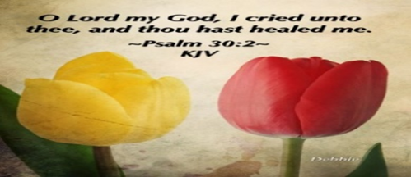
Please send a card, call, pray for, and support our Sick and Shut ins and recuperating brothers and sisters in Christ. Thank you.

Jennie Brown (1783 East 227th St, Euclid, OH 44117 216.785.9295)
Minnie Doaty (12005 Ablewhite Ave, Clev., OH 44108)
Natalie Franklin (daughter of Julie Wright cards only) (c/o Donnese Franklin, 4216 Colby Ave, Columbus, OH 43227)
Alfred Haywood (St. Augustine 7801 Detroit Ave, Rm 237, Cleveland, OH 44102)
Mary James (497 East 108th Street, Cleveland, OH 44108, 216-541-4114)
Savannah (Robin) Hill (Grande Pointe Healthcare Center, 3 Merit Dr, #323, Richmond Heights, OH 44143, 216-440-3440)
LaDonna Jessup (Shaker Gardens Nursing & Rehab. 3550 Northfield Rd – 360A – Shaker, OH 44122 - 216-255-7693)
Kent Kelton (Longmeadow Care Center, 565 Bryn Mawr St, Room 57, Ravenna, OH 44266, 216-672-2763)
Mildred Little (1344 East 90th St., Cleve., OH 44106)
Fannie Ruffin (8164 Dartmoor Rd, Mentor, OH 44060)
Edna Swoope (27100 Cedar Rd, Beachwood, OH 44122)
Brenda White (West Park Commons 4106 Rocky River Dr, Apt 207, Clev., OH 44135 216-377-7352)
Janet Williams (10516 Elgin Ave., Clevland, OH 44108)
New Life At Calvary
2020 East 79th Street
Cleveland, OH 44103
PH: 216-391-8448 / Fax: 216-391-4849
Email: officenlac@yahoo.com
Website: www.nlac.tv
Wi-fi-Life-Guest Password: Joinus2020

Pastors:
Rev. Kellie C. Sullivan
Rev. Antonia Martin Burton
Rev. Dr. Toby Gillespie-Mobley (Pastor Emeritus)
Rev. Dr. Rick Gillespie-Mobley (Pastor Emeritus)

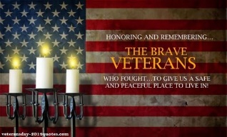
Life Connect Classes on Break
Monday 6:30 pm (Adult Class)
“AHA The God Moment that Changes Everything”
-Teachers: Andrea Billups
Zoom Meeting 891-1091-7393 PW: 2020 Zoom Call In 1-312-626-6799 891-1091-7373 ##2020#

Read The Bible in One Year/52 weeks/365 days - 7:30 pm: We will be using the NIV Version –
Teacher: Pastor Kellie
Meetings 1st, 3rd, 4th, & 5th Tuesday of the month
Meeting ID: 820-9791-8709 PW: 605886
Phone# 1-312-626-6799 ID: 820-9791-8709 ##605886#

2nd Tuesday (Monthly) 7:30pm Women with a Heart Bent Toward God. Teacher: Helen Britt
Zoom ID: 891-6849-5855 PW: 751319
Zoom Call In: 1-301-715-8592 Zoom Meeting ID: 896-0072-4832 Zoom Code: 709557#

Wednesday 7:00 pm (Adult Class)
Teacher: Clemon Walker, In Person in Fellowship Hall.

Wednesdays 7:00 pm (Adult Class)
Teacher: Pastor Toby Emeritus (The Chosen)
Zoom Meeting 334-158-729/2020 Zoom Call In 1-312-626-6799 334-158-729## 2020# (Resumes on Oct. 1^{st)}

Wednesday 7:30 pm (Adult Class)
Teacher: Sylvia Fields – Judah Looking Back From Isaiah Looking Forward To Exile.
Zoom Meeting 865-9998-5439/54321 Zoom Call In 1-301-715-8592 TD: 865-9998-5439## PW: 54321

Youth Life Connect on Zoom Classes on Fridays
Fridays 6:30pm-9:30pm, Teacher Pastor Kellie
Grades PK -K (3-5 years) 6:00-6:30
Grades 1-3 (6-8 years) 6:30 – 7:30pm
Grades 4-6 (9-12 years) 7:30-8:30pm
Grades 7-12 (13-17 years) 8:30-9:30pm
Zoom Meeting ID: 832-7903-1773 PW: 092683

The White pillars candle in the chancel is
a reminder for us to pray for the safety of all
the men and women serving in the military.
It reminds us to pray for peace in our land
and all lands.

Celebrating the 96th Birthday of Sarah L. Williams
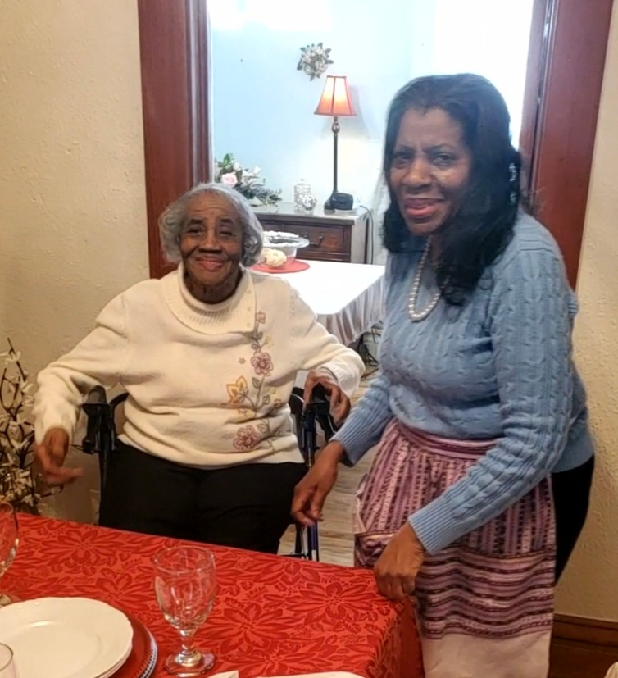
Sarah L. Williams was born on December 1, 1929, in Darwin, Mississippi. She was born to a teenage mother and was adopted by her aunt and uncle, Margaret & John Lunard. Sarah was the first grandchild of her grandparents, James and Sarah Ann Betts. She was dearly loved by her grandparents and spent many years on their farm as a child. Her grandfather owned his land, and her grandmother was a midwife. Sarah has many great memories of growing up on the farm. Sarah’s parents lived in Toledo, Ohio, she grew up going to Toledo schools. She met and married her husband, Percy Williams. They lived in Cleveland and raised their 6 children. Percy, Margaret, Joyce, Rosa, David, and Danny. Sadly, they lost their son, David in a tragic accident, when he was 7 years old. Although devastated by David’s loss, the family persevered with their faith, family, and friends.
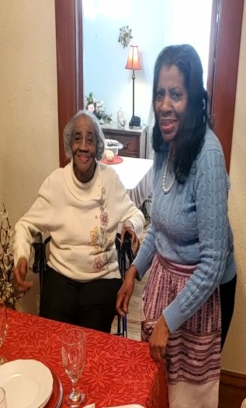
Sarah attended beauty school, she enjoyed doing hair, especially little girls. She also held a job at the US Post Office. Her final job, when she was 62 years old, was at the Cleveland Art Museum, where she traveled out of state to many events with other museums. Sarah and her husband were Charter Members of the newly formed Glenville New Life Community Church. The original Glenville Presbyterian Church had closed, because of the influx of African Americans from the south into the neighborhood. The Presbytery of the Western Reserve decided to re-open the church in 1962 under the leadership of Rev. David Zuverink. Sarah and Percy were there when Zuverink was ordained and installed. Sarah said, “I enjoyed the neighborhood because, I came from a mixed neighborhood, we had English and German, everyone worked together.” Sarah also remembers that when she moved to Glenville, she couldn’t understand that most of the black people went to Central High School. It was more segregated in Cleveland; she didn’t understand that.
Sarah says, “I remember my son, went to school and noticed that the curriculum was different, I complained to the Euclid Church of the Covenant Pastor. We protested the school board. They fired the superintendent. Then the white families left, they moved and went to private schools. It was two school systems in Cleveland. I never could understand that. Segregation never made sense.” Sarah was among the families that welcomed Rev. Dr. Martin Luther King, Jr. to Cleveland. She and other members had breakfast with him at a local restaurant.
Some other Sarah memories, “I’ve always liked to read; my grandmother told me that knowledge was written in books so read all you can.” “I planned to live a long life; my great grandmother lived to be 113 so I said I’m going to live to be 100.” Finally, Sarah’s life advice: “Put God First. All lessons come from Him. Read your bible. Be kind to everybody. Go to Sunday School.” Sarah has lived in Toledo with her daughter Rosa, since retirement. She became a Charter Member of New Life At Calvary in 2013, with the merger. She remains the longest living Charter Member of the former Glenville New Life Community Church. She is a dedicated member of our church. She loves the Lord and enjoys studying the word of God. We celebrate with Sarah! Happy 95th Birthday!

Celebrating the 91st Birthday of Billie Brown

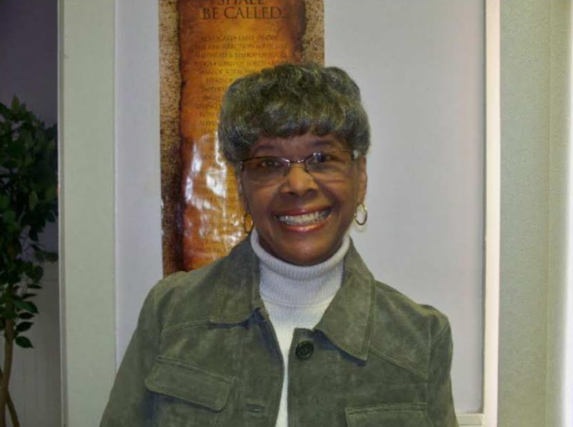
Billie Brown, was born on December 2, 1934 in Bluefield, West Virginia to Patti and William Carmichael. She was an only child. She was baptized at 1st Baptist Church in Bluefield at around 11 or 12. She then moved to Roanoke, Virginia. There she attended John Stewart Methodist Church. She attended Park Central High School and then went on to West Virginia State University, where she met her husband, Stanley Brown.
Stanley and Billie were married for 46 years. Their secret she said was that they were good friends, talked things out with each other, and talked things out with their girls, Patti and Stanette. At West Virginia State University, WVU, Billie studied Elementary Education. She decided to be a teacher because there were a lot of teachers in her family. As a freshman at WVU, Billie became a member of Alpha Kappa Alpha Sorority, Inc. She has been a member since 1952, a total of 72 years! She has been a Golden Member, a 50-year member, for some time now. She mostly enjoys the sisterhood and is still active. She meets with the RAKA’s, Retired AKA’s. Her daughter Patti was also a member of Alpha Kappa Alpha Sorority. Stanley was a member of Omega Psi Phi. At WVU, Billie was also a part of the Acapella Choir. She sang Alto. They travelled from state to state. Because of the times, with segregation, she and her choir always had arrangements to stay with Alumni. They never stayed at a hotel.
Billie went on to study at John Carroll University in University Heights, Ohio. She received a Master’s Degree in Reading. Billie was a teacher for 31 years. She first taught at Miles Standish Elementary School and then at Adlai Stevenson.
Billie and Stanley have attended Glenville New Life Community Church since the 1960’s. Stanley was an Elder and Billie was ushered and sang. They were both members of Glenville New Life Community Church and Billie is currently a part of New Life At Calvary. She currently enjoys spending time with her daughter Stanette, being a part of her AKA chapter, reading and doing crosswords. Her favorite book is “Five Smooth Stones.” Before the pandemic, she was on a bowling league and never missed Monday night bowling. This December 2nd, Billie will be 90 years old!
Happy 90th Birthday Billlie Brown, from you New Life At Calvary Family!


Pledge Card for support of the 2nd Milestone of the
Building On Faith Capital Campaign of
New Life At Calvary Cleveland, OH
A Capital Campaign is how we fund the future of New Life At Calvary. It challenges us to reach higher and dig deeper in order to meet the immediate and long-term needs of the church and the community. Like annual giving, giving to a Capital Campaign enhances the mission and ministry of the church through renovation and improvement of our church building.
Giving to the Capital Campaign is considered sacrificial giving. It does not come from our daily living expenses. Capital Campaign giving can be spread out over a three-year period to allow donors to manage their gifts according to their needs.
_____________________________________________________________________________
I/We pledge in faith to support the 2nd Milestone of the Capital Campaign of New Life At Calvary listed by making the financial contribution listed below:
Total Amount of Pledge $_________________ (for those renewing the pledge see reverse side of this form)

One-time Payment Date: ___________ Payments Over-Time
Regular Payment Schedule expected:

$_____________ each week/month/quarter/year
Method(s) of Payment
- Cash or Check Enclosed
- Online Giving through New Life At Calvary
- (set up on the www.nlac.tv website)
- Gift of Securities (see other side for more ways to give)
Start date: ______________ End Date: ______________
-or-

Other Payment Schedule described below:
__________________________________________________
__________________________________________________

__________________________________________________

Names: _____________________________________________________________________________________________________

Address: ____________________________________________________________________________________________________

City: _______________________________________________ State: __________________ Zip: ____________________________
Phone: ______________________________________________ Email: _________________________________________________

Signature Date of Pledge

____________________________________________________________________________________________________________
Signature Date of Pledge

Methods of Giving to New Life At Calvary Capital Campaign, Building on Faith Restoration
Cash or Checks- Checks payable to New Life At Calvary, sent to 2020 E. 79th Street, Cleveland, Ohio 44103
Online Giving- One time or Recurring payment directly from a bank account. This is set up and managed from the Online Giving tab on the New Life At Calvary website (nlac.tv).
Gifts of Securities- Gifts of stocks, bonds, and other financial instruments can be arranged by contacting the NLAC steering Committee: Pastor Kellie C. Sullivan, Sylvia Y. Fields, Ruby Turner and Ella Thomas. When giving gifts of securities, please contact the Steering Committee with the donor’s name, the type of security name, and the number of shares, no later than the day the gift is made.
Matching gifts- Many employers will match charitable donations made by their employees. By using your company’s Matching Gift benefit, you may be able to multiply the amount of your donation. If you are affiliated with a company that matches gifts, please send the Matching Gift Form (usually attained by contacting your Human Resources Department), along with your donation to New Life At Calvary. The church will complete the form and return it to the company.
Information pertaining to my companies matching gift program:
___ I/We work for a Company that has a Matching Gifts Program.
___ The Matching Gifts Form is enclosed with this Pledge Card.
___The Matching Gifts form will be forwarded in the near future.

------------------------------------------------------------------------------------------------------------------------------------------
I/We pledge in faith to support the Building on Faith Restoration Campaign of New Life At Calvary by making the financial contribution listed on the reverse side of this form. My/Our contact information is on the reverse side. I/We have also signed indicating our commitment to complete this pledge. I understand that if we are a couple making this pledge both parties must sign this pledge.

I/We made a pledge to the 1st Milestone. For the 2nd Milestone please do one of the following: (Check One)
- __________ Keep my/our pledge the same.

- . _________ Increase my/our pledge to $________________.

  - I/We plan on giving monthly, weekly, bi-weekly (please circle one).

- I /We want to discuss giving a Gift of Securities.
- I/We want to discuss doing a matching gift with my job.

1st Milestone givers please complete the contact information on the other side of this form. Thank you for your continued support.

The Christian Education Committee
is inviting you and your family to…
Advent Family Day
Soup, Sandwiches and Cards
Sunday December 7, 2025

Join us for this fun family day as we…
- Make Christmas cards For Our Sick and Shut In, our Prison Ministry, and a local Nursing Home
- Purchase Christmas Stars for the children in the Rotolu Orphanage
- Purchase an item for our HUGS TREE (Hats, Underwear, Gloves, and Socks)
- Choose and Angel Tree Child to support for Christmas
- Eat lots of cookies
- Learn more about Advent
We want you and your family there!
Cost: We are asking that everyone make a donation of at least $5.00.
Your money will go directly to purchasing the soup and sandwiches.
Please make donations to our soup and sandwich luncheon
During our soup and sandwich lunch we will be:
- Making Christmas Cards for three groups of people; a. the prison ministry members, b. the sick and shut in members, and c. a local nursing home.
- Purchasing a Christmas star for $1.00 and hanging your star on the wall, with your name on it or the name of a person that you want to honor. All proceeds will go directly to the ROTOLU Home in Nigeria.
- Selecting a Child to support from our Angel Tree: We are asking anyone that is able to choose an Angel off the Angel Tree. Take that information and then purchase a gift for a child in need. Gifts need to be returned by December 14, 2025.
- HUGS Tree: (Hats, Underwear, Gloves, Socks) Purchase a hat, a pair of gloves, underwear, or socks for an adult or child in need. These items will be given to persons that attend our community meal in the winter, children that receive a Christmas gift, and children at the Wade Park School.

New Life At Calvary
Christmas Assistance Form
New Life At Calvary realizes that the Holiday Season can be a very difficult time for some families. Bills keep going up, while our pay checks seem to stay the same. We know that times are not always easy, and we want to support our families that might need some help. We are asking for those families that have a real need, who truly can’t afford to purchase their children Christmas gifts to complete this form. Your information and your child’s information will not be shared. Your child or children will be considered a child on our Angel Tree. Their age, gender, and wish gift item will be shared with a member of our congregation at that member (who will also remain anonymous) will purchase a gift for your child for about $20.00. Please complete the below form and return in by SUNDAY, December 7, 2025. NLAC Families Only.
_____________________________________________________________________________
We need Christmas Assistance: My family would like help with a gift for our children this Christmas: Please Complete the form attached below and submit it ASAP to the NLAC office. Gifts will be given out after our Service on Sunday, December 21, 2025, after service.

Adult’s Name: ___________________________ Phone: _____________________

Child 1: _______________ Age: _____ Gender: _____ Gift Idea: ______________
Child 2: _______________ Age: _____ Gender: _____ Gift Idea: ______________
Child 3: _______________ Age: _____ Gender: _____ Gift Idea: ______________
Child 4: _______________ Age: _____ Gender: _____ Gift Idea: ______________
Child 5: _______________ Age: _____ Gender: _____ Gift Idea: ______________

Please note there is no guarantee that your child will receive the suggested gift idea. And please choose reasonably priced gifts less than $20.00. Thank you.

