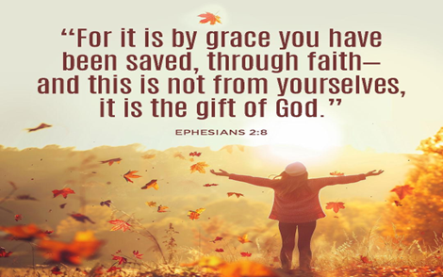
New Life At Calvary
Sunday, November 16, 2025

Prelude: Kerry Holland

Welcome/Opening Prayer:

Selection: “I Will Bless Thee, O Lord”

Scripture: Ruby Turner
OT: Exodus 16:4-5
NT: Matthew 6:25-34

Offering:

Special Music: “The Lord Is Blessing Me”
The Praise Team

Message: Counting Every Blessing:
“The Blessings of Provision” Pastor Kellie

Selection: “God Has Smiled On Me”

Announcements:

Benediction:
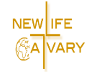
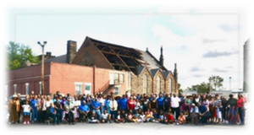

Church Purpose
In Response to God’s love, Our purpose is to love others, Teach the Word of God, and Reach the world for Christ. Therefore, as a Covenant Partner, I will be a part of a small group bible fellowship to grow in Christ. I will serve in the ministry with my gifts and talents. I will do my part in faithfully giving my tithes and offerings to keep the ministry of Jesus Christ alive in the World. I will love all those who enter our doors and accept them in our midst.
Counting Every Blessing
“The Blessing of Provision”
I Will Bless Thee, O Lord

I Will Bless Thee, O Lord
I Will Bless Thee, O Lord,
I Will Bless Thee, O Lord;
With A Heart Of Thanksgiving,
I Will Bless Thee, O Lord.
With My Hands Lifted Up
And My Mouth Filled With Praise;
With A Heart Of Thanksgiving,
I Will Bless Thee, O Lord.
I Will Bless Thee, O Lord,
I Will Bless Thee, O Lord,
With A Heart Of Thanksgiving,
I Will Bless Thee, O Lord.
With My Hands Lifted Up
And My Mouth Filled With Praise;
With A Heart Of Thanksgiving,
I Will Bless Thee, O Lord.
I Will Bless Thee, O Lord,
I Will Bless Thee, O Lord,
With A Heart Of Thanksgiving,
I Will Bless Thee, O Lord.
With My Hands Lifted Up
And My Mouth Filled With Praise;
With A Heart Of Thanksgiving,
I Will Bless Thee, O Lord.
With My Hands Lifted Up
And My Mouth Filled With Praise;
With A Heart Of Thanksgiving,
I Will Bless Thee, O Lord.
With A Heart Of Thanksgiving,
I Will Bless Thee, O Lord.
With A Heart Of Thanksgiving,
I Will Bless Thee, O Lord.
God Has Smiled On Me
Chorus
God has smiled on me,
He has set me free.
God has smiled on me,
He's been good to me.
Verse 1
He is the source of all my joy,
He fills me with His love.
Everything that I need,
He sends it down from above. (Chorus)
Verse 2
A light unto my path is He,
Without Him I would fall.
I don't know what He is to you,
But to me He's my all and all. (Chorus)

Announcements
Attention: Please refrain from walking during these times: Prayer, Soloist, Scripture and Sermon. Thank you.

The Women’s Guild is inactive until further notice.

Thank you, to this past Tuesday’s cleaning crew: Helen Britt, Barbara Lowry, Andrea Pride, David Blackshire, Caden Kingsbury, Lenny Gray and Yvonne Sims. We appreciate the time that you spent helping with the upkeep of our church.

Christmas Shopping at New Life At Calvary:
The Women's Guild Christmas Event, will be on Sunday, December 7th from 11:30am-2:30pm in the gym. All proceeds will go to the New Life At Calvary Building On Faith Restoration Campaign. Other vendors will also be available. Support our small business owners at New Life At Calvary this holiday season.

Cleaning Help Volunteers
Greetings NLAC Family, we need your help! After the sudden and tragic loss of our staff member, Reginald Woods, we are missing a part of our cleaning staff. While our Personnel Committee works on hiring a new custodian, we are setting up a Volunteer Clean-Up Day on Tuesdays from 10:00 am – 12:00 pm.

We are asking for just 2 hours a week to help with cleaning and sanitizing our restrooms, kitchen, fellowship hall, and gym. Tasks will include sweeping, mopping, cleaning tables and chairs, dusting, and washing windows.
Our first clean-up day will be on Tuesday, September 23, 2025. We hope you can join us in keeping God’s house clean!

Repast Committee
We are forming a Repast Committee to assist with meals after funerals. Members of this committee will help ensure that food is prepared or provided, families are served with care, and clean-up/set-up runs smoothly.

This committee will be activated in the event of a loss where the repast meal is hosted at NLAC.
If you are interested in serving, please sign the sign-up sheet in the foyer. Meeting dates will be announced soon.

Hospitality Committee
The Hospitality Committee is returning! The role of this committee is to provide refreshments on Sundays after service. Responsibilities include making coffee, putting out refreshments, and handling set-up and clean-up. If you are already serving in this role or would like to join, please sign the sign-up sheet in the foyer. Meetings will be announced soon so we can stay organized and ready to serve.

**Attention Everyone: We Need Your Help! **

Volunteers are needed to assist with our Thanksgiving meal on Tuesday, November 25, 2025. Please note that there will be no Thanksgiving meal served on Thanksgiving Day. Instead, everyone who attends the Hot Meals event on the 25th will be seated and served in a restaurant-style setting.

New Life At Calvary, in partnership with River of Life Church, will provide a traditional Thanksgiving meal alongside an African meal for our Hot Meals Ministry.

In these challenging times, we still have much for which we can be thankful. Answer the call to be the hands and feet of Christ and join us in serving others. Volunteers should arrive by 4 PM. We will gather together to give praise and thanks to God for His guidance and for the opportunity to serve those in need.

Please sign up on the sheet located in the foyer. Thank you for your support!

Birthdays The Week of November 16, 2025

Theotis Stubbs 18th

Scripture Readers November, 2025
Andrea Billups 2nd
Men’s Day 9th
Ruby Turner 16th
Kimili Gulley 23rd
Susan Gillespie 30th

Special Offering
1st Sunday – Deacon’s Offerings
2nd Sunday – Prison Ministry
3rd Sunday – Rotolu Orphanage Nigeria
4th Sunday – Two Cents A Meal
5th Sunday – Above & Beyond

Sermon Series November, 2025

11/2/25: “The Blessing of Salvation”
11/9/25: “The Blessing of Relationship”
11/16/25: “The Blessing of Provision”
New Life At Calvary
2020 East 79th Street
Cleveland, OH 44103
PH: 216-391-8448 / Fax: 216-391-4849
Email: officenlac@yahoo.com
Website: www.nlac.tv
Wi-fi-Life-Guest Password: Joinus2020

Pastors:
Rev. Kellie C. Sullivan
Rev. Antonia Martin Burton
Rev. Dr. Toby Gillespie-Mobley (Pastor Emeritus)
Rev. Dr. Rick Gillespie-Mobley (Pastor Emeritus)

GIVING OPTIONS
www.NLAC.tv Website Giving:

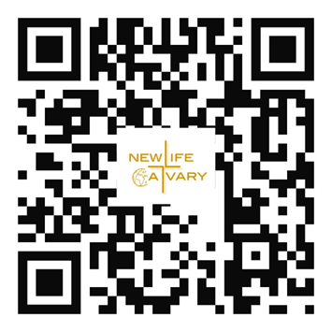

If you have Cash App you can send your offer to $2NLAC


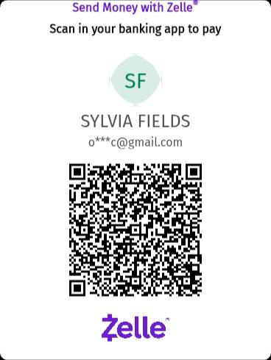
G o into your mobile banking app Click on pay with Zelle
Once inside your zelle app it will give you the option to scan the qr code below or type in the church email address: officenlac@gmail.com

You can mail in your offering throught the mail at New Life At Calvary
2020 E. 79th Street
Cleveland, OH 44103

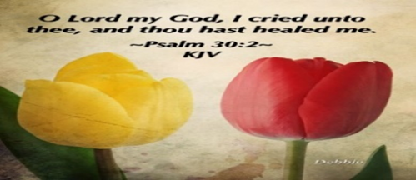
Please send a card, call, pray for, and support our Sick and Shut ins and recuperating brothers and sisters in Christ. Thank you.

Jennie Brown (1783 East 227th St, Euclid, OH 44117 216.785.9295)
Minnie Doaty (12005 Ablewhite Ave, Clev., OH 44108)
Natalie Franklin (daughter of Julie Wright cards only) (c/o Donnese Franklin, 4216 Colby Ave, Columbus, OH 43227)
Alfred Haywood (St. Augustine 7801 Detroit Ave, Rm 237, Cleveland, OH 44102)
Mary James (497 East 108th Street, Cleveland, OH 44108, 216-541-4114)
Savannah (Robin) Hill (Grande Pointe Healthcare Center, 3 Merit Dr, #323, Richmond Heights, OH 44143, 216-440-3440)
LaDonna Jessup (Shaker Gardens Nursing & Rehab. 3550 Northfield Rd – 360A – Shaker, OH 44122 - 216-255-7693)
Kent Kelton (Longmeadow Care Center, 565 Bryn Mawr St, Room 57, Ravenna, OH 44266, 216-672-2763)
Mildred Little (1344 East 90th St., Cleve., OH 44106)
Fannie Ruffin (8164 Dartmoor Rd, Mentor, OH 44060)
Edna Swoope (27100 Cedar Rd, Beachwood, OH 44122)
Brenda White (West Park Commons 4106 Rocky River Dr, Apt 207, Clev., OH 44135 216-377-7352)
Janet Williams (10516 Elgin Ave., Clevland, OH 44108)


Life Connect Classes
Monday 6:30 pm (Adult Class)
“AHA The God Moment that Changes Everything”
-Teachers: Andrea Billups
Zoom Meeting 891-1091-7393 PW: 2020 Zoom Call In 1-312-626-6799 891-1091-7373 ##2020#

Read The Bible in One Year/52 weeks/365 days - 7:30 pm: We will be using the NIV Version –
Teacher: Pastor Kellie
Meetings 1st, 3rd, 4th, & 5th Tuesday of the month
Meeting ID: 820-9791-8709 PW: 605886
Phone# 1-312-626-6799 ID: 820-9791-8709 ##605886#

2nd Tuesday (Monthly) 7:30pm Women with a Heart Bent Toward God. Teacher: Helen Britt
Zoom ID: 891-6849-5855 PW: 751319
Zoom Call In: 1-301-715-8592 Zoom Meeting ID: 896-0072-4832 Zoom Code: 709557#

Wednesday 7:00 pm (Adult Class)
Teacher: Clemon Walker, In Person in Fellowship Hall.

Wednesdays 7:00 pm (Adult Class)
Teacher: Pastor Toby Emeritus (The Chosen)
Zoom Meeting 334-158-729/2020 Zoom Call In 1-312-626-6799 334-158-729## 2020# (Resumes on Oct. 1^{st)}

Wednesday 7:30 pm (Adult Class)
Teacher: Sylvia Fields – Judah Looking Back From Isaiah Looking Forward To Exile.
Zoom Meeting 865-9998-5439/54321 Zoom Call In 1-301-715-8592 TD: 865-9998-5439## PW: 54321

Youth Life Connect on Zoom Classes on Fridays
Fridays 6:30pm-9:30pm, Teacher Pastor Kellie
Grades PK -K (3-5 years) 6:00-6:30
Grades 1-3 (6-8 years) 6:30 – 7:30pm
Grades 4-6 (9-12 years) 7:30-8:30pm
Grades 7-12 (13-17 years) 8:30-9:30pm
Zoom Meeting ID: 832-7903-1773 PW: 092683

The White pillars candle in the chancel is
a reminder for us to pray for the safety of all
the men and women serving in the military.
It reminds us to pray for peace in our land
and all lands.


Pledge Card for support of the 2nd Milestone of the
Building On Faith Capital Campaign of
New Life At Calvary Cleveland, OH
A Capital Campaign is how we fund the future of New Life At Calvary. It challenges us to reach higher and dig deeper in order to meet the immediate and long-term needs of the church and the community. Like annual giving, giving to a Capital Campaign enhances the mission and ministry of the church through renovation and improvement of our church building.
Giving to the Capital Campaign is considered sacrificial giving. It does not come from our daily living expenses. Capital Campaign giving can be spread out over a three-year period to allow donors to manage their gifts according to their needs.
_____________________________________________________________________________
I/We pledge in faith to support the 2nd Milestone of the Capital Campaign of New Life At Calvary listed by making the financial contribution listed below:
Total Amount of Pledge $_________________ (for those renewing the pledge see reverse side of this form)

One-time Payment Date: ___________ Payments Over-Time
Regular Payment Schedule expected:

$_____________ each week/month/quarter/year
Method(s) of Payment
- Cash or Check Enclosed
- Online Giving through New Life At Calvary
- (set up on the www.nlac.tv website)
- Gift of Securities (see other side for more ways to give)
Start date: ______________ End Date: ______________
-or-

Other Payment Schedule described below:
__________________________________________________
__________________________________________________

__________________________________________________

Names: _____________________________________________________________________________________________________

Address: ____________________________________________________________________________________________________

City: _______________________________________________ State: __________________ Zip: ____________________________
Phone: ______________________________________________ Email: _________________________________________________

Signature Date of Pledge

____________________________________________________________________________________________________________
Signature Date of Pledge

Methods of Giving to New Life At Calvary Capital Campaign, Building on Faith Restoration
Cash or Checks- Checks payable to New Life At Calvary, sent to 2020 E. 79th Street, Cleveland, Ohio 44103
Online Giving- One time or Recurring payment directly from a bank account. This is set up and managed from the Online Giving tab on the New Life At Calvary website (nlac.tv).
Gifts of Securities- Gifts of stocks, bonds, and other financial instruments can be arranged by contacting the NLAC steering Committee: Pastor Kellie C. Sullivan, Sylvia Y. Fields, Ruby Turner and Ella Thomas. When giving gifts of securities, please contact the Steering Committee with the donor’s name, the type of security name, and the number of shares, no later than the day the gift is made.
Matching gifts- Many employers will match charitable donations made by their employees. By using your company’s Matching Gift benefit, you may be able to multiply the amount of your donation. If you are affiliated with a company that matches gifts, please send the Matching Gift Form (usually attained by contacting your Human Resources Department), along with your donation to New Life At Calvary. The church will complete the form and return it to the company.
Information pertaining to my companies matching gift program:
___ I/We work for a Company that has a Matching Gifts Program.
___ The Matching Gifts Form is enclosed with this Pledge Card.
___The Matching Gifts form will be forwarded in the near future.

------------------------------------------------------------------------------------------------------------------------------------------
I/We pledge in faith to support the Building on Faith Restoration Campaign of New Life At Calvary by making the financial contribution listed on the reverse side of this form. My/Our contact information is on the reverse side. I/We have also signed indicating our commitment to complete this pledge. I understand that if we are a couple making this pledge both parties must sign this pledge.

I/We made a pledge to the 1st Milestone. For the 2nd Milestone please do one of the following: (Check One)
- __________ Keep my/our pledge the same.

- . _________ Increase my/our pledge to $________________.

  - I/We plan on giving monthly, weekly, bi-weekly (please circle one).

- I /We want to discuss giving a Gift of Securities.
- I/We want to discuss doing a matching gift with my job.
1st Milestone givers please complete the contact information on the other side of this form. Thank you for your continued support.
The Christian Education Committee
is inviting you and your family to…
Advent Family Day
Soup, Sandwiches and Cards
Sunday December 7, 2025

Join us for this fun family day as we…
- Make Christmas cards For Our Sick and Shut In, our Prison Ministry, and a local Nursing Home
- Purchase Christmas Stars for the children in the Rotolu Orphanage
- Purchase an item for our HUGS TREE (Hats, Underwear, Gloves, and Socks)
- Choose and Angel Tree Child to support for Christmas
- Eat lots of cookies
- Learn more about Advent
We want you and your family there!
Cost: We are asking that everyone make a donation of at least $5.00.
Your money will go directly to purchasing the soup and sandwiches.
Please make donations to our soup and sandwich luncheon
During our soup and sandwich lunch we will be:
- Making Christmas Cards for three groups of people; a. the prison ministry members, b. the sick and shut in members, and c. a local nursing home.
- Purchasing a Christmas star for $1.00 and hanging your star on the wall, with your name on it or the name of a person that you want to honor. All proceeds will go directly to the ROTOLU Home in Nigeria.
- Selecting a Child to support from our Angel Tree: We are asking anyone that is able to choose an Angel off the Angel Tree. Take that information and then purchase a gift for a child in need. Gifts need to be returned by December 14, 2025.
- HUGS Tree: (Hats, Underwear, Gloves, Socks) Purchase a hat, a pair of gloves, underwear, or socks for an adult or child in need. These items will be given to persons that attend our community meal in the winter, children that receive a Christmas gift, and children at the Wade Park School.

New Life At Calvary
Christmas Assistance Form
New Life At Calvary realizes that the Holiday Season can be a very difficult time for some families. Bills keep going up, while our pay checks seem to stay the same. We know that times are not always easy, and we want to support our families that might need some help. We are asking for those families that have a real need, who truly can’t afford to purchase their children Christmas gifts to complete this form. Your information and your child’s information will not be shared. Your child or children will be considered a child on our Angel Tree. Their age, gender, and wish gift item will be shared with a member of our congregation at that member (who will also remain anonymous) will purchase a gift for your child for about $20.00. Please complete the below form and return in by SUNDAY, December 7, 2025. NLAC Families Only.
_____________________________________________________________________________
We need Christmas Assistance: My family would like help with a gift for our children this Christmas: Please Complete the form attached below and submit it ASAP to the NLAC office. Gifts will be given out after our Service on Sunday, December 21, 2025, after service.

Adult’s Name: ___________________________ Phone: _____________________

Child 1: _______________ Age: _____ Gender: _____ Gift Idea: ______________
Child 2: _______________ Age: _____ Gender: _____ Gift Idea: ______________
Child 3: _______________ Age: _____ Gender: _____ Gift Idea: ______________
Child 4: _______________ Age: _____ Gender: _____ Gift Idea: ______________
Child 5: _______________ Age: _____ Gender: _____ Gift Idea: ______________

Please note there is no guarantee that your child will receive the suggested gift idea. And please choose reasonably priced gifts less than $20.00. Thank you.

