New Life At Calvary
Sunday, February 8, 2026
Black History Month

Prelude: Kerry Holland

Welcome/Opening Prayer:

Selection: “I Am A Friend of God”

Scripture: Jessica Franklin
OT: Proverbs 8:6-11
NT: Ephesians 6:14

Offering:

Black History Moment: Kadira Gulley

Special Music: “Every Time I Feel The Spirit”
Praise Team

Message: “Stand In Truth and Righteousness”
Pastor Kellie

Selection: “Holy Forever”

Announcements:

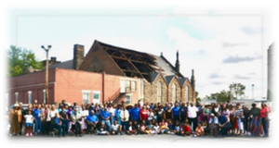
Benediction:


Church Purpose
In Response to God’s love, Our purpose is to love others, Teach the Word of God, and Reach the world for Christ. Therefore, as a Covenant Partner, I will be a part of a small group bible fellowship to grow in Christ. I will serve in the ministry with my gifts and talents. I will do my part in faithfully giving my tithes and offerings to keep the ministry of Jesus Christ alive in the World. I will love all those who enter our doors and accept them in our midst.
I Am A Friend Of God
Who am I that You are mindful of me
That You hear me when I call
Is it true that You are thinking of me
How You love me it’s amazing

Who am I that You are mindful of me
That You hear me when I call
Is it true that You are thinking of me
How You love me it’s amazing

I am a friend of God (3x)
God calls me friend (repeat)

Who am I that You are mindful of me
That You hear me when I call
Is it true that You are thinking of me
How You love me it’s amazing
It’s Amazing (x3)

God Almighty.....Lord of Glory
You have called me friend (4x)

I am a friend of God
You call me friend (x4)

Holy Forever by Chris Tomlin
A thousand generations falling down in worship
To sing the song of ages to the Lamb
And all who’ve gone before us and all
who will believe
Will sing the song of ages to the Lamb

Your name is the highest
Your name is the greatest
Your name stands above them all
All thrones and dominions
All powers and positions
Your name stands above them all
And the angels cry holy All creation cries holy
You are lifted high, holy Holy forever

If you’ve been forgiven
and if you’ve been redeemed
Sing the song forever to the Lamb
If you walk in freedom and
if you bear His name
Sing the song forever to the Lamb
We’ll sing the song forever and amen

And the angels cry holy All creation cries holy
You are lifted high, holy Holy forever

Hear Your people sing holy
To the King of kings, holy
You will always be holy Holy forever

Your name is the highest
Your name is the greatest
Your name stands above them all
All thrones and dominions
All powers and positions
Your name stands above them all (Repeat)

And the angels cry holy
All creation cries holy
You are lifted high, holy Holy forever
Hear Your people sing holy
To the King of kings (holy)
You will always be holy
Holy forever You will always be holy
Holy forever

Announcements
Attention: Please refrain from walking during these times: Prayer, Soloist, Scripture and Sermon. Thank you.

Karen’s Prayer Shawl Ministry Continues!
Meetings once a month
First Meeting – Tuesday, February 10th
Time: 6:00pm – 7:30pm
Location: New Life At Calvary, Room TBD

Session Meeting Thursday, February 12, 2026 on Zoom.

Congregation Meeting and Electing of officers has been rescheduled for Sunday, February 15, 2026.
Parking Lot Security: Due to the rash of car break-ins now targeting churchgoers, as part of a broader crime wave. We are asking for help in monitoring the church parking lot. Currently, Joseph Stewart monitors the parking lot until around 10:40am. We need someone to monitor from 10:40am until service is over.

Attention: Due to the rash of car break-ins, please do not leave anything valuable visible for others to see.

Per Capita: The 1st Sunday in January, your Per Capita for 2026 is due in the amount of $30. Thanks

Birthdays The Week of February 8, 2026

Andre Brooks, Jr. 13th

Scripture Readers February 2026
Kimili Gulley Feb. 1st
Jessica Franklin 8th
Olivera Perkins 15th
Ruby Turner 22nd

Special Offering
1st Sunday – Deacon’s Offerings
2nd Sunday – Prison Ministry
3rd Sunday – Rotolu Orphanage Nigeria
4th Sunday – Ten Cents A Meal
5th Sunday – Above & Beyond

Sermon Series February, 2026
Week 1: Stand in Strength
Week 2: Stand in Truth and Righteousness
Week 3: Stand Ready for Battle
Week 4: Stand in Prayer and Perseverance

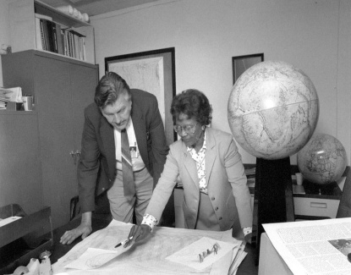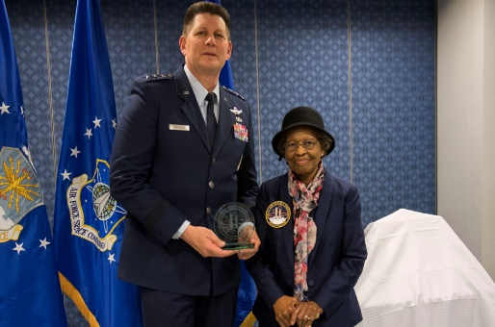
Dr. Gladys West
- Gladys West was the mathematician whose work led to the creation of GPS.
- West's vital contributions to GPS technology were recognized when a member of her sorority Alpha Kappa Alpha read a short biography West had submitted for an alumni function.
- West finished high school at the top of her class and later earned her bachelor's degree in mathematics. She then taught in public schools before earning her master's degree in 1955.
- This scholar was one of the first African American employees at the U.S. Navy's Naval Proving Ground in Virginia
- Her contribution to the development of the modern Global Positioning System, or GPS, which was achieved by compiling data from orbiting satellites and creating algorithms that could compute precise surface elevations and distortions in the Earth's shape
- In the early 1960s, she contributed to a landmark study on the regularity of Pluto’s motion relative to Neptune. However, it was her subsequent leadership on Seasat, and GEOSAT programs that cemented her role in satellite navigation which became the first satellite that could remotely sense the oceans on Earth.
- West was inducted into the United States Air Force Hall of Fame in 2018. She was awarded the Webby Lifetime Achievement Award for the development of satellite geodesy models.^{[2][3]}
- Known as a "hidden figure" of GPS, she recently passed at the age of 95.
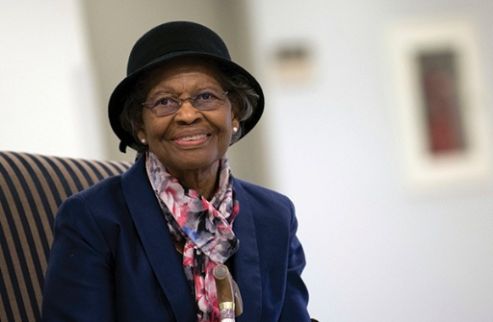
GIVING OPTIONS
www.NLAC.tv Website Giving:



If you have Cash App you can send your offer to $2NLAC




Go into your mobile banking app Click on pay with Zelle. Once inside your Zelle app it will give you the option to scan the QR code below or type in the church email address: officenlac@gmail.com

You can mail in your offerings through the mail at
New Life At Calvary
2020 East 79th Street
Dr. Gladys West
Cleveland, OH 44103

Youth Life Connect on Zoom Classes on Mondays
6:00pm-9:30pm, Teacher Pastor Antonia
Grades PK -K (3-5 years) 6:00-6:30
Grades 1-3 (6-8 years) 6:30 – 7:30pm
Grades 4-6 (9-12 years) 7:30-8:30pm
Grades 7-12 (13-17 years) 8:30-9:30pm
Zoom Meeting ID: 832-7903-1773 PW: 092683
Monday 6:30 pm (Adult Class)
Teachers: Andrea Billups
1 Thessalonians by Anand Mahadevan
Zoom Meeting 891-1091-7393 PW: 2020 Zoom Call In 1-312-626-6799 891-1091-7373 ##2020#

Reading Through The Bible - 7:30 pm: We will be using the NIV Version – Teacher: Pastor Kellie
Meetings 1st, 3rd, 4th, & 5th Tuesday of the month Meeting ID: 820-9791-8709 PW: 605886
Phone# 1-312-626-6799 ID: 820-9791-8709 ##605886#

Women with a Heart Bent Toward God. Teacher: Helen Britt (Return 2/10/26)
Zoom ID: 891-6849-5855 PW: 751319
Zoom Call In: 1-301-715-8592 Zoom Meeting ID: 896-0072-4832 Zoom Code: 709557#

Wednesday 7:00 pm (Adult Class) In Person
Teacher: Clemon Walker, In Fellowship Hall.

Wednesdays 7:00 pm (Adult Class)
(On Break)
Teacher: Pastor Toby Emeritus (The Chosen)
Zoom Meeting 334-158-729/2020 Zoom Call In 1-312-626-6799 334-158-729## 2020#

Wednesday 7:30pm (Adult Class)
Teacher: Pastor Antonia – Five Postures of a Global Christian
Zoom Meeting 872 5812 7559/2020 Call In 1-305-224-1968,,87258127559#,,,,*2020#

Wednesday 7:30 pm (Adult Class)
Teacher: Sylvia Fields – Enduring Belief of Looking Back The Christian Faith Looking Forward.
Zoom Meeting 865-9998-5439/54321 Zoom Call In 1-301-715-8592 TD: 865-9998-5439## PW: 54321

Please send a card, call, pray for, and support our Sick and Shut ins and recuperating brothers and sisters in Christ. Thank you.

Jennie Brown (1783 East 227th St, Euclid, OH 44117 216.785.9295)
Minnie Doaty (12005 Ablewhite Ave, Cleve., OH 44108)
Natalie Franklin (daughter of Julie Wright cards only) (c/o Donnese Franklin, 4216 Colby Ave, Columbus, OH 43227)
Marvin & Geraldine Hayes (1817 Marloes Rd, East Cleveland, OH 44112 216.541.6314)
Alfred Haywood (St. Augustine 7801 Detroit Ave, Rm 237, Cleveland, OH 44102)
Mary James (497 East 108th Street, Cleveland, OH 44108, 216-541-4114)
Savannah (Robin) Hill (Grande Pointe Healthcare Center, 3 Merit Dr, #323, Richmond Heights, OH 44143, 216-440-3440)
Kent Kelton (Longmeadow Care Center, 565 Bryn Mawr St, Room 57, Ravenna, OH 44266, 216-672-2763)
Mildred Little (1344 East 90th St., Cleve., OH 44106)
Fannie Ruffin (8164 Dartmoor Rd, Mentor, OH 44060)
Edna Swoope (27100 Cedar Rd, Beachwood, OH 44122)
Brenda White (West Park Commons 4106 Rocky River Dr, Apt 207, Cleve., OH 44135 216-377-7352)
David Wildermuth (Concord Reserve, 2116 Dover Center Rd, Rm 215, Westlake, OH 44145)
Janet Williams (10516 Elgin Ave., Cleveland, OH 44108)


