**New Life At Calvary**

**Sunday**

**May 18, 2025**

Prelude: *Kerry Holland*

Welcome/Opening Prayer:

Selection: *“Open The eyes of My Heart”*

*Praise Team/Band*

Scripture: Marvin Rogers

*OT: Proverbs 22:1-3*

*NT: Luke 16:1-13*

Offering:

Installation of Elders/Deacons

Special Music: *“I Will Bless The Lord”*

Message: Created for Significance: *“How To Invest Your One and Only Life”*

*Pastor Kellie*

Selection: *“Revive Us Again”*

Announcements:

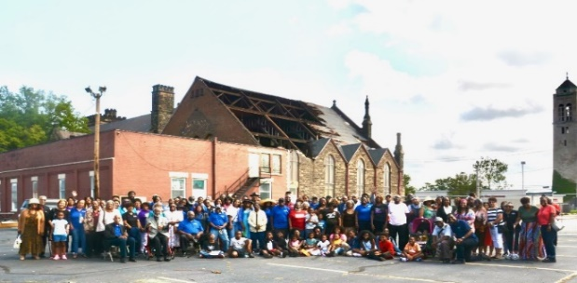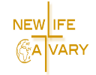Benediction:

**Church Purpose**

In Response to God’s love, Our purpose is to love others, Teach the Word of God, and Reach the world for Christ. Therefore, as a Covenant Partner, I will be a part of a small group bible fellowship to grow in Christ. I will serve in the ministry with my gifts and talents. I will do my part in faithfully giving my tithes and offerings to keep the ministry of Jesus Christ alive in the World. I will love all those who enter our doors and accept them in our midst.

**Open The Eyes Of My Heart**

Open the eyes of my heart, Lord,

Open the eyes of my heart;

I want to see You; I want to see You. (repeat)

To see You high and lifted up,

Shining in the light of Your glory.

Pour out Your pow’r and love;

As we sing holy, holy, holy. (repeat)

Open the eyes of my heart, Lord,

Open the eyes of my heart;

I want to see You; I want to see You. (repeat)

To see You high and lifted up,

Shining in the light of Your glory.

Pour out Your pow’r and love;

As we sing holy, holy, holy. (repeat)

Open the eyes of my heart, Lord,

Open the eyes of my heart;

I want to see You; I want to see You. (repeat)

To see You high and lifted up,

Shining in the light of Your glory.

Pour out Your pow’r and love;

As we sing holy, holy, holy. (repeat)

Thank You for Your Goodness

Thank you for Your Kindness

Thank you for Your mercy

We want to see you.

Holy, holy, holy;

Holy, holy, holy;

Holy, holy, holy, I want to see You. (Repeat)

**Revive Us Again**

We praise Thee, O God,

for the Son of Thy Love

For Jesus who died and is now gone above.

Chorus:

Hallelujah! Thine the glory!

Hallelujah! Amen!

Hallelujah! Thine the glory!

Revive us again.

We praise Thee, O God,

for Thy Spirit of Light

Who has shown us our Savior and scattered our night.

Chorus:

Hallelujah! Thine the glory!

Hallelujah! Amen!

Hallelujah! Thine the glory!

Revive us again.

All glory and praise to the lamb

that was slain,

Who has borne all our sins and cleansed every stain.

Chorus:

Hallelujah! Thine the glory!

Hallelujah! Amen!

Hallelujah! Thine the glory!

Revive us again.

Revive us again, fill each heart

with Thy love.

May each soul be rekindled with fire from above.

Chorus:

Hallelujah! Thine the glory!

Hallelujah! Amen!

Hallelujah! Thine the glory!

Revive us again.

**Announcements**

Attention: Please refrain from walking during these times: Prayer, Soloist, Scripture and Sermon. Thank you.

The Women’s Association will meet Sunday, May 25, 2025 after worship service in the Sanctuary.

The Men’s Association will meet Sunday, May 25, 2025 after Worship Service.

Sign-up for Swings and Things, May 31, 2025 with Pastor Antonia. If you need a ride, be at the church by 10:00am. If you want to go directly there meet at 11:00am. 8501 Sterns Road, Olmsted Township, OH 44138. Cost $12 per person.

Sign-up for Community Clean up day Saturday, June 14, 2025.

***Congratulations***! Trinity Sullivan officially graduated Saturday, May 17th, with her Masters of Arts in Clinical Mental Health Counseling from John Caroll University.

**Care Giver Needed for Elderly Person**. Minnie Doaty’s Family is looking for a sitter for eight (8) hours on Saturdays & Sundays. Must be 18 years or older, have experience working with the elderly and must pass a background check. Speak with Pastor Antonia for more information.

PINE VALLEY BIBLE CAMP: We are trying to reserve for term 3. June 29th – July 4th Sunday-Friday. You can register at pinevalleycamp.org

Thank you to all who supported and assisted Billie Brown in the loss of her daughter, Stanette Israel Brown. Thank you to Pastor Antonia and Pastor Toby for leading her home going celebration. Stanette was a beloved member of New Life At Calvary and she will be missed.

New Life At Calvary is invited to attend the play called, Fred Taylor's Memorial. Greg is the assistant director. Just Forgiven is opening the play.

Fred Taylor's MEMORIAL Bone-Chilling tales of history retold by homeless travelers that are walking (Vietnam War, Hough Riots, Gangster Blues and Kent State Shootings of 1970. Disciple Christian Church 3663 Mayfield Rd Cleveland Heights Ohio 44121 May 24th 5pm-7pm

**Birthday The Week of May 18, 2025**

Dallas Taylor 18th

James Taylor, III 19th

**Scripture Readers**

Unique Willis-Norris 4th

Andrea Billups 11th

Marvin Rogers 18th

Ruth Yarbrough 25th

**Special Offering**

1st Sunday – Deacon’s Offerings

2nd Sunday – Prison Ministry

3rd Sunday – Rotolu Orphanage Nigeria

4th Sunday – Two Cents A Meal

5th Sunday – Above & Beyond





***April/May Sermon Series:***

***Created for Significance***

*4/27: What’s My Purpose?*

*5/4: What Matters To God?*

*5/11: Measure Your Worth in God’s Eyes*

*5/18: How to Invest Your One and Only Life*

*5/25: A Look at The Life to Come*

***“What’s Your Purpose?” 4/27/25***



***“What Matters To God?” 5/4/25***



*“Measure Your Worth in God’s Eyes” 5/11/25*



*“How to Invest Your One and Only Life” 5/18/25*

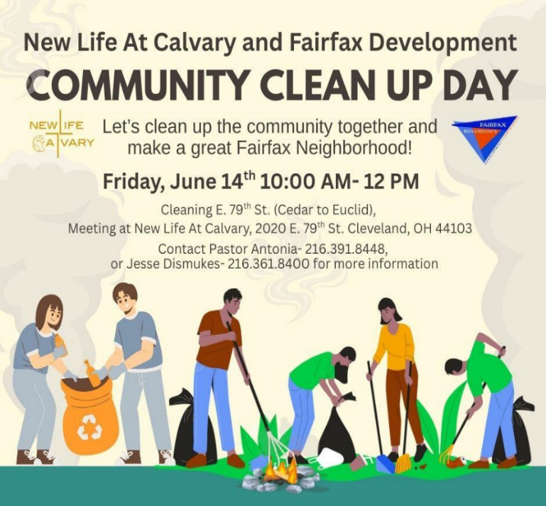

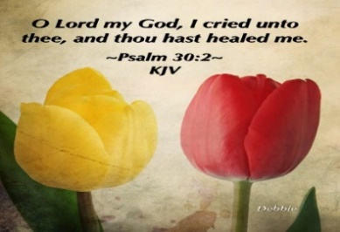

**Life Connect Classes**

**Youth Zoom Classes on Mondays**

**Worship Class – God’s Children Worship**

**Teacher (Pastor Antonia Martin) (On Break)**

(Grades PK-K) 2-5 years (6:00-6:30 pm)

(Grades 1-3) 6-8 years (6:30-7:30 pm)

(Grades 4-6) 9-12 years (7:30-8:30 pm)

(Grades 7-12) 13-17 years (8:30-9:30 pm.)

Zoom ID: 832 7903 1773 PC: 092683

**Monday 6:30 pm (Adult Class)**

**Salvation**

**Teachers: Marvin Rogers and Andrea Billups**

Zoom Meeting 891-1091-7393/2020 Zoom Call In 1-312-626-6799 891-1091-7393 # # 2020#

**Grief Class** on Tuesdays, at 7pm on Zoom: Zoom Meeting ID: 829-8003-5837, Password: 2020 Zoom Call In 1-312-626-6799 829-8003-5837 # # 2020#

**2nd Tuesday (Monthly)** **7:30pm Women with a Heart Bent Toward God. Teacher: Helen Britt** Zoom Meeting 891-6849-5855 PC: 751319. June 10, 2025

**Wednesday 7:30pm (Adult Class)**

**Teacher: Pastor Antonia – Colossians**

Zoom Meeting 829-8003-5837/2020 Zoom Call In 1-312-626-6799 829-8003-5837 # # 2020#

**Wednesday 7:30 pm (Adult Class)**

**Teacher: Sylvia Fields - Costly Sacrifice**

Zoom Meeting 865-9998-5439/54321

Zoom Call In 1-301-715-8592 ID: 865-9998-5439 # # PW: 54321 #

**Wednesday 7:00 pm (Adult Class)**

Teachers: Reginald Woods – **Romans Part 2**

In person in Fellowship Hall.

**Wednesdays 7:00 pm (Adult Class)**

**Teacher: Pastor Toby Emeritus (Listen To Your Day “The Life Changing Practice of Paying Attention)** Zoom Meeting 334-158-729/2020 Zoom Call In 1-312-626-6799 334-158-729# # 2020#

**Read The Bible in One Year/52 weeks/365 days - 7:30 pm:** We will be using the NIV Version –

Teacher: Pastor Kellie

Meetings 1st, 3rd, 4th & 5th Tuesday of the month

Meeting ID: 82097918709 PW: 605886

Phone# 13126266799 82097918709 # # 605886 #

*Please send a card, call, pray for, and support our Sick and Shut ins and recuperating brothers and sisters in Christ. Thank you.*

**Jennie Brown** (1783 East 227th St, Euclid, OH 44117 216.785.9295)

**Bessie Bryant** (Jennings Rehab Center, 10210 Granger Rd, #367 Garfield Hts 44125 216-246-3453)

**Minnie Doaty** (12005 Ablewhite Ave, Clev., OH 44108)

**Natalie Franklin** (daughter of Julie Wright cards only) (c/o Donnese Franklin, 4216 Colby Ave, Columbus, OH 43227)

**Marvin Hayes** (1817 Marloes East Cleveland, OH 44112 216.650.2312)

**Alfred Haywood** (St. Augustine 7801 Detroit Ave, Rm 237, Cleveland, OH 44102)

**Savannah (Robin) Hill** (Falling Water Healthcare Center, RM 236D, 18840 Falling Water Rd. Strongsville, OH 44136)

**LaDonna Jessup** (Shaker Gardens Nursing & Rehab. 3550 Northfield Rd – 360A – Shaker, OH 44122 - 216-255-7693)

**Kent Kelton** (Larchmere Ct. 4110 Rocky River Dr. #146 Cleveland, OH 44135 - 216-672-2763)

**Mildred Little** (1344 East 90th St., Cleve., OH 44106)

**Fannie Ruffin** (8164 Dartmoor Rd, Mentor, OH 44060)

**Edna Swoope** (27100 Cedar Rd, Beachwood, OH 44122)

**Brenda White** (West Park Commons 4106 Rocky River Dr, Apt 207, Clev., OH 44135 216-377-7352)

**Janet Williams** (10516 Elgin Ave., Clevland, OH 44108)



**The White pillars candle in the chancel is**

**a reminder for us to pray for the safety of all**

**the men and women serving in the military.**

**It reminds us to pray for peace in our land**

**and all lands.**

**Pledge Card for support of the 2nd Milestone of the**

**Building On Faith Capital Campaign of**

**New Life At Calvary Cleveland, OH**

A Capital Campaign is how we fund the future of New Life At Calvary. It challenges us to reach higher and dig deeper in order to meet the immediate and long-term needs of the church and the community. Like annual giving, giving to a Capital Campaign enhances the mission and ministry of the church through renovation and improvement of our church building.

Giving to the Capital Campaign is considered sacrificial giving. It does not come from our daily living expenses. Capital Campaign giving can be spread out over a three-year period to allow donors to manage their gifts according to their needs.

_____________________________________________________________________________

**I/We pledge in faith to support the 2nd Milestone of the Capital Campaign of New Life At Calvary listed by making the financial contribution listed below:**

**Total Amount of Pledge $_________________** (for those renewing the pledge see reverse side of this form)

**One-time Payment Date: ___________ Payments Over-Time**

Regular Payment Schedule expected:

$_____________ each week/month/quarter/year

**Method(s) of Payment**

* Cash or Check Enclosed
* Online Giving through New Life At Calvary
* (set up on the [www.nlac.tv](http://www.nlac.tv) website)
* Gift of Securities (see other side for more ways to give)

Start date: ______________ End Date: ______________

-or-

Other Payment Schedule described below:

__________________________________________________

__________________________________________________

__________________________________________________

Names: _____________________________________________________________________________________________________

Address: ____________________________________________________________________________________________________

City: _______________________________________________ State: __________________ Zip: ____________________________

Phone: ______________________________________________ Email: _________________________________________________

Signature Date of Pledge

____________________________________________________________________________________________________________

Signature Date of Pledge

**Methods of Giving to New Life At Calvary Capital Campaign, *Building on Faith Restoration***

**Cash or Checks**- Checks payable to New Life At Calvary, sent to 2020 E. 79th Street, Cleveland, Ohio 44103

**Online Giving**- One time or Recurring payment directly from a bank account. This is set up and managed from the Online Giving tab on the New Life At Calvary website (nlac.tv).

**Gifts of Securities**- Gifts of stocks, bonds, and other financial instruments can be arranged by contacting the NLAC steering Committee: Pastor Kellie C. Sullivan, Sylvia Y. Fields, Ruby Turner and Ella Thomas. When giving gifts of securities, please contact the Steering Committee with the donor’s name, the type of security name, and the number of shares, no later than the day the gift is made.

**Matching gifts**- Many employers will match charitable donations made by their employees. By using your company’s Matching Gift benefit, you may be able to multiply the amount of your donation. If you are affiliated with a company that matches gifts, please send the Matching Gift Form (usually attained by contacting your Human Resources Department), along with your donation to New Life At Calvary. The church will complete the form and return it to the company.

**Information pertaining to my companies matching gift program:**

___ I/We work for a Company that has a Matching Gifts Program.

___ The Matching Gifts Form is enclosed with this Pledge Card.

___The Matching Gifts form will be forwarded in the near future.

------------------------------------------------------------------------------------------------------------------------------------------

I/We pledge in faith to support the *Building on Faith Restoration Campaign* of New Life At Calvary by making the financial contribution listed on the reverse side of this form. My/Our contact information is on the reverse side. I/We have also signed indicating our commitment to complete this pledge. I understand that if we are a couple making this pledge both parties must sign this pledge.

**I/We made a pledge to the 1st Milestone. For the 2nd Milestone please do one of the following: (Check One)**

1. __________ Keep my/our pledge the same.
2. . _________ Increase my/our pledge to $________________.
   1. I/We plan on giving monthly, weekly, bi-weekly (please circle one).
3. I /We want to discuss giving a **Gift of Securities.**
4. I/We want to discuss doing a matching gift with my job.

1st Milestone givers please complete the contact information on the other side of this form. Thank you for your continued support.