Journey Partnership Packet
Becoming A New Covenant Partner

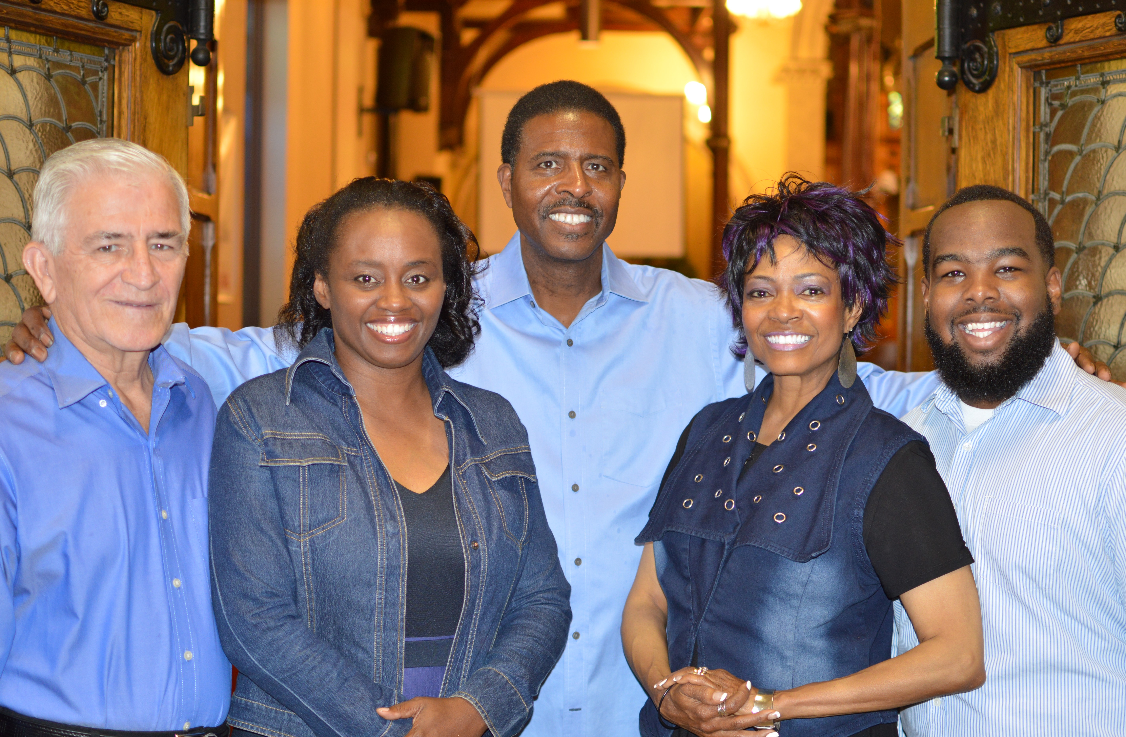
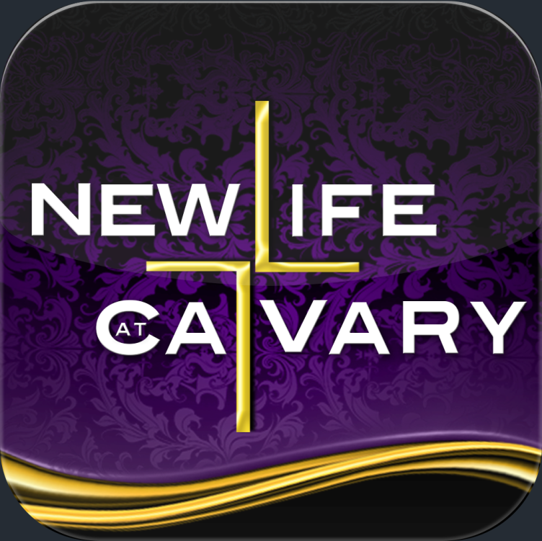
Becoming A Covenant Partner
New Life At Calvary, E.C.O.
2020 East 79th St.
Cleveland, OH 44103
www.newlifeatcalvary.com (216) 391-8448
Pastor Toby, Pastor Kellie, Pastor Rick, Pastor Willy, Keon Abner
Let us not give up meeting together, as some are in the habit of doing, but let us encourage one another--and all the more as you see the Day approaching. Hebrews 10:25

Why Should You Become A Covenant Partner?
- You become a covenant partner in order to…
- To use your talents, gifts, and financial resources to further the health and growth of that church.
- To give and to serve for God’s Kingdom
- To be a part of the family of God
- Because God expects and requires his people to attend church.

What Happens When I Become A Covenant Partner?
- We discover what it is to have brothers and sisters in the faith who love and care about us.
- Warning, there are no perfect churches. Everyone falls short of the glory of God at some point.
- We are called to glorify the Lord Jesus Christ in the way we live, talk, dress, speak, act, work, handle anger, express love, express sympathy and in everything else that we do.
- When a person joins a church, he or she willingly agrees to submit to the rules and teachings of the church, as well as to its governing boards.
Luke 9:23-24 Then he said to them all: "If anyone would come after me, he must deny himself (herself) and take up his (her) cross daily and follow me. For whomever wants to save his (her) life will lose it, but whoever loses his (her) life for me will save it.

- When one can no longer do this, he or she should resign his or her membership and join another church.
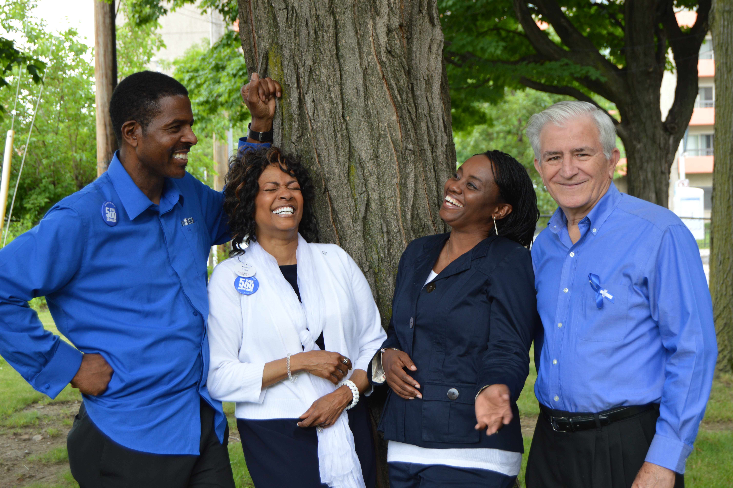

New Life At New Life At Calvary (ECO)
- New Life At Calvary is not for all people because no church is for all people in terms of its worship style, preaching style, music style, organizational style, and leadership style. All people who want to be a part of New Life At Calvary are more than welcome to be a part of the church if they accept our tenets, but our church will not compromise who God is calling it to be in order to satisfy the desires of others. The BIBLE is our guide for faith and practice.

- New Life At Calvary seeks Covenant Partners who are not perfect, but who want to grow in Jesus Christ and aspire to become all that God is calling them to be within the guidelines of the church. Membership in our church will not save anyone. One joins because he or she is already saved and is willing to meet the standards requested by the church, in saying yes to becoming a covenant partner, one is saying, "Yes, I offer myself to serve." We seek those who are simply willing to say, "Here am I Lord, and please send me." Our doors are as open as the invitation of Jesus Christ.
Luke 9:23-24 Then he said to them all: "If anyone would come after me, he must deny himself (herself) and take up his (her) cross daily and follow me. For whomever wants to save his (her) life will lose it, but whoever loses his (her) life for me will save it.

Summary of Our Basic Essential Tenets.
The Essentials Tenets of Our Faith
Each church has a group of beliefs that it considers important to who it is as a congregation. Our tenets or beliefs set the boundaries of who we can be in unity with one another and work together to build the kingdom of God. Not every Christian will hold to the same tenets, and that is why our church may not be for everyone. Each believer should be a part of a congregation in which he or she can joyfully serve the Lord in a way consistent to the tenets he or she holds.

Our basic Essential Tenets (Beliefs) are as follows:
1. The great purpose toward which human life is drawn is to glorify God and to enjoy God forever.
- Each believer has a duty to glorify God.
- Each believer enjoys God by being united with Christ, through the power of the Holy Spirit.
- Each believer is to allow God to be at work in his or her life so that God is able to manifest Christ in his or her life.
2. God’s Word: The Authority of Our Confession
- We discover who God is through the Incarnate Word (Jesus Christ) and the written word (The Bible).
- Jesus Christ shows us the full nature of God the Father and how God truly loves us and desires to be in relationship with each of us.
- The Bible proclaims the saving gospel of Jesus Christ, and graciously teaches all that is necessary for faith and life.
- We glorify God by recognizing and receiving God’s authoritative self-revelation both in the infallible Scriptures of the Old and New Testament and also in the incarnation of the God the Son, Jesus Christ.
- We affirm that the same Holy Spirit who overshadowed the Virgin Mary also inspired the writing and preservation of the Scriptures.
- The Holy Spirit illuminates our hearts and minds so that we might rightly receive both the Bible and the Jesus Christ.
- The Holy Spirit will never prompt our hearts or our minds to conclusions that are contrary to the Scriptures that The Holy Spirit has inspired.
- The Book of Confessions are a secondary authority of faithful expositions of the Word of God
3. The Trinity
- The Triune nature of God is the first mystery of the Christian Faith.
- We worship the only true God-Father, Son and Holy Spirit-who is both one essence and three persons.
- God is infinite, eternal, and cannot be divided against Himself.
- The Godhead is still one God with three persons. The Son is eternally begotten from the Father, and The Spirit proceeds eternally from the Father and the Son. All three persons are worthy of worship and praise.
- God has made human beings in God’s own image, with a unique desire to know God and a capacity for relationship with God.
4. The Incarnation
- Jesus Christ is both truly God and truly human.
- Jesus Christ is the Second Person of the Trinity.
- Jesus was conceived by the Holy Spirit and born of the Virgin Mary.
- Jesus’s glory fills heaven and earth.
- Jesus has risen from the dead and ascended to the Father in his resurrection body.
- Jesus is one day going to physically return to us.
5. God’s grace in Christ
- The chaos, pain, destruction and sin in the world today is not God’s doing, but is the result of humanity’s free, sinful rebellion against God’s will.
- Since the fall, our natural tendency is to hate God and our neighbor, to worship idols of our own devising rather than the one true God.
- No part of human life is untouched by sin. All humanity participates in the fall to sin.
- We are dead in our sin and unable to save ourselves. Apart from God’s initiative, salvation is not possible for us.
- Jesus Christ assumed our human nature, joining us in our misery and offering Himself on the cross in order to free us from slavery to death and sin.
- Those who are united through faith with Jesus Christ are fully forgiven from all our sin, so that there is indeed a new creation.
- We are declared justified, not because of any good that we have done, but only because of God’s grace extended to us in Jesus Christ.
- In union with Christ, through the power of the Spirit, we are brought into right relation with the Father, who receives us as God’s adopted children.
- Jesus Christ is the only Way to this adoption, the sole path by which sinners become children of God.
6. Election for salvation and service.
- God chooses us for Himself in grace before the foundation of the world, not because of any merit on our part, but only because of God’s love and mercy.
- We are not chosen to be saved for our own purpose and benefit. The Spirit gathers us in a community that is built up and equipped to be light, salt, and yeast in the world.
- Christ sends us into the world to make disciples of all nations baptizing them in the name of the Father, Son and Holy Spirit and teaching them to obey everything that Christ taught us.
- We are called to preach Christ, calling others to repent and believe the gospel.
- We also care for the natural world, claim all areas of culture in the name of Jesus, serve the poor, feed the hungry, visit the prisoner, and defend the helpless.
7. Covenant life in the Church
- In Christ, we are adopted into the family of God and find our new identity as brothers and sisters of one another, since we now share one Father.
- Our faith requires our active participation in the covenant community (local church).
- In Christ, the dividing wall of hostility created by nationality, ethnicity, and gender, race, and language differences is brought down.
- Within the covenant community, God’s grace is extended through the preaching of the Word, the administration of the Sacraments, and the faithful practice of mutual discipline.
- We need the Spirit’s power both to preach the word of God and to receive the word of God.
- In the baptism of infants, we confess our confidence in God’s gracious initiative, that a baby who cannot turn to God is nonetheless claimed as a member of the covenant community, a child of God, cleansed by grace and sealed by the Spirit.
- In the baptism of adults, we confess our confidence that God can make us new creations at any stage of our lives.
- In the Lord’s Super, we confess that as we at the bread and share one cup, the Spirit unites us to the ascended Christ, so that Christ’s resurrection life may nourish, strengthen, and transform us.
- The community of the Church practices discipline in order to help one another along the path to new life, speaking the truth in love to one another, bearing one another’s burdens, and offering to one another the grace of Christ.
8. Faithful Stewardship of all life
- The ministries of the church reflect the three fold office of Christ as prophet, priest, and king—reflected in the church’s ordered ministries of teaching elders, deacons, and ruling elders.
- Men and women alike are called to all the ministries of the church.
- Every Christian is called to participate in the three fold offices within the world beyond the church, 1) proclaiming the good news to the world, 2) extending the lordship of Christ to every corner of the world and 3) offering intercessory prayer to God on behalf of the world.
- We are called to love the Lord our God with all our heart, with all our soul, and with our entire mind. There is no part of human life that is off limits to the sanctifying claims of God.
- All of our affections and desires must be brought under God’s authority as shown forth in God’s word.
- To be faithful, we are called to a life of daily prayer. The life of prayer includes praise to God for God’s nature and works, sincere confession of our sin, and intercession for the needs of those we know and for the needs of the world.
9. Living in obedience to God’s word.
- We will worship God alone, refusing to worship or trust in any other.
- We will worship God in humility, not creating our own images of God but worshiping God as God reveals Himself in the Scriptures and sacraments.
- We will eliminate from speech and thought and blasphemy, irreverence or impurity concerning God and the Name of God.
- We will observe the Sabbath as a day of worship and rest being faithful in gathering with the people of God.
- We will give honor toward those set in authority over us and practice mutual submission with the community of the church.
- We will eradicate a spirit of anger, resentment, callousness, violence, or bitterness, and instead cultivate a spirit of gentleness, kindness, peace, and love; recognize and honor the image of God in every human being from conception to natural death.
- We will maintain chastity in thought and deed, being faithful within the covenant of marriage between a man and a woman as established by God at the creation or embracing a celibate life as established by Jesus in the new covenant.
- We will practice right stewardship of the goods we have been given, showing charity to those in need and offering generous support of the Church and its ministries.
- We will pursue truth, even when such pursuit is costly and defend truth when it is challenged, recognizing that truth is in order to goodness and that its preservation matters.
- We will resist the pull of envy, greed, and acquisition and instead cultivate a spirit of contentment with the gifts God has given us.
- We will strive to allow the Holy Spirit to work in us so that the holy life of Jesus will become our holy life.
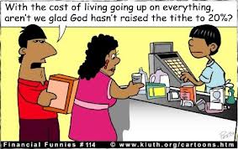
Giving & Per Capita
BE A TITHER. KEEP 90% OF YOUR INCOME AND GIVE GOD 10%. THAT'S ONE PENNY FOR EACH TEN PENNIES YOU EARN.
- Every church has to have money to pay its bills. As a member, you are expected to tithe. Tithing is giving God one dollar for every ten dollars that you earn. It is a means of learning to trust God for our needs. If we are not willing to trust God with our money, it is unlikely that we will be able to trust God with much else.
- You may also contribute to special offerings each year if you like. We take up a Deacon's offering on a regular basis. We also have other special offerings during the year that you may or may not desire to contribute to. You should not take your tithes and designate them as special offerings.
- If you are absent for a Sunday, you are to bring your offering to the church the following Sunday, or send it in the mail to the church during the week.
- Your pledge should be a minimum of 10% of your income. Feel free to make donations to other organizations, but use a portion of your 90% to do it. Don't rob God and the church by using the portion that’s a part of your tithes.
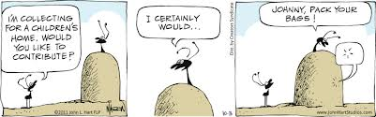
If you are Faithful in your giving, many people will come to know Christ and be able to serve the Lord in the way and manner that God desires. You will feed the hungry, clothe the naked, and shelter the homeless. We all need for you to be faithful in providing your resources to the church. The Church will be able to accomplish the mission that God intended for it to do. Remember, each person can make a difference within the Kingdom of God. You are either being a blessing to the church or part of the problem in the church in your giving. It’s YOUR Choice

PER CAPITA GIFT PRIVILLEGE
Each year, each Presbyterian member pays a per capita GIFT. Your Per Capita is not part of your tithes. A portion of the money of per capita goes to our presbytery and to our Synod. This is how the denomination meets its bills and administrative expenses in order to do the mission work it does. Your per capita gift makes our denomination a stronger witness for Christ. Per Capita should be paid by January 31st of each year. If you become a covenant partner (member), you must agree to pay per capita each year. You begin your covenant partner relationship by paying your share of per capita. If you can’t afford it all up front, we will gladly work out a schedule with you. Currently per capita is $28.00.

How Our Church Works?
The Session
- 22 Elders, 2 Co-Clerks of Session, and 3 Pastors
- The Session Makes the decisions for the church
- Elders are elected by the congregation members
- Elders serve for 3 year terms.
Congregation is made up of
- Covenant Partners
- Friends
- Covenant Partners In Process
- Guests

Pastors and Staff
(3) Pastors: Pastor Toby, Pastor Rick, Pastor Kellie
- Are elected by the congregation
- Can remain a part of the church for an indefinite period of time
- Choose the scriptures, songs, and sermon topics
- Offer counsel, visits, marriages, & funerals
- Staff (See Page 24 for a list of staff members)

The Deacons
- 15 Deacons, 2 Co-Moderators of Deacons, and 1 Pastoral Staff Member
- Provide Care for the Church
- Elected by the congregation
- Serves for 3 years
- Does not make any decisions for the church.

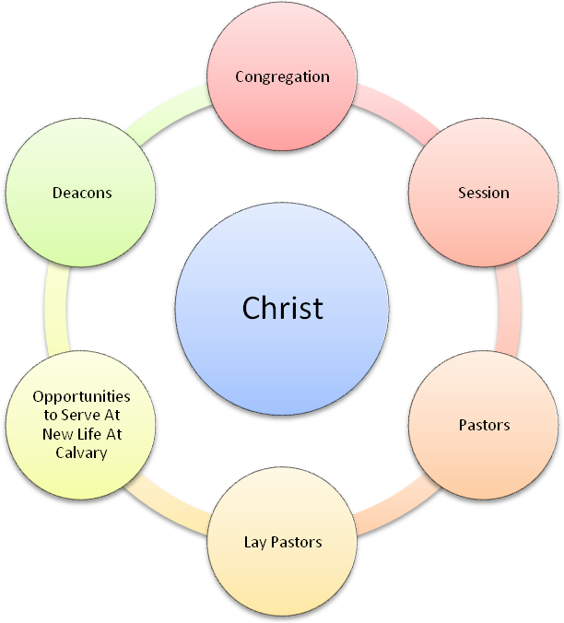

Lay Pastors
- Lay Pastors lead Life Sharing groups, they pray for people during worship service, they serve in the pastors absence, they visit, they offer counsel to the congregation and to the pastors

- They are not a decision making body in the life of the church. They are appointed only by pastors.

+
Opportunities to Serve At New Life At Calvary
For A Full List of Opportunities see our NLAC Ministries Booklet
Ministry Teams provide opportunities for everyone to serve Jesus Christ, using their gifts and talents

First Half Question Review
(Please Complete This Section Prior To the Class)

1. What are three things a person agrees to use when he or she joins a church? (Page 2)

2. Why become a Covenant Partner? (Page 2)

3. What are three of our Essential Tenants? (Page 3-6)

4. On page 5 under “Covenant Life In The Church,” name two requirements for covenant life in the church? (Page 5)

5. What are the four different groups present in the congregation for worship on Sunday morning? (Page 8)

6. What groups make up the session? (Page 8)

7. How long do deacons serve in office and name one thing that they do? (Page 8)

8. What are three things that Lay Pastors do? (page 8)

9. What are tithes and offerings and what is the Per Capita Gift? (page 7)

A Covenant Order Of Evangelical Presbyterians
Our Denomination:
We are a part of a denomination called the Covenant Order of Evangelical Presbyterians. Also known as ECO.
The Congregation:
- The congregation’s fellowship shall be open to all who seek to explore spiritual life by participating in the fellowship of the risen Lord. The congregation shall be gracious in providing pastoral care to all who consider themselves a part of the congregation in the the hope that these spiritual friends might become members of Christ’s body. All who put their trust in Jesus Christ are welcomed to receive The Sacrament of Holy Communion.
- After completing a meaningful preparation prcoess as determined by the session, those who wish to embrace the congregation’s covenantal expectations may become covenant partners by action of the session after hearing testimony of their faith in Jesus Christ as Lord and Savior. For those not previously baptized, the Sacrament of Baptism is to be provided for these new members and offereed to children unde their care..
- Individuals may testigy of their faith in two ways: 1) Public profession of faith in Jesus as Savior and Lord, after the regenerating work of the the Holy Spirit yeilds personal faith in Christ. 2) Reaffirmation of faith for those who previously professed faith and have already been baptized in the name of the Father, and of the Son, and of the Holy Spirit. If they are members of another congregation, the other congregation shall be informed of the transfer of membership.
The Synod
- Loans for Churches
- College Scholarships
- Grants for Ministry Projects
The Local Church
- Worship
- Teaching
- Fellowship & Ministry Opportunities
- Support (Counseling, Financial, Emotional, Social, Limited Financial)
- The categories of membership of a congregation of ECO includeds baptized members and covenant parters. 1) A baptized member is a person who has received the the Sacrament of Baptism, but has not made a profession of faith in Jesus Christ as Lord and Savior. A covenant partner is a person who has made a profession of faith in Christ, has been baptized, has been received in the membership of the church, has voluntarily submitted to the government of this church, and participates in the church’s worship and work.
Benefits of Covenental Partnership.
- Covenant partners are positioned to receive encouragement, support and correrction that the Lord provides to those who share
- Covenant partners grow in Christian community together to become more Christ-Like.
- Covenant partners realize the fullness of life together and life in Christ.
- Covenant partners discover our unique place in common mission and narrative of God’s work.
- Covenant partners and the congregation are both blessed and become a great blessing as they covenant together, intentionally, in Christ’s work.
- Covenant partners vote in congregational meetings.
What does the Congregation of New Life At Calvary Pledge To You?

We pledge ourselves to you in the following ways:
1. You have the right to pastoral services in your time of need. You must make it known to the pastors that you have such a need.

2. You have the right to be supported spiritually, emotionally, and physical during your time of difficulties. You must make it know that you have this need either to your elder, deacon, or to the pastors.

3. You have the right to vote and to hold office if elected by the congregation. You will only be nominated to office only if you meet the guidelines in terms of your giving, your attendance, and your participation in the life of the church.

4. You have the right to bring issues before the Session.

5. You have the right to nominate others for office.

6. You have the right to be a part of an encouraging and supportive church family.

7. You have the right to use the building for weddings, funerals, or special family events at a reduced rate.

8. You have the right to participate in the life of the church in areas where you can make a positive contribution.

9. You have the right to be on a care team or part of a bible study or Life Sharing group.

10. You have the right to be contacted by others you are absent for more than two Sundays.

11. You have the right to give beyond 10% of your income if you should so desire.

The Congregation’s Expectations of Covenantal Partnership
- Each covenant partner shall strive to be faithful to Christ by participating in the congregations’ worship, fellowship, and service on an ongoing basis.
- Faithfulness in Christ involves each covenant partner’s dedication of time and talents for the congregation’s mission and ministry, in accordance to the gifts that God has bestowed upon him or her.
- Faithfulness also involves the stewardship of finances. As each covenant partner grows in the grace of giving, financial support of the congregation’s mission and ministry should grow, along with tangible support for other ministries that advance God’s kingdom.
- Faithfulness to Christ also involved each covenant partner’s dedication of time and talents for the congregation’s mission and ministry.
- Those who are invited to take significant leadership roles in the congregation shall be spiritually mature, agree with the Essential Tenets of ECO, be carefully selected, be trained and or/mentored, supervised, and should ordinarily be members for at least a year.
Meetings of The Congregation
- The congregation shall hold an annual meeting and special meetings as needed.
- A quorum of ten percent of the covenant partners is needed and only those covenant partners who are present may vote in a congregational meeting.
- Meetings of the congregation may be called by session, by the presbytery, or by the session when requested in writing by one fourth of the covenant partners.
- Congregational meetings shall be moderated by the pastors. The clerk of Session shall take notes at the meeting.
The Session
- Every congregation is governed by the Session. The session consists of the elders duly elected by and from the covenant partners of the congregation, along with the congregation’s installed pastors and associate pastors. By its own rules, the church determines the number of Elders, their length of service, and the offering of the session. The minimum number shall be three active elders plus the moderator.
- The Session shall hold stated meetings at least quarterly, and shall meet at the call of the moderator, at the request of two or more elders or at the request of the presbytery. Full minutes shall be kept and shall be available to any covenant partner or at the request of the presbytery.
Responsibilities of Session
- The session has responsibility and authority for governing the congregation and guiding its mission for Christ in the world. In the Reformed tradition the marks of the church are the proclamation of the Word, the Sacraments rightly celebrated, and the exercise of discipline. Therefore, the session shall:

- a. Provide for the worship and educational life of the congregation; provide a place
where the congregation may regularly worship; provide for the regular preaching of
the Word by persons properly approved; oversee the planning and the ordering of the worship services of the congregation; lead the congregation in ministries of
evangelism, compassion, and justice; and develop and nurture relations with other
congregations.

- b. Authorize and provide for the regular celebration of the Lord’s Supper; authorize the administration of Baptism; exercise due care and provide sufficient education to the congregation and to new believers that the Sacraments may be rightly received as means of grace.

- c. Plan for and provide means of discipleship for the congregation and new believers;
provide for and nurture the common life of the congregation; receive and dismiss
members; exercise oversight of all programs and finances of the congregation; train,
examine, ordain and install those men and women chosen to serve as elders and
deacons; lead and teach the congregation in matters of stewardship and Christian
living; direct the ministry of deacons, trustees, and all other organizations of the
congregation; bear witness against error in doctrine and practice; and serve in judicial matters pertaining to the congregation as specified in the
Rules of Discipline.

- d. Elect elder commissioners to the presbytery and may propose to the presbytery matters of common interest or concern as well as proposals to amend the ECO
Constitution The maximum number of elder commissioners which the session may elect shall be equal to the number of pastors with voting authority as set forth in Section 2.0401 serving the congregation. The session is encouraged in its selection of elder commissioners to promote representation in areas of difference recognized as the basis of discrimination and inequality in church and society, namely race, ethnicity, gender, ability/disability, and age.

- e. Maintain a Roll of Covenant Partners (members) and a Roll of Baptisms. The session may by its own rule grant affiliate status to members of a congregation in another Christian denomination.

- f. The session shall adopt and administer an annual budget and shall publish it to the congregation. The session shall purchase appropriate casualty and liability insurance for the program and property. The session shall arrange for the congregation to participate in the synod’s plan of health and welfare benefits and program of assistance and relief covering the congregation’s pastors and full
-time lay employees, as such plan is described in the membership agreement (unless the congregation and the synod agree to an alternative plan providing comparable coverage).

- g. Arrange for an independent financial review annually, and shall publish the report to the congregation and to the presbytery.

- h. Evaluate the congregation’s ministry and mission and report to the presbytery for
reasons of mutual accountability and the sharing of best practices

The Presbytery
- The Presbytery is made up of a number of congregations in a particular geographical area with a minimum of ten congregations but no more than twenty churches, A group of congregations may petition to form a non-geographic presbytery for reasons of language.
- The members of presbytery are its congregations, pastors installed in service to member congregations, pastors serving in validated ministries, and pastors honorably retired. The Presbytery shall hold stated meetings at least twice a year. Elder commissioners elected by the congregations and its installed pastors have a vote.
- The presbytery, as a covenant community exercises apostolic authority by and for the nurture and benefits of its congregations, that the communities they serve may know the love and invitation of Christ.
- The presbytery has the authority and pastoral responsibility to:

- a. Promote the health of the covenant community to the end that its congregations and members may bear fruit for the Kingdom of God.

- b. Charter and receive new congregations into the presbytery.

- c. Dismiss congregations to other presbyteries or denominations.

- d. Exercise special care and oversight of congregations that do not have an installed
Pastors, and appoint the moderator of such sessions.

- e. Dissolve congregations when their mission work has ceased.

- f. Authorize the celebration of the Lord’s Supper beyond particular congregations.

- g. Receive, dismiss, examine, install, provide pastoral care for, and discipline pastors.

- h. Enroll, dismiss, and examine candidates and ordain them to called service.

- i. Validate the call of ministers to service beyond a congregation.

- j. Settle differences between congregations and pastors

- k. Propose and vote on amendments to the Constitution
.
The Synod Purpose

- The synod is the widest council of ECO giving support and guidance to the presbyteries and congregations. The synod shall assess and proclaim the missional vision and theology of ECO. The Synod Shall:

- a. Provide linkage of presbyteries to one another for mutual encouragement.

- b. Correspond and connect with global mission partners, other denominations and
- ministry partners.

- c. Maintain the Constitution and Essential Tenets of ECO.

- d. Where appropriate and necessary, provide services (i.e., pension and health insurance) for ECO.

Meetings of Synod Commissioners

- The synod commissioners shall meet at least bi-annually. The meetings shall serve the purpose of encouraging presbyteries and churches in their mission as well as conducting the business necessary for the mission of ECO. Meetings of the synod, including its quorum shall be governed by the latest edition of Robert’s Rules of Order, Newly Revised, unless by its own rule the synod has adopted other procedures and practices.

- The Synod commissioners shall have the authority to elect and remove members of the synod executive committee and to amend and vote on proposed amendments to this Constitution submitted to the synod by at least two presbyteries.

- Voting members of the synod are those individuals commissioned by and from their presbyteries. Presbyteries shall commission an equal number of ministers and elders. The synod, by its own rule, shall determine the number of commissioners from each presbytery, and each presbytery shall be entitled to at least one elder and one pastor commissioner.

Synod Executive Council

- The synod executive council shall consist of between six and nine individuals, with at least three being elders and the remainder being ordained pastors. The synod executive committee shall have the power to:

- a. Constitute, divide, and dissolve presbyteries, and settle disputes between them,
provided any such action is approved by two thirds of the members of the council
then in office.

- b. Receive and approve union presbyteries into ECO, provided any such action is
approved by two thirds of the members of the governing board then in office.

- c. Adopt an annual budget and may receive, hold, manage, sell and expend funds and other assets.

- d. Elect corporate officers (including a president) and hire staff.

- e. Represent ECO to ecumenical and mission partners when needed.

- f. Develop a manual of operations for its activities and functions.

- g. Own the distinctive trademarks, trade names, and other intellectual property of ECO and protect against unauthorized use thereof.

- h. Exercise all other powers of a nonprofit corporation under applicable law.

Jesus Said, “Let the little children come to me, and do not hinder them, for the kingdom of heaven belongs to such as these.” (Matthew 19:14)
At New Life At Calvary we believe that people of all ages are loved by God. We believe that scripture teaches to raise children knowing God and loving God. Proverbs 22:6 says, “start children off on the way they should go, and even when they are old they will not turn from it.” At our churches children can become a part of the church as a baptized child and/or as a full member once they have met all of the requirements for baptism and membership.

1. Baptized Child: A baptized child is a child who is between the ages of newborn to 12. This is a child whose parents, grandparents, or legal guardians are full members of the church. We baptize children not because we believe that the baptism saves their souls, but because we believe that the promises of God that are given to a person’s parents extend to the children. We only baptize children that are a part of our church because we (the congregation and pastors) make a promise to help raise the baptized child up in the faith. If a child becomes baptized and then leaves the church then we cannot fulfill our promise.
- Baptized children are expected to attend youth worship classes and bible study classes so that they can learn about God, learn how to read and understand the bible, and learn about the church and church history.
- Baptized children are expected to serve in ministries, as they are able, such as the children’s choir, praise dancers, ushers, or other ministries. A baptized child is often able to serve alongside their parents or other adult members of the church.
- Baptized children are able to participate in communion.
- Baptized children are not considered full covenant partners of the church. Baptized children are always encouraged to complete their membership process, however, we never force a baptize child to become a full member.

2. Baptized Child becomes a Covenant Partner:
When a baptized child comes to an age that they are able to understand the steps to membership and they can fully understand the materials described in the adult class, then they can attend a new members class and join the church by AFFIRMATION OF FAITH. This is where a baptized child states what they believe on their own. This usually occurs after the age of 8, when a baptized child is able to fully read and understand the process of membership. Once a baptized child becomes a covenant partner gain all the rights and responsibilities of a covenant partner.

3. When A Baptized Child Becomes a Covenant Partner Do They Get Re-Baptized?
Usually the answer to this question is no. We believe that once a person is baptized that they do not need to have a second baptism. However, there are times when a baptized child cannot remember their baptism and the experience is a part of their journey and can be very meaningful. In these instances we will perform a baptism for a baptized child that is becoming a full member.

4. Can a child be baptized if their parents or legal guardians are not covenant partners of the church? In certain instances a child can be baptized if their parents are not a part of the church. Usually the grandparents or aunts/uncles are members of the church. In these situations a parent must give written permission for the child to be baptized. If there is no adult representation for the child at our church and the child has been coming on their own, then the child must provide written permission from their parents or legal guardian in order to be baptized. Usually this child is old enough to become baptized and a full member at the same time.

5. Baptized Children Can Become A Covenant Partner at the same time: If the child is 12 and up or old enough to understand the baptism and membership process, then they can go through the membership class and become a covenant partner at the same time. They still need to have their parent’s permission. This child must still fulfill the covenant partner requirements of church attendance, serving in a ministry, tithing, and per capita.

Missions Projects

Missions Projects that We Support as a Church Financially
- Rotolu Home: Nigerian Orphanage
- Haiti Poor Children’s Assistance Project
- India Assembly of God Church
- Christmas Gifts
- Prison Ministry
- Prescription Fund
- Prayer Shawl Ministry

(All who attend New Life At Calvary are encouraged, if they are able, to support these projects financially. These special financial donations are above and beyond your tithe.)

Elected Officers of NLAC

Ministries that You Need To Be Elected To
or you may be asked to serve on one of the following below listed committees

Session & Session Committees: Clerk of Session: Sylvia Fields
Elders serve 3 year terms. After three years the elders may be reelected to for an additional three years. No elder can serve more than two consecutive years. Once you’ve served for two consecutive terms you must have one year off. Elders are required to tithe, participate in bible study, attend church on a regular basis, help with prayer times during the invitation, serve communion, serve on a session committee, serve on and Elder/Deacon Care Team, and live a Christ-like lifestyle.

Deacons & Deacon Committees: Moderator of Deacons: Demetrius Darmond
Deacons: Deacons are not a governing body. Their job is to help those who are hurting. They will seek to provide assistance to those who have physical, financial, and emotional needs. They will attempt to provide emergency food, clothing, shelter, and gifts when needed. One of their largest jobs is to assist during funerals. Deacons help with preparation and serving of the repast meal for families. They also provide presence and assistance during the home going celebration. Deacons serve 3 year terms. After three years the deacons may be reelected to an additional three years. No deacon r can serve more than two consecutive years. Once you’ve served for two consecutive terms you must have one year off. Deacons are required to move toward tithing if not already tithing, participate in bible study, attend church on a regular basis, help serve communion, serve on a deacon committee, serve on and Elder/Deacon Care Team, and live a Christ-like lifestyle.

Session Committees with Elder & Deacon Representation:

- Building & Grounds Committee
- Evangelism & Outreach Committee
- Music Worship & Sacraments Committee
- Membership Committee
- The Finance Committee
- The Christian Education Committee
- The Nominating Committee
- Elder/Deacon Care Teams
- Personnel Committee
- Celebration Committee

The 7 Steps to Full Covenant Partnership At New Life At Calvary
1. You must have accepted Jesus Christ as Lord and Savior of your life and be actively living for God in your life-style. You must agree to adhere to the Essentials Tenets of what we as a church believe.

2. You must attend church at least 3 times in one month.

3. You must agree to join a ministry

4. You must meet with the Session Representatives and answer these questions
- "How do you see God at work in your life?"
- "Why have you chosen to join New Life At Calvary?"
- What ministry have you decided to join? Other questions may also be asked.

5. You must complete
- A Membership Application (included in this packet)
- A Faith Pledge Sheet
- An Opportunities for Service to Christ Sheet (also included in this packet)

6. You must agree to pay yearly per capita and pay your per capita.

7. You must agree to financially support the church with your talents, gifts, and financial
resources.

After you complete the class, you will have a one month period to become engaged in the life of the church as a pre-covenant partner. Once you have shown yourself willing to become a full partner through your service, your presence, your giving, and your lifestyle, you will be accepted as a full covenant partner.

What Happens After I Complete the 7 Steps To Membership?
Upon completion of the above listed steps you will come before the church and be received as a member of our church in front of the congregation
- You are invited to bring family and friends & You will receive a membership certificate

Other Information About Becoming A Member:
- If you have already been baptized you do not need a 2nd Baptism we recognize your baptism
- Affirmation of faith (first time confession of Christ)
- Reaffirmation of faith (acknowledgment that you have drifted from Christ and have come back home),
- Or by letter of transfer (currently a member of another church and you ask them to send a letter stating they are transferring your membership to us.

We Thank You For Carefully Studying This Packet & We Welcome You To Our Church!
Review Questions Part II
(Please Complete This Section Prior To The Class)

1. What are three benefits of being in the Covenantal Partnership? (Page 11)

2. Name three things that New Life At Calvary Pledges to You? (Pages 11 & 12)

3. Describe the Synod. (page 15)

4. What is a Baptized Child? (page 17)

5. What are three of the 7 steps to full membership at New Life At Calvary? (Page 20)

6. What happens if you have already been baptized? (page 20)

7. What happens after you complete the 7 steps to full membership? (Page 20)

8. What are the three forms that you must complete and turn in during your New Members Class is complete?

9. What are at least two things you are asked to do in your faith pledge sheet to the Lord? (page 27)

Current Elders And Deacons
New Life At Calvary PCUSA

Class of 2015 Elders | Class Of 2016 Elders | Class Of 2017 Elders
Walter Glenn* | Gloria Jester | Karen Hogland*
Felicia Earl | Denise Nevins | Gail H. Banes
William Hasson Philips-Bey | Gerald Nevins | Shannon Hendrix
LaTanya Deane* | LaDonna Jessup | Franklin Jones
Ruth Yarbrough | Edward Harrison | Laverne Mason
Glynn Jackson* | Marian Wallace** | Yvonne Sims
Emma Jackson*
George Beach
Class of 2015 Deacons | Class of 2016 Deacons | Class of 2017 Deacons
Joyce Jones | Deborah Jolly | Kamilah Williams
Susan Gillespie | Michael Milan | Demetrius Darmond Sr.
Linda Huff | Julia Wright | Joseph Pledger
Pearlie Huff | June Phillips | Laureen Beach
Brenda Lyle | Patricia Anderson | Tonya Weatherspoon
*Serving a second consecutive term
**Completing a term & eligible to serve a 2nd term

Elder Deacon Care Teams
Care Team | Elder | Deacon
1 | Karen Hoagland | June Philips
2 | Gail H. Banes | Pearlie Huff
3 | Shannon Hendrix | Laureen Beach
4 | LaTanya Deane | Brenda Lyle
5 | Felicia Earl/Laverne Mason | Linda Huff
6 | Walter Glenn | Kamilah Williams
7 | Ruth Yarbrough/Marian Wallace | Joseph Pledger
8 | Gerald Nevins | Tonya Weatherspoon
9 | Hassan Philips-Bey/George Beach | Patricia Anderson
10 | Denise Nevins & Glynn Jackson | Julia Wright
11 | Gloria Jester | Deborah Jolly
12 | Helena Harrison | Susan Gillespie
13 | Franklin Jones/LaDonna Jessup/Emma Jackson
14 | Edward Harrison/Yvonne Sims | Joyce Jones/Michael Milan

New Life At Calvary
Moderators:
Pastor Rick Gillespie-Mobley, Pastor Toby Gillespie-Mobley, & Pastor Kellie C. Sullivan
Sylvia Fields, Clerk of Session
Demetrius Darmond, Moderator of Deacons

Contact Phone Numbers:
Lay Pastor Sylvia Fields: (216) 932-0965
Pastor Rick Gillespie-Mobley (216) 338-5118
Pastor Toby Gillespie-Mobley (216) 376-1209
Pastor Kellie C. Sullivan (440) 315-2791
Pastor Willy (Parish Associate) (440) 522-1032
Church Phone Number: (216) 391-8448
Church Email Address: officenlac@yahoo.com
Church Website: www.newlifeatcalvary.com
Church Worship Times:
8:15 am Sundays 10:45 am Sundays 12:30 noon Sundays
New Life At Calvary Church Staff
Office Staff: Ruth Yarbrough, Gail H. Banes
Maintenance: Frank Jones, Hasson Phillips-Bey, Morrell Davison, LaDonna Jessup, Demetrius Darmond Sr. and Demetrius Darmond, Jr.
Young Adult Ministries: Keon Abner
Musicians: Blossom Williams & Shelly Wheeler (Piano/Keyboard), Tracy Pruitt (Bass Guitar), Frank Jones (Saxophone), Susan Gillespie and Demetrius Darmond Jr. (Drummer) Keon Abner (Praise Choir Director), Demetrius Darmond (WOGT Choir Director), Gwen Coats (Praise Choir Director), Antonia Martin (One Voice Director)
Our New Life At Calvary Purpose
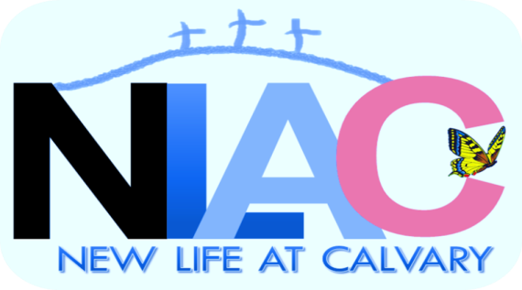
In Response to God’s Love, Our purpose is to love others, teach the Word of God, and to reach the world for Christ!
Notes &/Or Questions
____________________________________________________________________________________________________________________________________________________________________________________
____________________________________________________________________________________________________________________________________________________________________________________
____________________________________________________________________________________________________________________________________________________________________________________
________________________________________________
________________________________________________

Faith Pledge Sheet

MY FAITH PLEDGE SHEET TO THE LORD
By
___________________________________________ (Name)
1. I PLEDGE TO COME TO CHURCH AT LEAST ______ (NUMBER OF TIMES A MONTH) UNLESS PREVENTED FROM DOING SO BY MY JOB ILLNESS, OR AN EMERGENCY.

2. I UNDERSTAND I SHOULD STRIVE TO BECOME A TITHER (GIVING 10%). IF I AM UNABLE TO GIVE 10%, I AM GOING TO START BY GIVING ______% OF MY INCOME AND WILL INCREASE IT YEARLY UNTIL I AM AT OR ABOVE 10%. I UNDERSTAND I CAN INCREASE OR DECREASE MY GIVING BASED UPON MY INCOME.

3. I PLEDGE TO BECOME A PART OF __________________________ (SELECT A MINISTRY) UNLESS ILLNESS LIMITS MY ACTIVITIES.

4. I EXPECT ELDERS/DEACONS/PASTORS AND OTHERS TO CONTACT ME IF I'M MISSING FROM CHURCH FOR 3 OR MORE WEEKS.

5. IF I HAVE A PROBLEM WITH THE SOMETHING OR SOMEONE IN THE CHURCH I WILL DEAL WITH THE RIGHT PEOPLE TO HAVE IT RESOLVED.

6. I WILL LIVE A SEXUAL AND MORAL LIFESTYLE IN ACCORDANCE WITH THE SCRIPTURES...

7. WHEN I COME TO CHURCH FOR WORSHIP, I WILL BE IN THE WORSHIP SERVICE UNLESS SERVING IN THE NURSERY OR TEACHING.

8. I WILL INFORM THE CHURCH OFFICERS WHEN I AM ILL.

Signature: ____________________________________________ JESUS IS MY WITNESS.

Covenant Partner Application
First Name: _______________________________________________________________
Last Name: ________________________________________________________________
Maiden Name: _____________________________________________________________
Address: __________________________________________________________________
City: _________________________State: ____________________ Zip: _______________
Telephone Number: _______________________ Cell Phone:________________________
Date of Birth: _______________ Age if under 21: ___________ Grade: ________________
Marital Status: _____ Single _____Married ____Divorced ____Widowed
Spouse Full Name: ___________________________________________________________
If Minor:
Mother’s Full Name (Including Maiden Name: _____________________________________
Father’s Full Name: ___________________________________________________________
Previous Church: ________________________________ Phone: ______________________
Denomination: _________________________________ Pastor: ________________________
I have been baptized: ______ Yes _________ No If yes, (Baptismal Date: ________________)
- __________I am joining by
- __________Affirmation of faith (first time confession of Christ),
- __________Reaffirmation of faith (acknowledgment that you have drifted from Christ and have come back home),
- __________Or by letter of transfer (currently a member of another church and you ask them to send a letter stating they are transferring your membership to us.
I understand the steps to membership at New Life At Calvary. I understand that I am agreeing to attend church, pay yearly per capita, tithe, and support the church with my gifts, talents and financial resources.
Signature: ___________________________________ Date: ___________________________
Witness: ____________________________________ Date: ____________________________
I give permission for my child listed above to receive the sacraments of baptism and communion and/or to join as a member of New Life At Calvary.
Parent Name: ______________________ Signature: __________________ Date: __________

Opportunities to Serve
We want all members of NLAC to serve in a ministry or to become a member of a ministry. Please review the list and write down in the space provided what ministries you would like to join or serve.

Name: _____________________________________________

Music Ministries (Choirs, Bands, Dancers)
- Praise Choir Member
- Men’s Choir Member
- Women’s Choir Member
- Warriors On God’s Team Choir Member
- One Voice Teen/Young Adult Choir Member
- Praise Team Member
- Praise Band Member
- Liturgical Dancers Member
- Praise Dancers Member

Ministries that support Worship or Gathering Times As A Church
- Media Ministry Team Member
  - T.V. Camera Helper
  - Projector Helper
  - T.V. Mixer Helper
  - Sound System Helper
  - T.V. Broadcast Helper
  - Web Ministry Helper
- Parking Lot Ministry
  - Attendants
- Ushers & Greeters
- Coffee Hour
- Church Driver
  - Pick Up People in your own vehicle for church
  - Help Drive the Van
- Set Up Cleanup for Service

Evangelism
- Distribute Flyers
- Do Invitations to Christ on Television
- Community Days
  - Volunteers
  - Follow-up Team
- Call Missing Members
- Call Guests

Member & Friend Support
- Sick & Shut In Visitation Team

Buildings and Grounds
- Yard Work
- Mow Lawn
Ministries in Support of the Community
- Feeding The Community Meals Ministry
- Food Pantry (Deacons)
- Prison Ministry
- Breakfast with Santa Volunteers
- Harvest Party Volunteers
Ministries for All Adults
- 60+ Club
- Prayer Shawl Ministry
- Spiritual Journey
- Marriage Sensation
Women’s Ministries
- Women’s Guild
- Women’s Association
- Sisters-In-The Lord
Men
- Men’s Ministries
- Transparent Men
Christian Education
Christian Education for Children & Youth
- Nursery (0 to 5)
- Nursery Youth
- Nursery Teachers
- Nursery Assistants
- Youth Church (grades 1st-6th)
- Youth Church Students
- Youth Church Teachers
- Spring Break Camp (K- 6th Grade)
- Spring Break Youth
- Spring Break Volunteers
- Spring Break Teachers
- Pioneers (grades 2nd to 6th)
- Pioneers Youth
- Pioneers Teachers
- Teen Youth Group (7th-12th )
  - Teen Youth Member
  - Teen Youth Teacher
- True Love Waits (6th-12th Grade)
  - Youth
  - Teacher
- Vacation Bible School
- Vacation Bible School Youth
- Vacation Bible School Teacher
- Vacation Bible School Volunteer

Christian Education for Adults
- Adult Sunday School Sundays 9:30
- Member
- Teacher
- Christian Awareness Sundays 1:00pm
  - Member
  - Teacher
- Journey Thru The Bible Thursdays 11:00 Joyce Moore
  - Member
  - Teacher
- Bible Study & Prayer: Fridays 10:30 Anna Sharp
- Member
- Assistant Teacher
- Life Sharing
Tuesday Class off Campus
- Andrea Billups 5:30 pm
Wednesday Classes At NLAC at 7:30
  - Lay Pastor Sylvia Fields & Jeanette Williams-Daniels
  - Lay Pastor Helen Britt & Pastor Toby
  - LaTanya Deane
Wednesday Classes off Campus
  - Lay Pastor Laverne Mason 5:00
  - Lay Pastors Katy & Walter Glenn 7:30
Christian Education for Young Adults (Ages 18 to 25)
  - The Gathering
    - Member
    - Leader
    - Speaker
  - College Scholarship Ministries
I would like to join the following ministries:
(Please write down what you would like to serve or join)
___________________________________________________________

