New Life At Calvary
2020 East 79th Street
Cleveland, OH 44103
216-391-8448
Email: officenlac@yahoo.com
Website: nlac.tv

Sunday
September 13, 2026

10:00 AM
Celebration Service

Pastors:
Rev. Kellie C. Sullivan
Rev. Antonia M. Burton
Rev. Dr. Toby Gillespie-Mobley (Emeritus)
Rev. Dr. Rick Gillespie-Mobley (Emeritus)

Pastoral Ministry Staff:
Elder Sylvia Y. Fields

Music Ministry:
Mr. Kerry Holland
Ms. Susan Gillespie
Mr. Greg Cosper

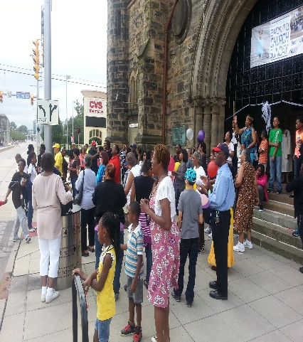

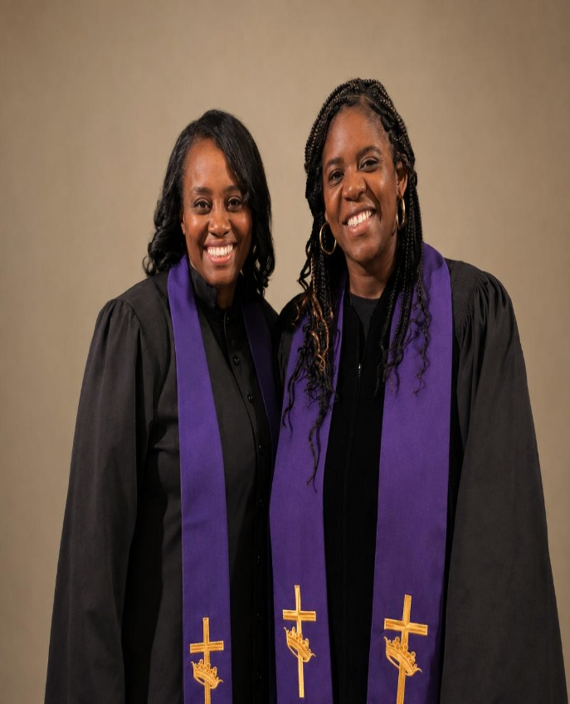
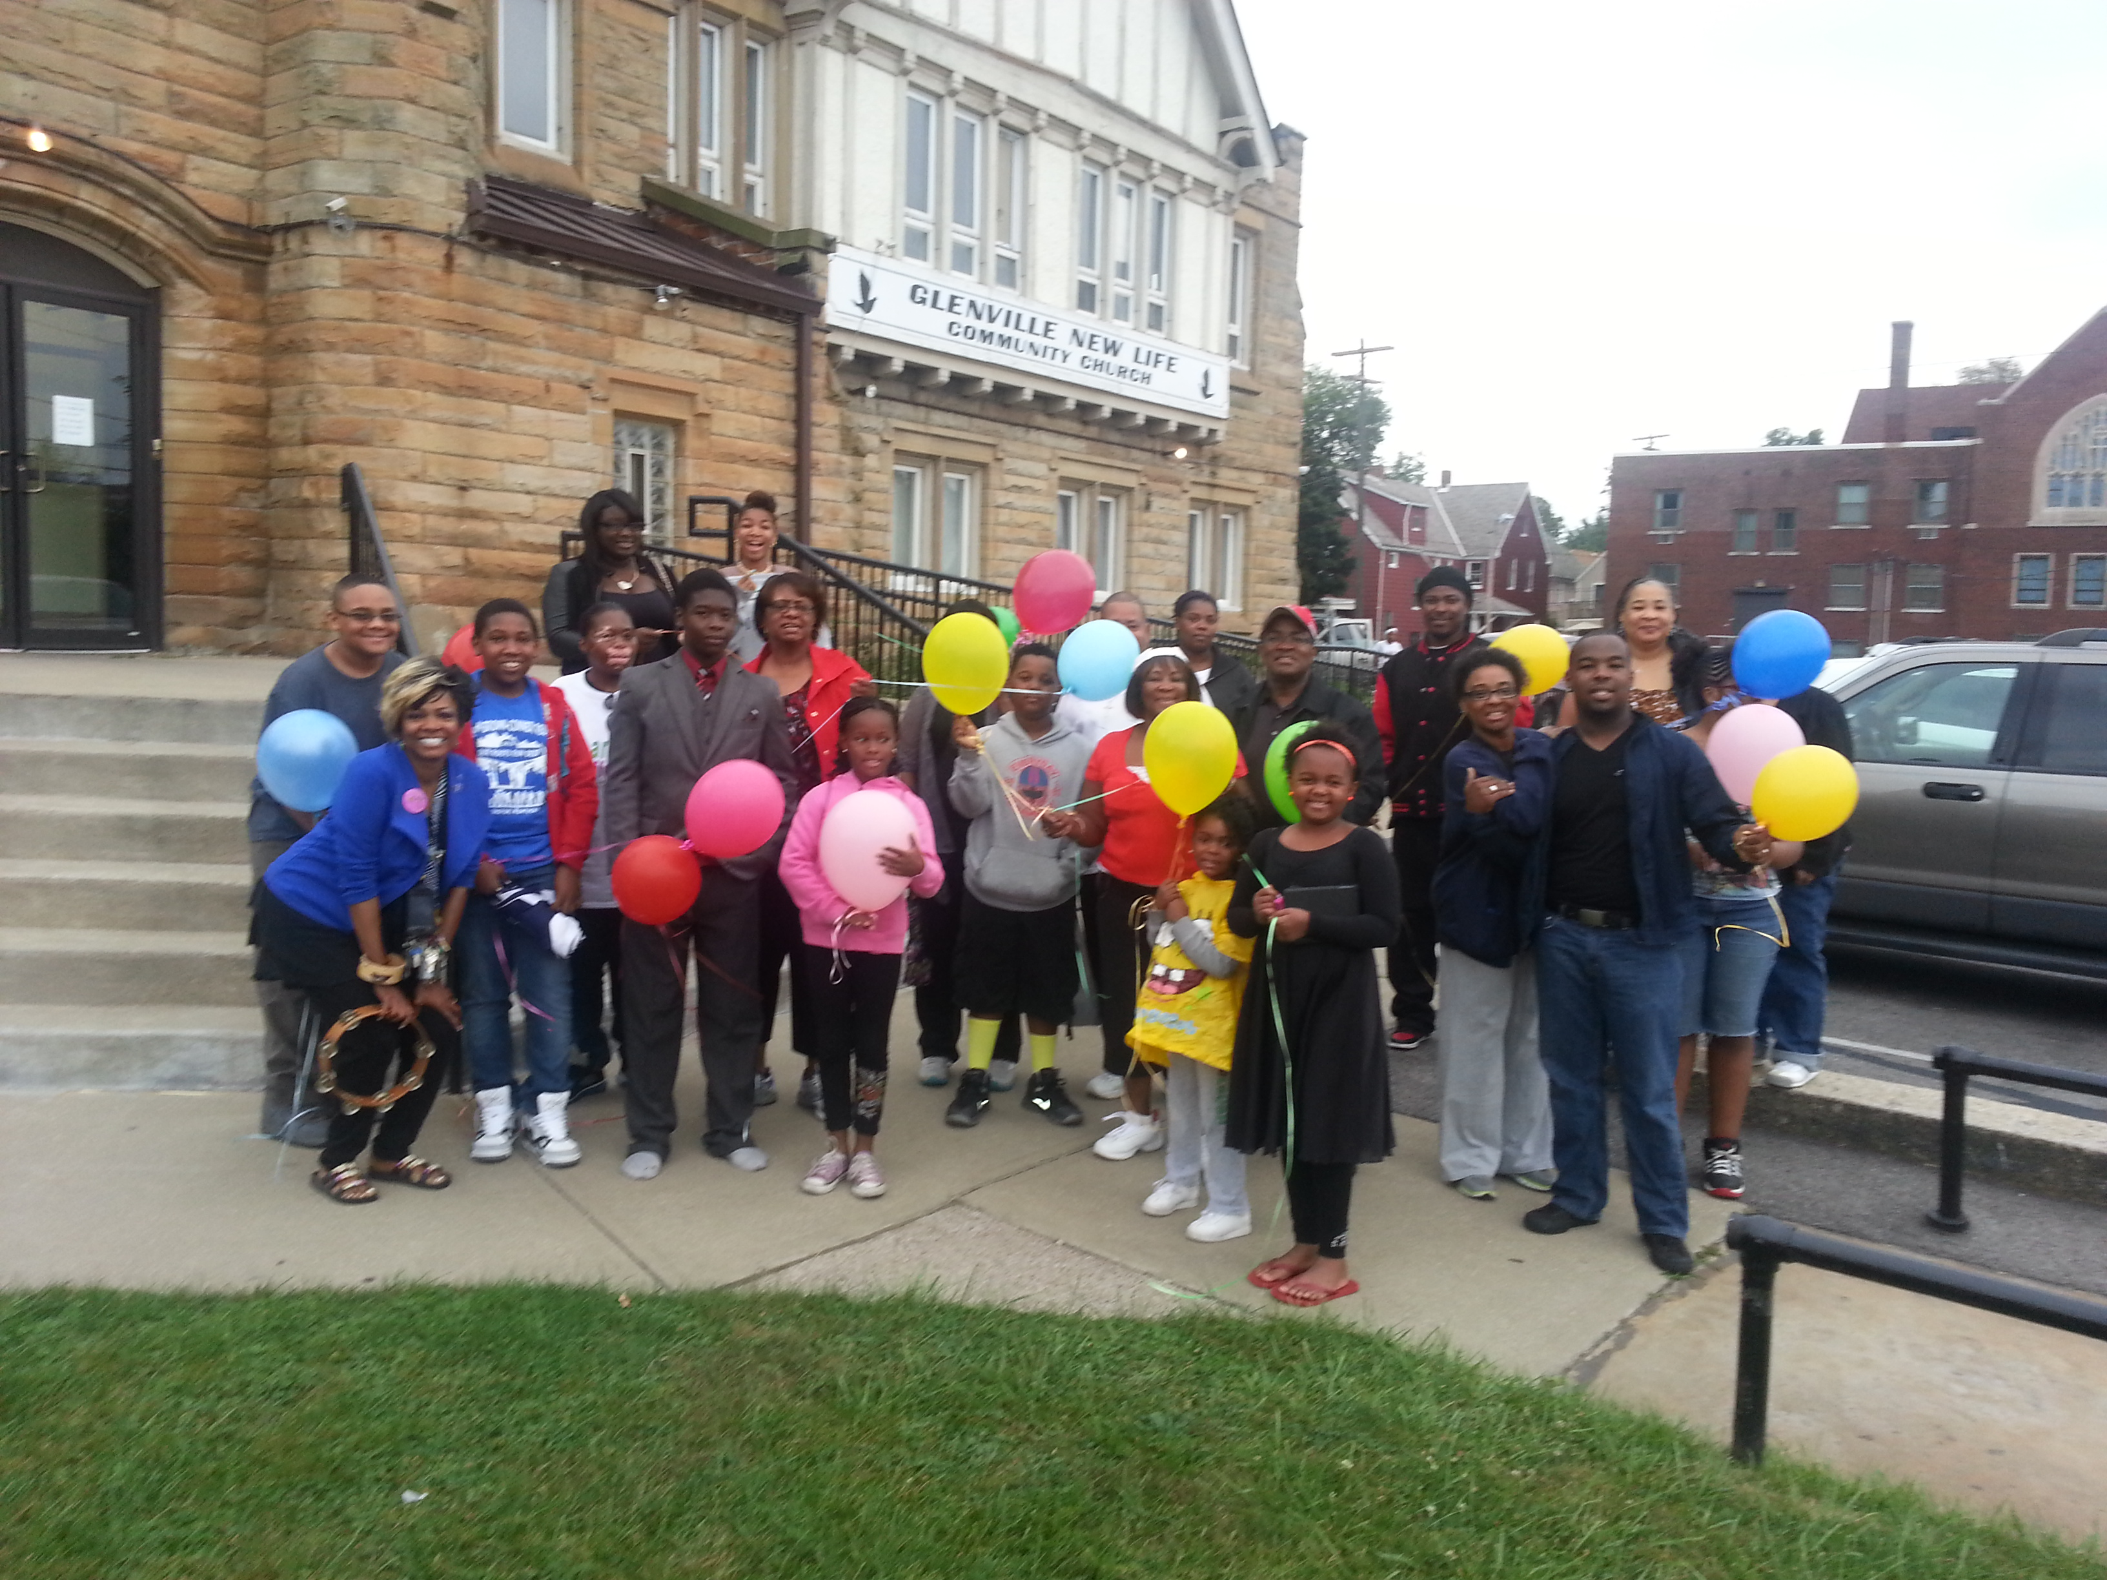
Pastor Kellie Pastor Antonia
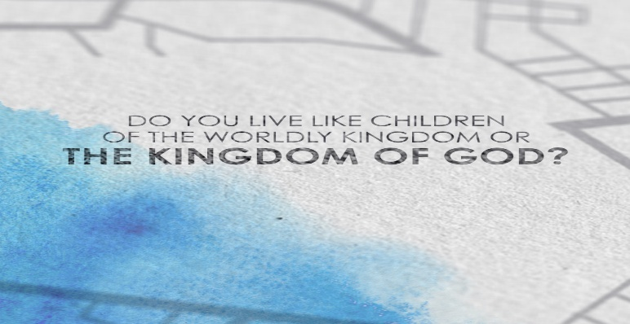
New Life At Calvary
Sunday
September 13, 2026

Prelude: Kerry Holland

Welcome/Opening Prayer:

Selection: “I Cannot Tell It All”

Scripture: Sharon Thomas
OT: Isaiah 55:8-9
NT: Luke 12:29-32

Offering:

Special Music: Ms. Deborah Forest
“Lord Don’t Move The Mountain”

Message: Pastor Kellie
The Kingdom of Heaven is Near: “Learning Kingdom Values”

Selection: “Jesus, Jesus”

Reception of New Members, Recognition of Deacon Moderator & The Sacrament of Baptism

Announcements:

Benediction:

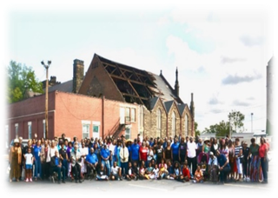
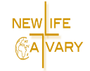
Church Purpose
In Response to God’s love, Our purpose is to love others, Teach the Word of God, and Reach the world for Christ. Therefore, as a Covenant Partner, I will be a part of a small group bible fellowship to grow in Christ. I will serve in the ministry with my gifts and talents. I will do my part in faithfully giving my tithes and offerings to keep the ministry of Jesus Christ alive in the World. I will love all those who enter our doors and accept them in our midst.
I Cannot Tell It All by Chicago Mass Choir
Verse:
God's been so good to me
I cannot, cannot tell it all.
He's opened doors for me,
I cannot, cannot tell it all.
He's made a way for me,
I cannot, cannot tell it all.
He supplies my every need,
I cannot, cannot tell it all.
Loosed my shackles, set me free,
you don't know like I know
what He's done for me;
I cannot tell it all, I cannot tell it all.
(Repeat x3)

Tenors:
God has been so good to me,
I cannot tell it all.
God has been so good to me,
I cannot tell it all.

Altos:
God's been so good, He's been so good,
I cannot tell it all. God's been so good,
He's been so good, I cannot tell it all.

Sopranos:
Picked me up, turned me around,
I cannot tell it all.
Placed my feet on solid ground,
I cannot tell it all. I cannot tell it all.
I cannot tell it all.

Jesus, Jesus by the Brooklyn Tabernacle Choir
Jesus, Jesus, Jesus, Jesus, Jesus, (x2)

Savior, Savior, Savior, Savior, Savior (x2)
Healer, Healer, Healer, Healer, Healer, (x2)

Thank You, thank You, thank You
Thank You, thank You, (x2)

Jesus, Jesus, Jesus, Jesus, Jesus, (x2)

Ending:
Jesus, Jesus, Jesus

Announcements
Attention: Please refrain from walking during these times: Prayer, Soloist, Scripture and Sermon. Thank you.

Food Pantry Delivery: Friday, September 18, 2026. Volunteers are needed to help bring food into the gym and pack grocery bags. Please arrive around 9:30am.

Food Pantry Distribution: Saturday, September 19, 2026. Volunteers are needed to help distribute grocery bags. Please arrive around 8:30am.

The youth trip to Fun N Stuff is this Friday the 18th at 6pm. Please meet us at the Macedonia location. The cost is $15 including food.

The teen trip, ages 13-17, to Slick City is next Sunday after church. The cost is $20 including food.

The Youth Choir will be rehearsing this Saturday at 12:30 pm.

Change in receiving offering statements. We will only email unless you have told us to mail them to you. Please speak with Gail H. Banes if you want your statements mailed.

Birthdays The Week of September 13, 2026

Sylveta Russell 15th
Joy Williams 16th
LaTanya Deane 19th

Scripture Readers Sept.
Hazel Hicks 6th
Sharon Thomas 13th
Yvonne Sims 20th
Za’Niya Conner 27th

Special Offering
1st Sunday – Deacon’s Offerings
2nd Sunday – Prison Ministry
3rd Sunday – Rotolu Orphanage Nigeria
4th Sunday – Two Cents A Meal
5th Sunday – Above & Beyond

GIVING OPTIONS
www.NLAC.tv Website Giving:

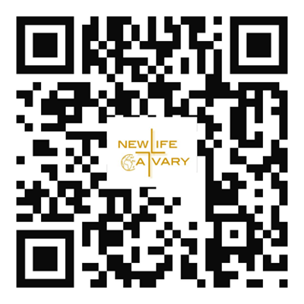

If you have Cash App you can send your offer to $2NLAC




Go into your mobile banking app Click on pay with Zelle. Once inside your Zelle app it will give you the option to scan the QR code below or type in the church email address: officenlac@gmail.com

You can mail in your offerings through the mail at
New Life At Calvary
2020 East 79th Street
Cleveland, OH 44103

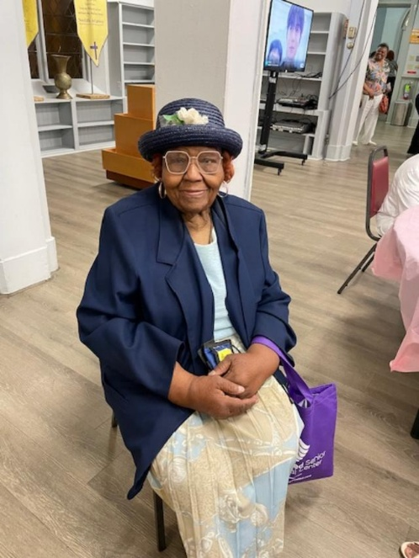

Mrs. Julia Wright: One of my most favorite times I have had at NLAC is when my great-grand children from Atlanta were in Cleveland. The church children staff often have activities that interest them and they enjoyed being a part of the activities, such as, the Easter Egg Dying. They liked the holiday skits. I’m also, glad to bring them out for game night. All these things give them a good reason to visit their Great-Grand Ma in Cleveland.

Sharon Thomas: There have been many, many memories I can elaborate on, but one of the most memorable ones is the walk from Glenville New Life Community Church to Calvary Presbyterian Church to unite us as one. This is what has brought us together and has evolved into where we are today. Praise God for his Grace and Mercy!

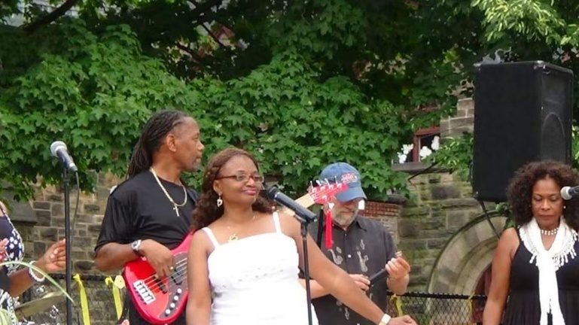
Jazz In NLAC Garden

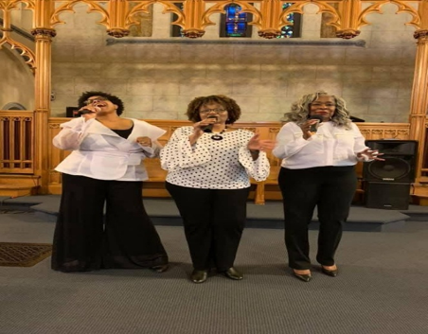
Gwen Coats Trio 2019
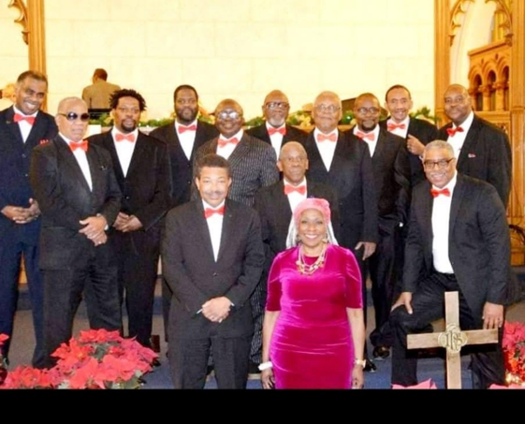
The Men’s Choir Directed by Gwen Coats

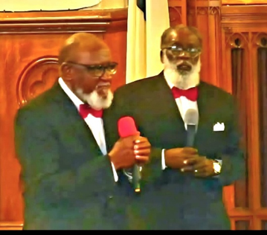
Duet John Coats & Rufus Sims

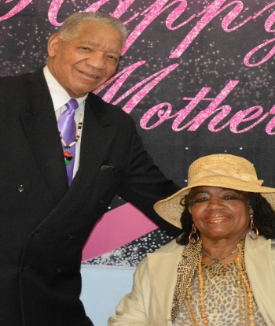
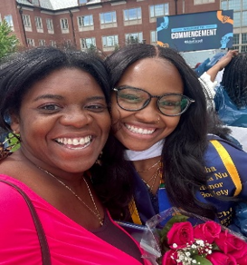


Monday Night Bible Class
Pastor Antonia & Trinity Larry & Jackie Rush

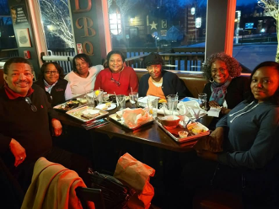

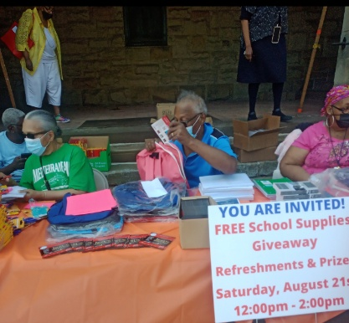

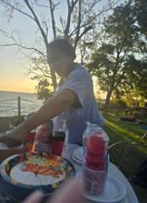

Monday Night Bible Class
Picnic on the Lake

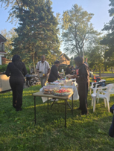

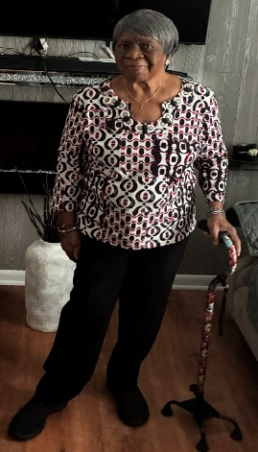

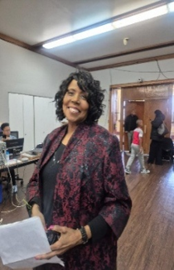

Susan Gillespie Jennie Brown
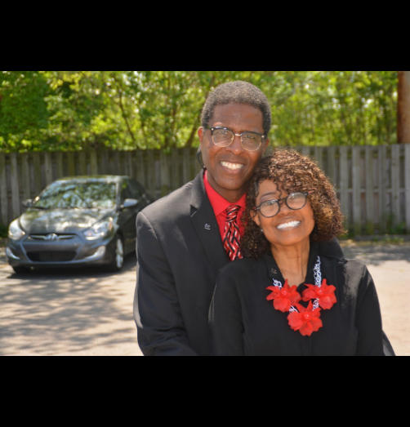

Pastor Rick & Pastor Toby
New Life At Calvary,
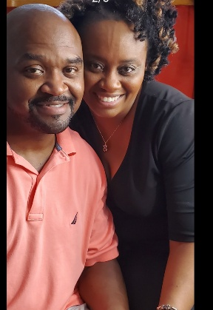
We Love You!
Today we celebrate 13 years since God brought our churches together to become New Life At Calvary. We have treasured this journey, the good days, the difficult days, and even the most challenging days, because through every season, God has been present, God has been faithful, and together we have made it this far. Thank you to everyone who has stayed the course and to everyone who has joined this journey along the way. Here’s to 13 years of faith, perseverance, and becoming who God has called us to be.

“Thus far the LORD has helped us.” — 1 Samuel 7:12

Blessings,
Pastor Kellie C. Sullivan &
Terrence A. Sullivan

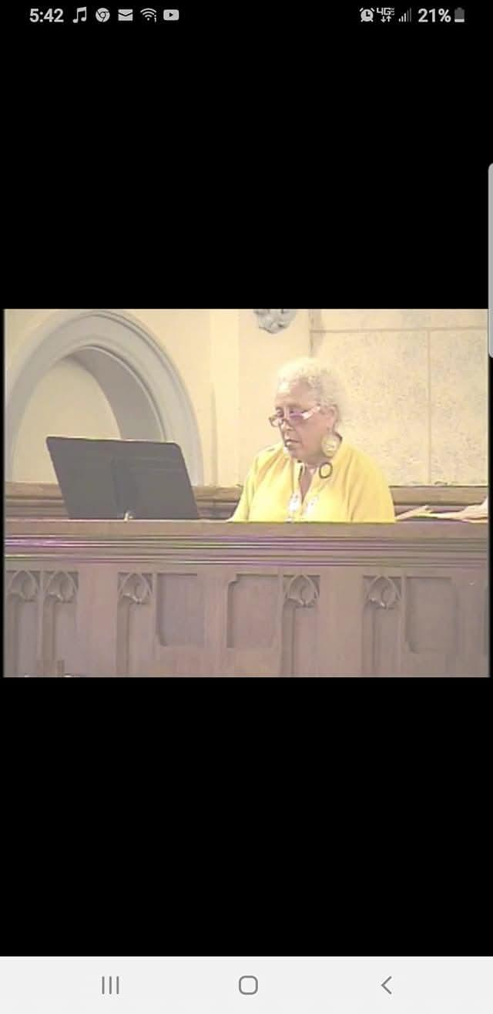
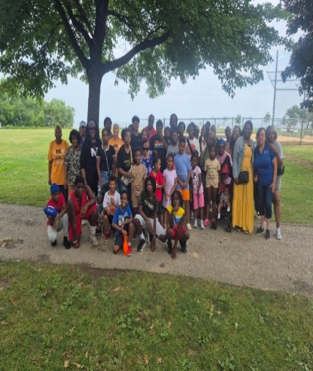
Youth on a Field Trip

Blossom Williams

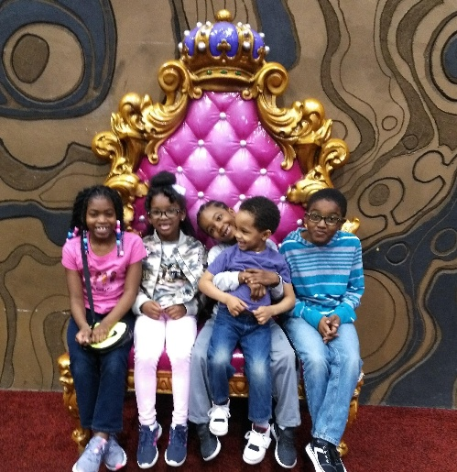

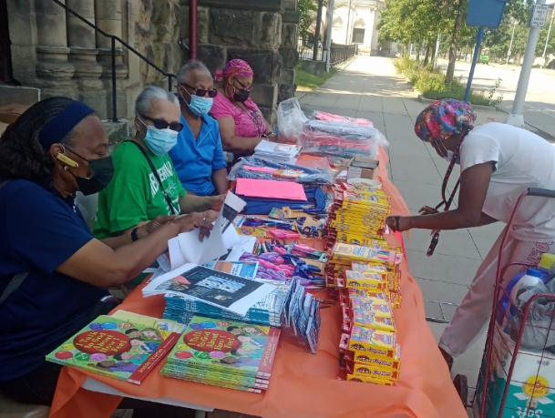
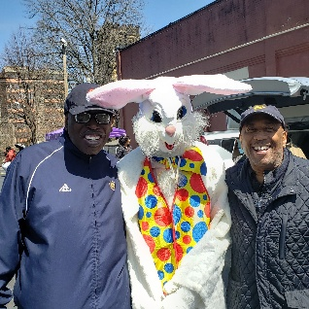

Kerry Holland, Lenny Gray & Phoenix

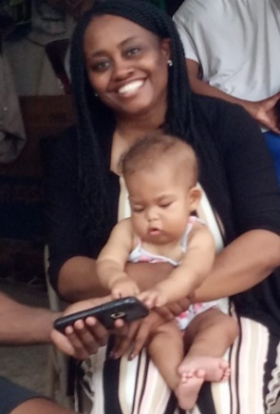
Hey NLAC,
This is my memory from 13 years.
There have been so many special memories at New Life At Calvary. Attending Bible Study with Ms. Sylvia, the beautiful liturgical dances, back to school supply give aways, and even the Margaret Hamilton program. However, I will never forget the COVID e-mail messages of encouragement and watching the church literally rise out of the ashes of the tornado. Happy Anniversary New Life At Calvary! May God continue to bless NLAC!
School Supplies Give Away
Pearlie, Helena, Ed

Kacie Armstrong

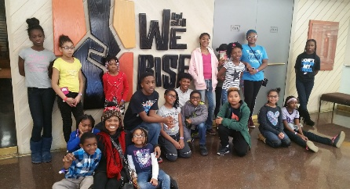
Youth on a field trip

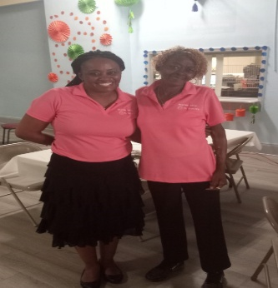

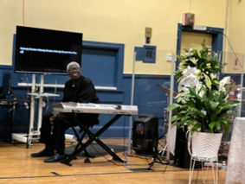
Kerry Holland

Pastor Kellie & LaDonna

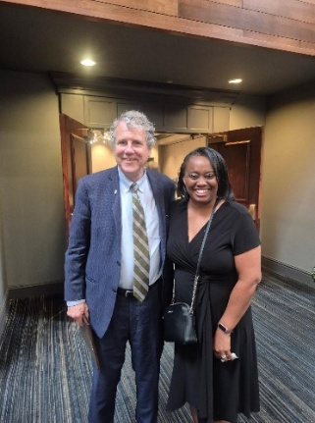
Pastor Kellie

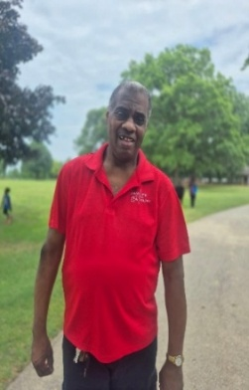
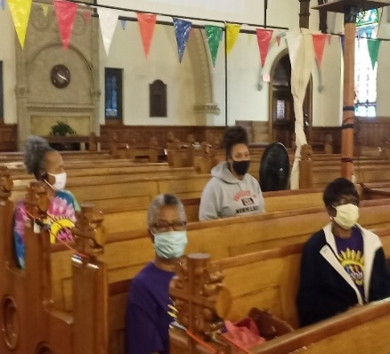
Michael Milan
Service During COVTD

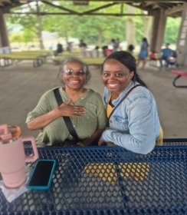
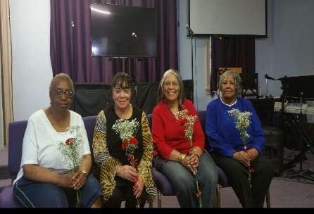
Karen Hogland, Jessica Franklin, Helena Harrison, Emma Jackson
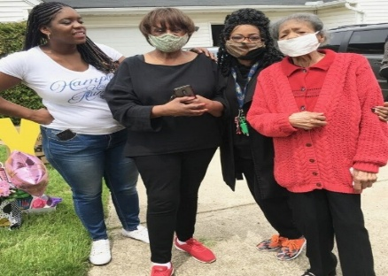
Pastor Antonia, Sylvia, Pastor Toby & Evelyn Davis
Debra Gullantt (mom)
Pastor Kellie

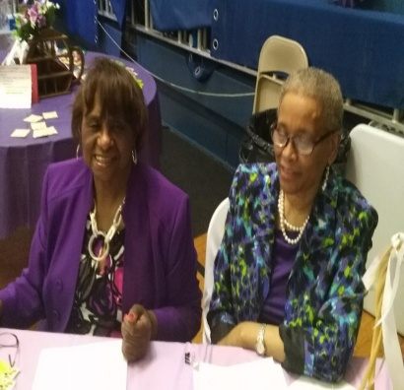
Favorite Memory
It is difficult to choose just one favorite memory from the past 13 years, because I have so many. Most of them center on the people I have met along the way. For example, the pastor’s faith building sermons, the prayer services led by prayer Warriors, and the whole congregation’s Joshua prayer walk around the Church seven times.
One of my most cherished top favorite memories, however, is my Life Connect Class and the faithful people who have faithfully participated throughout the past 13 years. I have shared this weekly Wednesday night class with the following people: Joy Williams, Lori Williams, Tina Williams, Yvonne Sims, Ruby Turner, Helen Britt, Barbara Shepherd, Ella Thomas, Nelson Campbell, Ruth Yarbrough, Terrence and Pastor Kellie, Esther and Rev. Banaci, Stephanie and Melvin Simons, Viviane Boyd (Alabama), Annie Sifford (Shaker Hts) and David Wildermuth (Westlake). During this time, we have also had the opportunity to study with our college students, Unique Avery, Whitney Bryant, and Cameron Fields. Over the years, we studied, shared, developed deeper friendships and grew together in the Word of God.
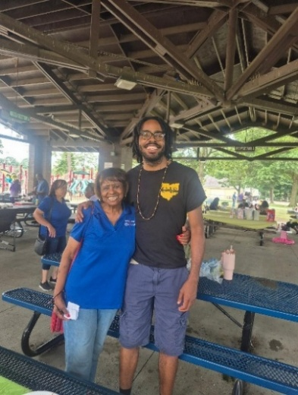
Sylvia Y. Fields

Sylvia & Camaron
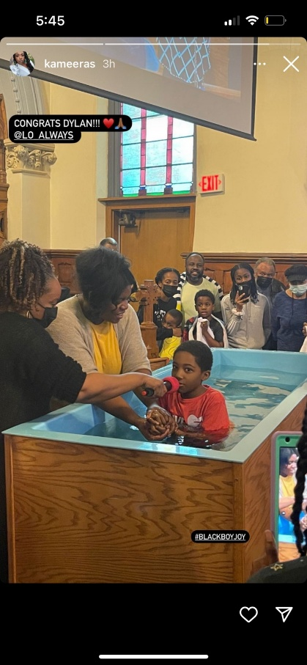
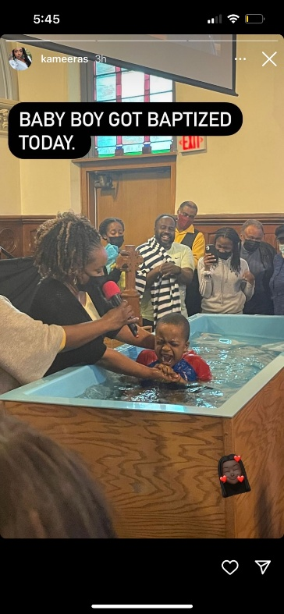
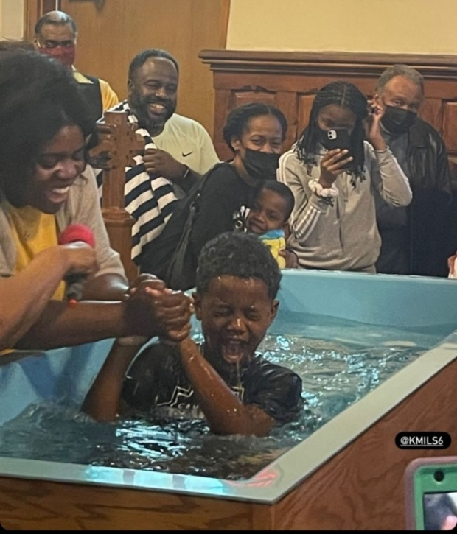
Wakil Gulley Galel Gulley Dylan Williams

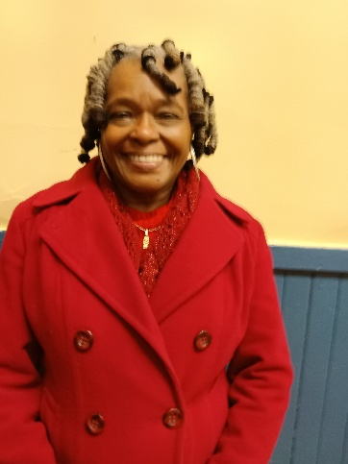
My most favorite memory has now become when we had our church service in the parking lot outside of the building after the tornado. To me it showed the community and ourselves the power of the Holy Spirit and our resilience to serve and worship God in the good times and the bad. All praise to our God. The kingdom continues. Hazel Hicks

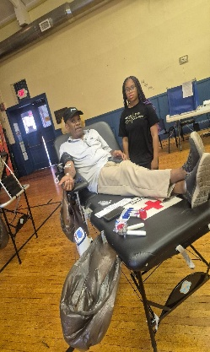
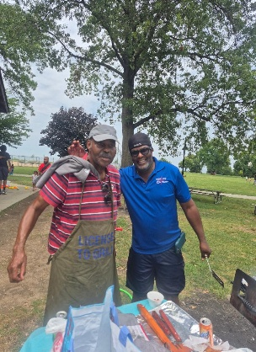
Clemon Walker & David Blackshire Melvin Simmons & Averee Jessie & Terrence

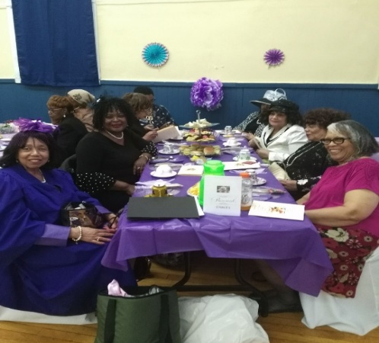

Marian Wallace Helena Harrison

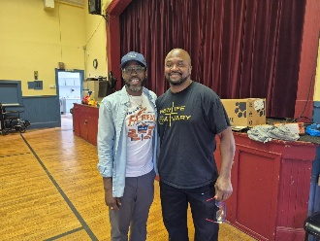

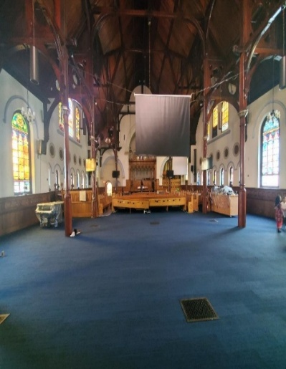
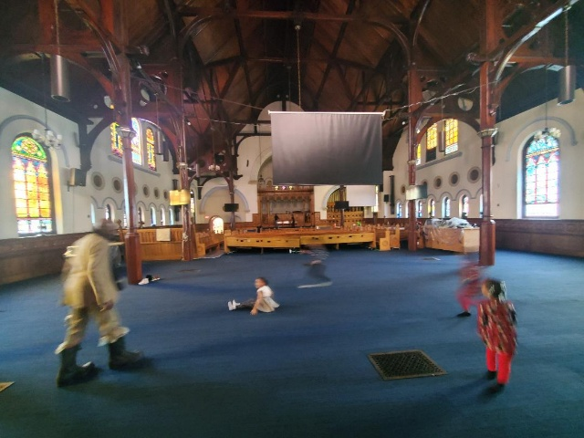
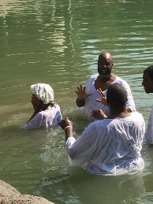
Special Memories At NLAC
Andrea Billups
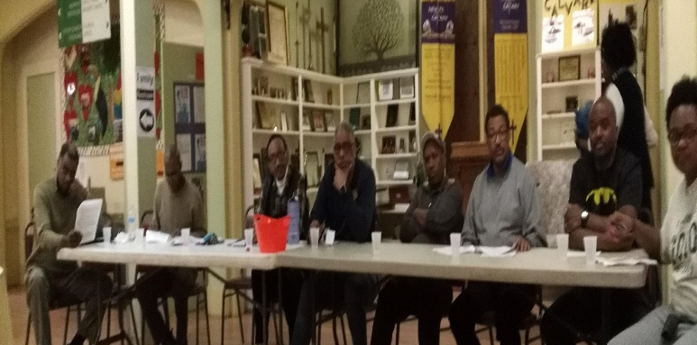
My best memory being at NLAC is meeting new people that are now friends and like family. I also treasure my trip to Egypt and Israel with our church family and friends. It was a very emotional and memorable trip walking the grounds that Jesus Christ walked!

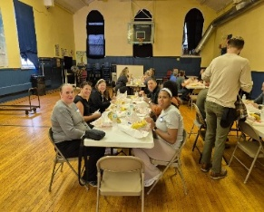

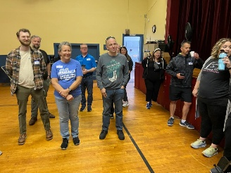

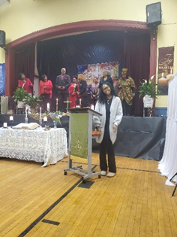
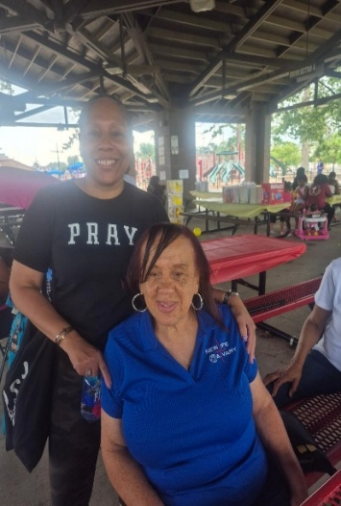
"For the Lord is good and his love endures forever;
his faithfulness continues through all generations." Psalm 100:5

Helen Britt

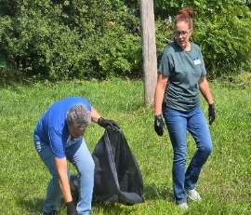

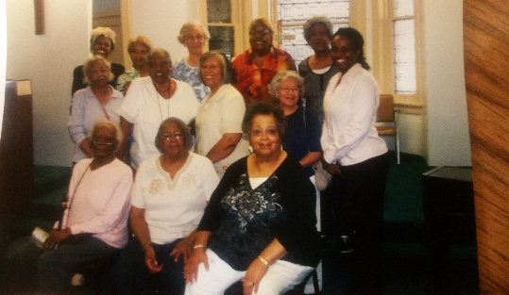
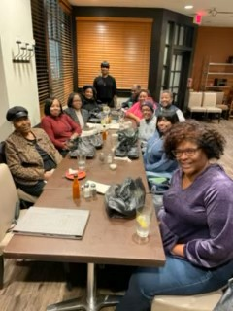
Raffia Billups
My best memory at NLAC is attending Life Connect Class. We started by having classes in person and we all became like family. During Covid, God provided the technology for us to continue meeting online. We now have class online and we are still like family. We also enjoy meeting outside of class for dinners and get togethers.

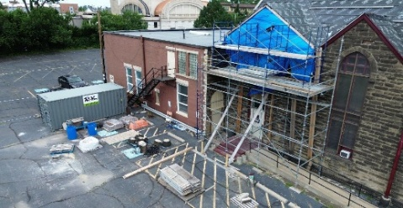

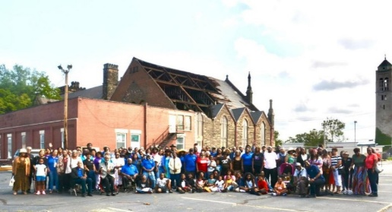

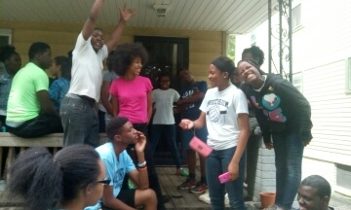
Youth

NLAC 13TH ANNIVERSARY
09-8-2013-09-8-2026

I thank God for the blessings of being a part of New Life At Calvary, the result of the
Merger between Glenville New Life and Calvary Churches. At NLAC, we are blessed with a
loving and faithful community of Believers. The prayers, encouragement, and acts of
kindness that are shared within and outside of the Church are a constant reminder of God’s goodness.

In times of Joy or seasons of Challenge, we have stood TOGETHER as a Church Family,
praying for each other, lifting up each other, and depending on the Love and Promises
of the Lord to see us through. I am deeply grateful for my Covenant Partners
for sharing and caring for each other with loving and genuine hearts for the betterment
of the Kingdom of God.

I pray that the Lord continues to strengthen our fellowship, guide our steps, increase
our giving and refresh our spirits. I also ask that He never stops using us as a Beacon
of Hope and Light in this Community, and Beyond.

Faithfully submitted, Gail H. Banes
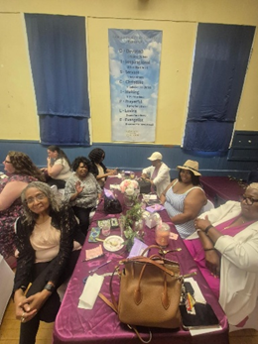

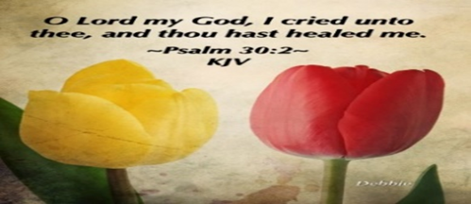

Please send a card, call, pray for, and support our Sick and Shut ins and recuperating brothers and sisters in Christ. Thank you.
Fred Blackshaw (Franklin Skilled Nursing, 3600 Franklin Blvd Rm 425, Cleveland, OH 44113)
Jennie Brown (1783 East 227th St, Euclid, OH 44117 216.785.9295)
Natalie Franklin (daughter of Julie Wright cards only) c/o Donnese Franklin, 4216 Colby Ave, Columbus, OH 43227)
Katy Glenn (6296 Richmond Rd, Oakwood Village, OH 44146)
Alfred Haywood (St. Augustine 7801 Detroit Ave, Rm 237, Cleveland, OH 44102)
Savannah (Robin) Hill (Grande Pointer Healthcare Center, 3 Merit Dr, #323, Richmond Heights, OH 44143, 216-609-6920)
Kent Kelton (Longmeadow Care Center, 565 Bryn Mawr St., Room 22, Ravenna, OH 44266, 216-672-2763))
Mildred Little (1344 East 90th St., Cleve., OH 44106)
Joseph McIntosh (VA Hospital, 10701 East Blvd, Cleveland, OH 44106)
June Phillips (Forest Hills Place 3151 Mayfield Rd., Cleveland Hts., OH 44118)
Fannie Ruffin (8164 Dartmoor Rd, Mentor, OH 44060)
Edna Swoope (27100 Cedar Rd, Beachwood, OH 44122)
Brenda White (West Park Commons 4106 Rocky River Dr, Apt 207, Clev., OH 44135 216-377-7352)
Janet Williams (10516 Elgin Ave., Clevland, OH 44108)

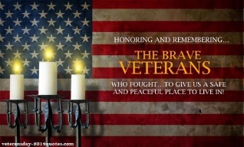
The White pillars candle in the chancel is
a reminder for us to pray for the safety of all
the men and women serving in the military.
It reminds us to pray for peace in our land
and all lands.

Life Connect Classes are resuming this Sept.
Youth Life Connect on Zoom Classes on Mondays: Teacher Pastor Antonia
Grades PK- 6th. Be on the lookout for bible study bags. Zoom ID: 832 7903 1773 Password: 092683
Grades PK-K (2-5 years old) 6 pm- 6:30 pm
Grades 1-3 (6-8 years old) 6:30 pm- 7:30 pm
Grades 4-6 (9-12 years old) 7:30 pm- 8:30 pm

Monday 6:30 pm (Adult Class)
Teachers: Andrea Billups
Hallelujah Anyhow – Charlie Dates
Zoom Meeting 891-1091-7393 PW: 2020 Zoom Call In 1-312-626-6799 891-1091-7373 ##2020#

Reading Through The Bible - 7:30 pm: We will be using the NIV Version – Teacher: Pastor Kellie
Meetings 1st, 3rd, 4th, & 5th Tuesday of the month Meeting ID: 820-9791-8709 PW: 605886
Phone# 1-312-626-6799 ID: 820-9791-8709 ##605886#

Karen ‘s Prayer Shawl Ministry: Susan Gillespie meets once a month on Tuesdays 6pm-7:30pm

Women with a Heart Bent Toward God. Meets once a month on Tuesdays at -7:30 pm: Teacher: Helen Britt
Zoom ID: 895-0072-4832 PW: 709557#
Zoom Call In: 1-301-715-8592 Code: 709557#

Wednesday 6:00 pm (Adult Class) In Person
Teacher: In Fellowship Hall.

Wednesdays 7:00 pm (Adult Class)
Teacher: Pastor Toby Emeritus
Zoom Meeting 334-158-729/2020 Zoom Call In 1-312-626-6799 334-158-729## 2020#

Wednesday 7:30pm (Adult Class)
Teacher: Pastor Antonia
Zoom Meeting 872 5812 7559/2020 Call In 1-305-224-1968,,87258127559#,,,,*2020#

Wednesday 7:30 pm (Adult Class)
Teacher: Sylvia Fields Class Resumes Sept. 16th
The Soul of a Nation
Zoom Meeting 865-9998-5439/54321 Zoom Call In 1-301-715-8592 TD: 865-9998-5439## PW: 54321

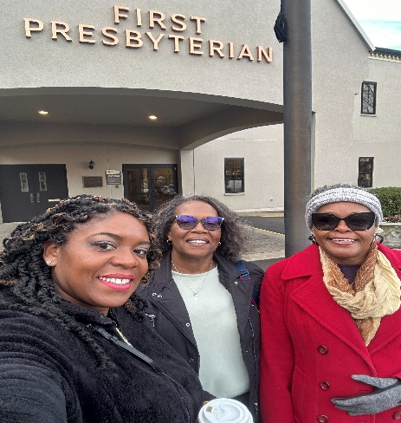
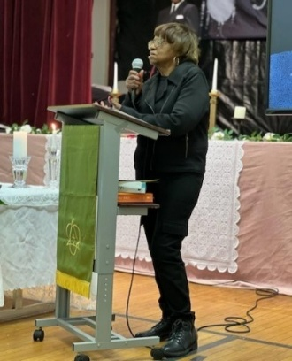
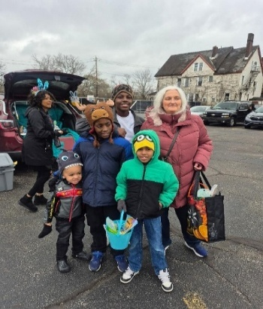
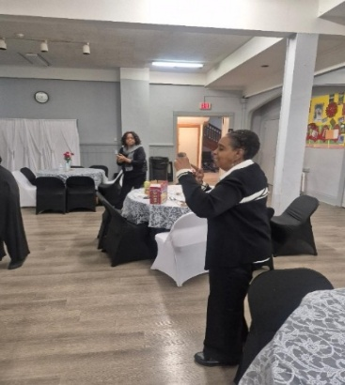
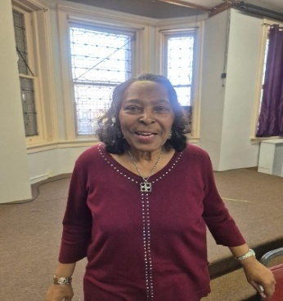
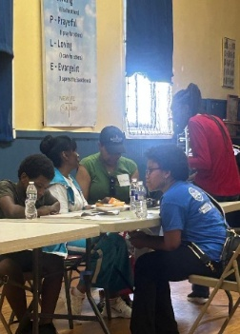
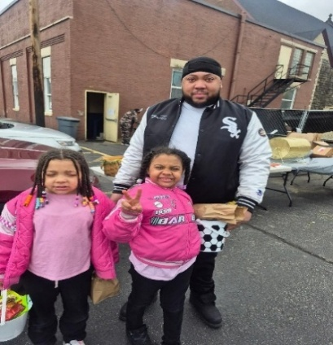
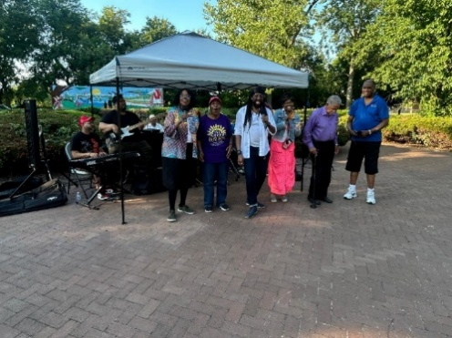
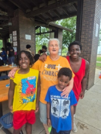
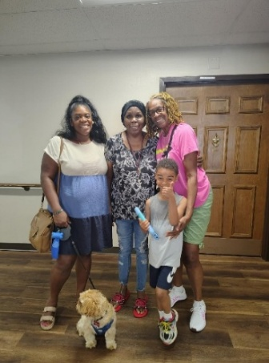
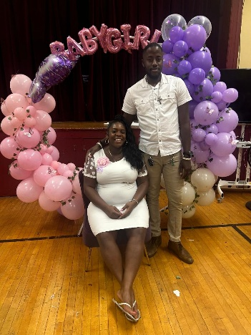
Damone & Terrence Fellowship Hall Cindy & Familt Sylvia Fields
Youth Gabriella & Izabella Deane Pearlie Huff
PA, Susan C., James T. PA & Sabastian Cindy, Andre, Steven, Royal PA, Ruth & Hazel
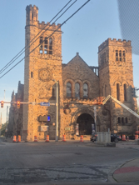
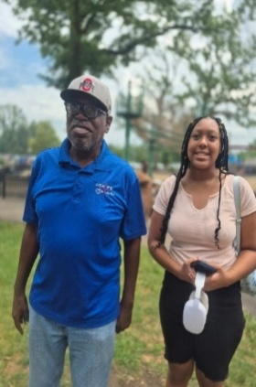
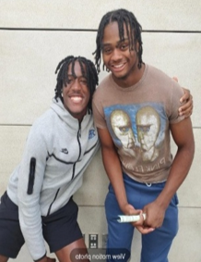
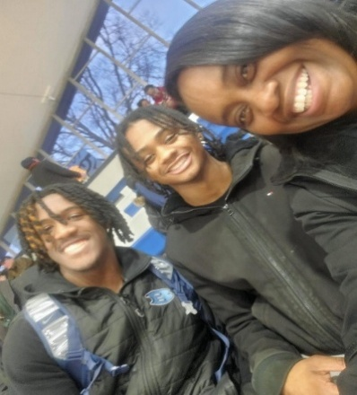

Damone, Terrence & PK Kerry & Za’Niya
"For I know the plans I have for you, declares the Lord, plans to prosper you and not to harm you, plans to give you hope and a future." Jeremiah 29:11

New Life At Calvary 2026
13th Anniversary

Founding Pastors of NLAC

September 8, 2013
(13 Years)
Rev. Dr. Rick Gillespie-Mobley (Pastor Emeritus)
Rev. Dr. Toby Gillespie-Mobley (Pastor Emeritus)
Rev. Kellie C. Sullivan

Pastors 2019 (7 Years)
October 2019
Rev. Antonia S. Burton

Charter Members Of
New Life At Calvary 2013
September 8, 2013
(13 Years)

Arnwine, Elbert
Banes, Gail H.
Beach, Laureen
Billups, Andrea
Billups, Raffia
Black, Jaylen
Blackshire, David
Bradfordt, Elaine
Britt, Helen
Brown, Billie
Brown, Jennie
Bryant, Bessie
Bryant, Whitney
Chapman, Marcello
Chapman, Mekel
Clark, Twana
Cleveland, Lily
Coats, Gwendolyn
Coats, John
Cosper, Gregory
Darmond Sr., Demetrius
Deane, LaTanya
Fields, Sylvia Y. (Clerk of Session)
Flowers, Valerie
Fountain, Larry
Franklin, Jessica
Gillespie, Susan
Grim, Vickie
Gulley, Kimili
Gulley, Terrence
Harrison, Edward
Harrison, Helena
Hayes, Geraldine
Hayes, Marvin
Haywood, Alfred
Hendrix, Glenn
Hendrix, Shannon*+
Hicks, Hazel
Huff, Linda
Huff, Pearlie
Jackson, Emma
James, Mary
Jeffrey, Linford
Jeffrey, Margaret
Kee, Henrietta
Kee, Joy
Kee, Stephanie
Kelton, Kent
Leach, Eula
Little, Mildred
Love-McClain, Betty
Lowry, Barbara
Martin, Joann
McIntosh, Joseph
Milan, Michael
Mull, Elizabeth
Norris, Sandra
Oliver, Tomeika
Owens, Ellen
Owens-Hall, Dianne
Parker, Brian
Perkins, Olivera
Phillips, June
Phillips-Bey, Wm. Hasson
Pride, Andrea
Pride, Renee
Rogers, Cassandra
Rogers, Marvin
Rush, Jacquelyn
Rush, Larry
Russell, Grover
Russell, Sylveta
Sharp, Anna
Shepherd, Barbara
Simmons, Sierra
Simmons, Stephanie
Sims, Rufus*
Sims, Yvonne*
Sloan, Vanessa
Smith, Bessie
Smith, Janae
Smith, Jennifer
Smith, Michael
Smith, Vivian
Stewart, Joseph
Stubbs, Theotis
Sullivan, Terrence A.
Sullivan, II Terrence
Sullivan, Trinity
Swoope, Edna
Taylor, Antonio L.
Thomas, Averee
Thomas, Juanita
Thomas, Sharon
Thompson, Annette
Townsend, Monesha
Turner, Ruby
Wallace, Marian
Wallace, Samuel
Weatherspoon, Tonya
White-Grim, Samaria
Williams, Jacia
Williams, Janet
Williams, Jeremy
Williams, Joy
Williams, Kamaria
Williams, Kamilah
Williams, Karimah
Williams, Kathlyn
Williams, Lori
Williams, Sarah L.
Williams, Tina
Willis-Norris, Unique
Wright, Julia
Wright, Rosie
Yarbrough, Ruth

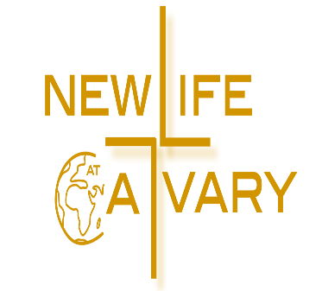

"Rejoice always, pray continually, give thanks in all circumstances; for this is God’s will for you in Christ Jesus."
1 Thessalonians 5:16-18

Baptized Children/
Charter Members
of New Life At Calvary
September 8, 2013

2013 (13 Years)
Darmond, Damone
Elam, Tamaria
Gulley, Kadira
Gulley, Wakil^
Williams-Hunt, Javae
Ward, Jaylen
Williams, Dylan A.^
Williams Jr., Jeremy
Williams-McDaniels, Kalilah

Covenant Partners of
New Life At Calvary

2015 (11 Years)
Abrams, Katherine
Baylor, Constance
Craig-Fry, Cindy
Hardin, Tiki
Simmons, Melvin
Williams, Blossom

2016 (10 Years)
Dickerson, Adia
Jackson, Keith E.
Jackson, Tonaya
Watts, David

2017 (9 Years)
Banaci, Rev. Joseph S.
Darmond-Newsome, Dacia

2018 (8 Years)
Burton, Jacqueline
Campbell, Nelson Sr.
Jackson, Ocie “Peaches”
Walker, Clemon

2019 (7 Years)
Frazier, Robin
Robb, Katharina
Robb, Michael

2020 (6 Years)
Townsend, Patricia

2021 (5 Years)
Grice-Williams, Sharon

2022 (4 Year)
Shepherd, Barbara

2023 (3 Year)
Jenne, Brian
Jenne, Vanessa
Robinson-Smith, Evelyn
Shaw, Nicola

2024 (2 Year)
De’Armond, Arleen

2025 (1 Year)
Livermore, Jacqueline
Rhodes, Tanahya
Banaci, Esther Dukuly
Williams, Vince Edwards
Gray, Lenny
Jackson, Kyra

2026 Newest Members
Jackson, Alexis
Jackson, Breana
Rountree, Vincia

Baptized Children of NLAC
Smith, Zyaire (2014)
James, Christian (2014)
McClain-Wright, Javion ~ 2015
Gulley, Galel^ ~ 2015
Breeding, Phoenix ~ 2018
Robinson, Anaiyah ~ 2018
Kee, Jaidah ~ 2018
Abner, Kailyn ~ 2019
Breeding, Alyse ~2019
Pearl, Emery Giselle ~ 2019
Dowdell, Elijah ~ 2021
Dowdell, Nyah ~ 2021
Wilson, Jamal ~ 2021
Williams, Dylan ~ 2022
Williams, Jaxon J. ~ 2022
Williams, J′mire Greatness ~2022
Wilson, Darriel M. ~ 2022
Owens, Maverick A.A.G ~ 2022
Brooks Jr., Andre ~ 2022
Taylor, Dallas ~ 2022
Taylor III., James ~ 2022
Rush, Jr. Steven ~ 2023
Garrett, Malik ~ 2023
Robinson, Brooklyn ~2023
Robinson, London ~ 2023
Robinson, Noelle~2023
Martin, Brianna ~ 2023
Rhodes, Tatum~ 2025
(We anticipate more baptisms to be added in 2025)
*
+ Baptized Adult Member
^ Reaffirmation of Faith



We Remember…
Harvey, Katie (2013)
Atkinson, Craig (2014)
Conner, Juanita (2014)
McLean, James (2014)
Bizzell, Beatrice (2015)
Carter-Reese, Eleanor (2015)
Moffett, Aileen (2015)
Voik, Sharon (2015)
Davis, Orba (2016)
Hayes, John (2016)
Jolly, Deborah (2016)
Moore, Joyce (2016)
Oglesby, Doris (2016)
Thomas, Douglas (2016)
Wagner, Lottie (2016)
Baylor, Terrence (2017)
Britt, Mamie (2017)
Doman, Linnett (2017)
Jones, Joyce (2017)
Love, Larry (2017)
Mosley, Mary (2017)
Parker, Dorothy (2017)
Battiste, Frances (2018)
Bryant, Robert (2018)
Deadwyler, Juliette (2018)
Deadwyler, Ralph (2018)
Nevins, Denise (2018)
Thompson, Andy (2018)
Labrozzi, Pauline (2019)
McIntosh, Carolyn (2019)
Reese, Evelyn (2019)
White, Daniel (2019)
Beasley, Betty J. (2020)
Glover, Rebecca (2020)
Greene, Mayme (2020)
Reed, Delilah (2020)
Haynesworth, Wanda (2020)
Ray, Willie Mae (2020)
Davis, Evelyn (2021)
Hayes, Jonnie (2021)
Wilson, Anthony (2021)
Jester, Gloria (2021)
Nevins, Laverne (2021)

Hall, Karen (2022)
Legrand, Edith (2022)
Atkins, Betty (2022)
Sy, Frances (2022)
Huffman, Cordelia (2023)
Lyle, Brenda (2023)
Baskerville, Titus A (2023)
Cheeks, Darnay (2023)
Briskey, Freddie (2023)
Martin, Madelin (2024)
Naylor, Georgia (2024)
Beach, George (2024)
Williams, Delois (2024)
Robinson, Martha (2024)
Payne, Eloise (2024)
Burton, Lynden Ramone (2024)
Mallory, Margaret (2025)
Brown, Stanette (2025)
Jackson, Glynn (2025)
Woods, Reginald (2025)
Jessup, LaDonna (2025)
Bryant, Bessie (2025)
Doaty, Minnie (2025)
Milan, Estelle (2026)
Thomas, Ella (2026)

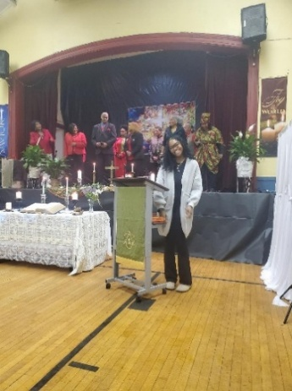
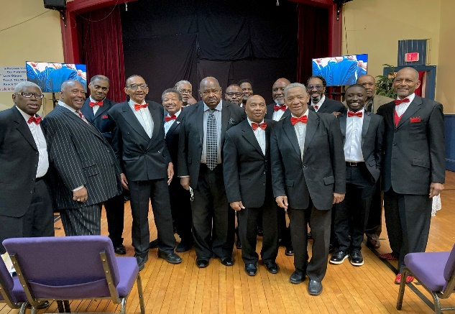
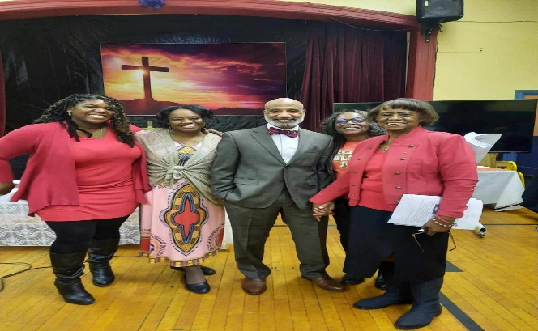
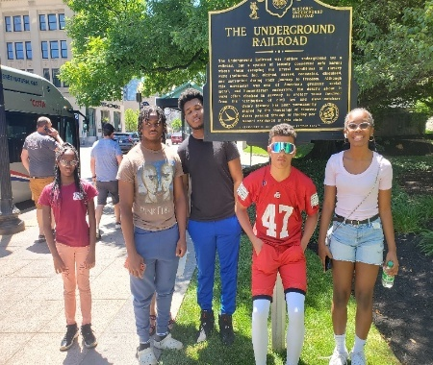
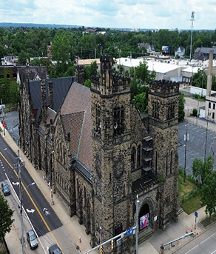
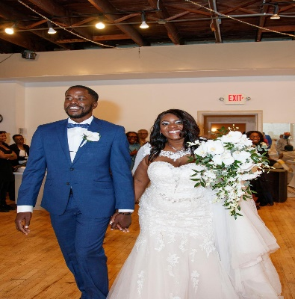
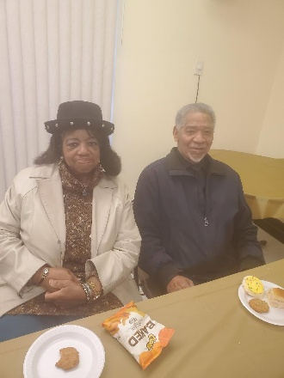
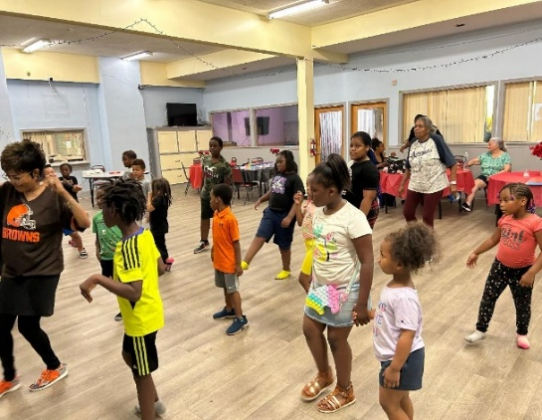
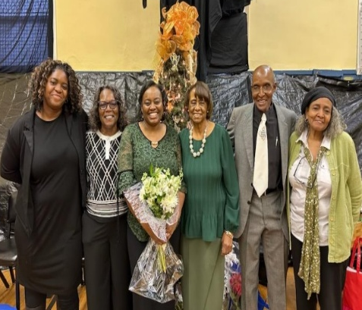
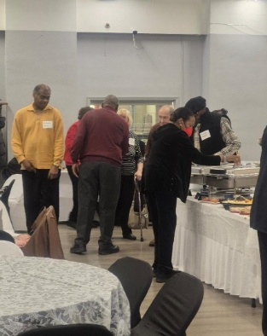
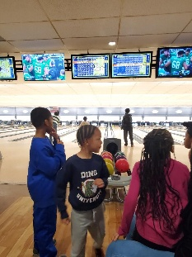
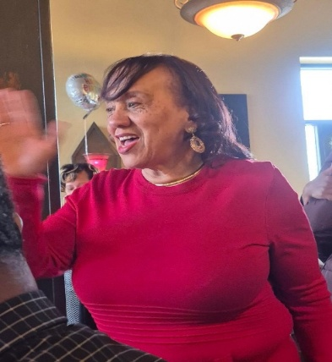
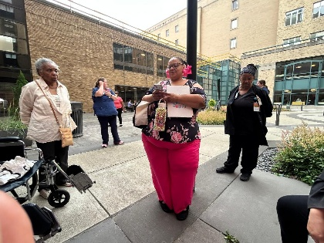
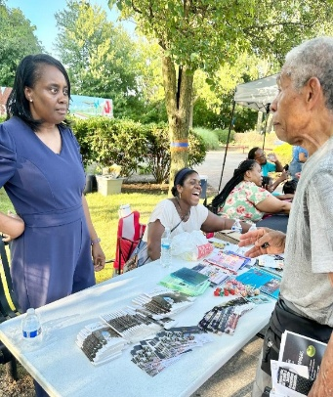
Built To Last: Living To Serve
Built To Last: One People
Built To Last: Called and Sent
Built To Last: Heaven’s Design

Though God’s people come from many tribes and places, we are united under one God and one promise.

