
New Life At Calvary
Communion June 7, 2026

10:00am
Celebration Service
New Life At Calvary
2020 East 79th Street at Euclid
Cleveland, OH 4103
216-391-8448
Email: officenlac@yahoo.com
Website: NLAC.tv
Wi-fi-Life-Guest Password is Joinus2020

Pastors: Pastoral Ministry Staff:
Rev. Kellie C. Sullivan Elder Sylvia Y. Fields
Rev. Antonia Martin Burton
Rev. Dr. Toby Gillespie-Mobley (Pastor Emeritus) Music Ministry:
Rev. Dr. Rick Gillespie-Mobley (Pastor Emeritus) Mr. Kerry Holland
Ms. Susan Gillespie
Mr. Greg Cosper
Speakers
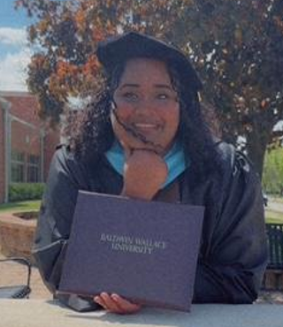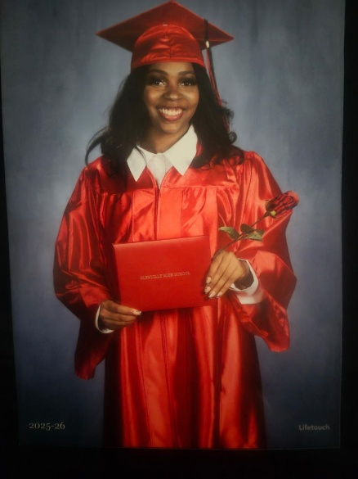
Monesha Townsend Amari Rouse Jayden Hendrix
Baldwin Wallace Glenville High School Charles F. Brush High School

New Life At Calvary
Graduation Promotion Sunday
June 7, 2026

Prelude: Kerry Holland

Welcome: James Taylor, III

Prayer: ZaNiya Conner

Selection: “You Make Me Stronger"
Youth Church Choir

Scripture: OT: Isaiah 6:8-10
Ja′Vae Williams-Hunt
NT: Matthew 16:13-20
Dakari Avery

90 Day Tithing Challenge: Dallas Taylor

Offering: Wakil Gulley

Special Music: “War Cry” by Queen Naija
ZaNiya Conner

Speakers: “Who Am I”
Jayden Hendrix
Amari Rouse
Monesha Townsend

Selection: “This I Believe”

*Affirmation of Faith

The Sacrament of Holy Communion

Awards: Pastor Kellie & Pastor Antonia

Good News: Kadira Gulley

Benediction: Kadira Gulley

Ushers: Galel Gulley, Jeremy Williams, Jr., Kalilah Williams-McDaniel, Ja’Vae Williams-Hunt, Dylan Williams

You make me Stronger by Kevin Downswell
You are my creator, Lord You know my times
Seasons of breakthrough, my seasons of trials
So, I will seek you, and you I will find
You're my strong tower, in you I will hide

Chorus
Lord, you make me stronger
Oh oh oh, oh oh oh
You make me stronger, oh oh oh, oh oh oh (repeat)

I lift my spirit; Lord I take your hand
You fixed my focus, now I know who I am
I used to run from my battles, but you made me
strong, God strong and mighty, I AM That I AM

You make me stronger
Oh oh oh, oh oh oh
You make me stronger, oh oh oh, oh oh oh (repeat)

This I Believe
I believe in God our Father
I believe in Christ the Son
I believe in the Holy Spirit
Our God is three in one
I believe in the resurrection
That we will rise again
For I believe in the Name of Jesus

*Affirmation of Faith

*THE APOSTLES’ CREED (Ecumenical)
I believe in God, the Father almighty, creator of heaven and earth. I believe in Jesus Christ, His only Son, our Lord, who was conceived by the Holy Spirit, born of the Virgin Mary, suffered under Pontius Pilate, was crucified, died, and was buried; he descended to the dead. On the third day he rose again; He ascended into heaven, and he is seated at the right hand of the Father, Almighty, from thence He will come to judge the living and the dead.

I believe in the Holy Spirit, the holy Christian Church, the communion of saints, the forgiveness of sins, the resurrection of the body, and the life everlasting. Amen

Communion Service

(Examination of our Hearts)

L. Here’s what Jesus Christ promises: Happy are those who hunger and thirst for what is right. They shall be satisfied.

P. Jesus said, “I am the bread of life. The one who comes to Me will never be hungry. The one who believes in Me will never thirst.
L. This is also the word of the Lord: “All those whom I love, I correct and discipline. Therefore, shake off your complacency and repent. See I stand knocking at the door
If anyone listens to My voice and opens the door, I will go in and dine.”

P. Let us open our hearts to the Lord. Let us open every door of our lives to God.

L. Lift up your hearts.
P. We lift them to the Lord.
L. Holy God: We praise You for Your Son Jesus, who shared our weakness, and was tempted in every way as we are; Who obeyed You by suffering and dying for us. You have raised Him to rule The world and have given Jesus a name above every name, Lord And Christ. We praise Him, and we glorify You. Great God our Creator.

P. Now give us Your Spirit in the breaking of bread and sharing of the cup, So that by Your power, we may be drawn together and made one with Jesus, Who is the Way, the Truth, and the Life.

Unison: Our Father, who art in heaven, hallowed be Thy Name. Thy kingdom come. Thy will be done on earth as it is in heaven. Give us this day, our daily bread. And forgive us our debts, as we forgive our debtors; and lead us not into temptation. But deliver us from evil. For thine is the kingdom and the power and the glory forever. Amen.

The Words of Institution ~ The Distribution
Prayer of Thanksgiving: (Unison)
Bountiful God, we give you thanks that you have refreshed us at your table by granting us the presence of Christ. Strengthen our faith, increase our love for one another, and send us forth into the world in courage and peace, rejoicing in the power of the Holy Spirit. Amen

Thank You Lord
Thank You, Lord, thank You, Lord,
Thank You Lord,
I just want to thank You, Lord.

Been so good, been so good,
Been so good,
I just want to thank You, Lord

Announcements
Attention: Please refrain from walking during these times: Prayer, Soloist, Scripture and Sermon. Thank you.

Session Meeting, Thursday June 11, 2026 at 6:00pm on Zoom.

The Ushers will meet next Sunday after worship in the Chapel.

The Deacons will meet Thursday, June 18, 2026 at 6pm on Zoom.

Lost/Found: Are you missing 6 pairs of kid’s pants. If so, please see Pastor Kellie.

Parking Lot Security: Due to the rash of car break-ins now targeting churchgoers, as part of a broader crime wave. We are asking for help in monitoring the church parking lot. Currently, Joseph Stewart monitors the parking lot until around 10:40am. We need someone to monitor from 10:40am until service is over.

Attention: Due to the rash of car break-ins, please do not leave anything valuable visible for others to see.

Birthdays The Week of June 7, 2026
Devona Ashbrook 7th
Melvin Simmons 8th
Terrence Sullivan, Sr. 8th
Jacqueline Livermore 10th
Alyse Breeding 12th
Demetrius Darmond, Sr. 12th
Eula Leach 13th

Anniversaries The Week of June 7, 2026
Terrence & Kellie Sullivan 8th

Scripture Readers June
Ja′Vae Williams-Hunt & Dakari Avery 7th
Sharon Thomas 14th
Gail H. Banes 21st
Jessica Franklin 28th

Special Offering
1st Sunday – Deacon’s Offerings
2nd Sunday – Prison Ministry
3rd Sunday – Rotolu Orphanage Nigeria
4th Sunday – Ten Cents A Meal
5th Sunday – Above & Beyond

Women’s Choir Father’s Day Rehearsal Schedule
Dates for the Father’s Day Choir
Wednesday June 10, 2026 6 pm
Saturday June 13, 2026 12:00 noon
Saturday June 20, 2026 10:30 am
Call Gwen Coats (216) 598-4936

GIVING OPTIONS
www.NLAC.tv Website Giving:



If you have Cash App you can send your offer to $2NLAC





Go into your mobile banking app Click on pay with Zelle. Once inside your Zelle app it will give you the option to scan the QR code below or type in the church email address: officenlac@gmail.com

You can mail in your offerings through the mail at
New Life At Calvary
2020 East 79th Street
Cleveland, OH 44103

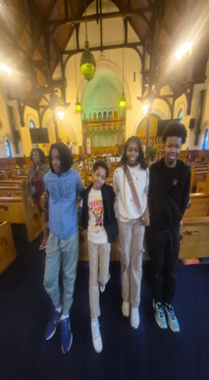

“For With God Nothing Shall Be Impossible” Luke 1:37 (KJV)
New Life At Calvary
90-Day Tithing Challenge
Stewardship Lesson: Giving With the Right Heart
Key Scriptures: 2 Corinthians 9:7 (NIV): “God loves a cheerful giver.”
Matthew 6:1 (NIV)
“Be careful not to practice your righteousness in front of others to be seen by them.”
God cares not only about what we give, but also about the spirit in which we give.
The Bible teaches that giving should not come from:
- Pressure, guilt, showing off, competition
Instead, giving should come from love, gratitude, faith, and worship.
Jesus warned against giving simply to impress other people. Real generosity is not about receiving praise from others. It is about honoring God.
At the same time, God does not want us to give with resentment or frustration.
Giving becomes meaningful when it flows from a willing and grateful heart.
That is why stewardship is not just a financial issue. It is a heart issue.
As followers of Christ, we are growing not only in generosity, but also in humility, compassion, and faithfulness.
At New Life At Calvary, we believe every gift matters because every act of faithful giving is an act of worship.
God is not measuring us against one another.
God is shaping our hearts.
Faithful Together Reflection
What attitude do I want to bring when I give to God?
Weekly Challenge
Before giving this week, pause and say:
“Lord, I give this to You with gratitude and love.”
Remember
God is not looking for perfect amounts. God is looking for faithful hearts.

Please send a card, call, pray for, and support our sick and Shut ins and recuperating brothers and sisters in Christ. Thank you.

Jennie Brown (1783 East 227th St, Euclid, OH 44117 216.785.9295)
Minnie Doaty (12005 Ablewhite Ave, Cleve., OH 44108)
Natalie Franklin (daughter of Julie Wright cards only) (c/o Donnese Franklin, 4216 Colby Ave, Columbus, OH 43227)
Marvin & Geraldine Hayes (1817 Marloes Rd, East Cleveland, OH 44112 216.541.6314)
Alfred Haywood (St. Augustine 7801 Detroit Ave, Rm 237, Cleveland, OH 44102)
Savannah (Robin) Hill (Grande Pointe Healthcare Center, 3 Merit Dr, #323, Richmond Heights, OH 44143, 216-609-6920)
Kent Kelton (Longmeadow Care Center, 565 Bryn Mawr St, Room 22, Ravenna, OH 44266, 216-672-2763)
Mildred Little (1344 East 90th St., Cleve., OH 44106)
Joseph McIntosh (864 E. 73rd St., Cleveland, OH 44103)
Fannie Ruffin (8164 Dartmoor Rd, Mentor, OH 44060)
Edna Swoope (27100 Cedar Rd, Beachwood, OH 44122)
Ella Thomas (115 Farwood Drive, Moreland Hills, OH 44022, 440-247-5360)
Brenda White (West Park Commons 4106 Rocky River Dr, Apt 207, Cleve., OH 44135 216-377-7352)
Janet Williams (10516 Elgin Ave., Cleveland, OH 44108)
June Phillips (Forest Hills Place 3151 Mayfield Rd. Cleveland Hts., OH 44118)

Youth Life Connect on Zoom Classes on Mondays
6:00pm-9:30pm, Teacher Pastor Antonia
(On Summer Break)

Monday 6:30 pm (Adult Class)
Teachers: Andrea Billups
Revelations by Tony Evans
Zoom Meeting 891-1091-7393 PW: 2020 Zoom Call In 1-312-626-6799 891-1091-7373 ##2020#

Reading Through The Bible - 7:30 pm: We will be using the NIV Version – Teacher: Pastor Kellie
Meetings 1st, 3rd, 4th, & 5th Tuesday of the month Meeting ID: 820-9791-8709 PW: 605886
Phone# 1-312-626-6799 ID: 820-9791-8709 ##605886#

Karen ‘s Prayer Shawl Ministry: Susan Gillespie meets once a month on Tuesdays 6pm-7:30pm (6/9/26).

Women with a Heart Bent Toward God. Meets once a month on Tuesdays at -7:30 pm: Teacher: Helen Britt (6/9/26)
Zoom ID: 895-0072-4832 PW: 709557#
Zoom Call In: 1-301-715-8592 Code: 709557#

Wednesday 6:00 pm (Adult Class) In Person
Teacher: Clemon Walker, In Fellowship Hall.

Wednesdays 7:00 pm (Adult Class)
Teacher: Pastor Toby Emeritus (The Chosen)
Zoom Meeting 334-158-729/2020 Zoom Call In 1-312-626-6799 334-158-729## 2020#

Wednesday 7:30pm (Adult Class) (On Break for 2 Weeks)
Teacher: Pastor Antonia – Fruit of the Spirit
Zoom Meeting 872 5812 7559/2020 Call In 1-305-224-1968,,87258127559#,,,,*2020#

Wednesday 7:30 pm (Adult Class)
Teacher: Sylvia Fields – Social Teachings Looking Back Of The Church Looking Forward.
Zoom Meeting 865-9998-5439/54321 Zoom Call In 1-301-715-8592 TD: 865-9998-5439## PW: 54321


Graduation Promotion Sunday 2026

Graduate School
Monesha Townsend – Baldwin Wallace University – Masters of Arts in Education with a focus on Leadership in Higher Education. My next plans are to become a Higher Administrator within Cuyahoga Community College or another institution and later pursue a PhD.

College Graduation

Marcello A. Chapman – University of Northern Texas – Manga Cum Laude, B.S. with a Major in Psychology and Minors in Counseling and HDFS (Human Development and Family Science). On the Dean’s List/President List the entire class year of 2025-2026. On the Dean’s List/Presidents list 6 out of 8 semesters at UNT. Career Plans: To go into Human Resources or Registered Behavior Technician Role. In the future pursue my Masters in Counseling and eventually go back for my PhD.


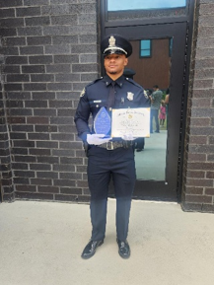
ShaMarr Simmons – Atlanta, Georgia, Police Academy – May 8, 2026. Highest Physical (Male) Training Average. Graduated at the top of his class, which allowed him to choose his designated area of the city to work in.

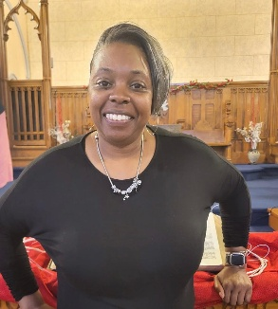
Melody “Joy” Williams – Northern Career Institution – Licensed Practical Nurse – Graduation 2026. Next Step: after graduation she will take the State License Test in 2026.

College Promotion

Pastor Keon Abner – enrolled in Grace Theological Seminary – working toward M.Div. – one class left will graduate in January, 2027. Career Plans: On June 7, 2026 Pastor Abner will be ordained in the Evangelical Presbyterian Church (EPC). He will be dually ordained in (ECO) Covenant Order of Evangelical Presbyterians & the EPC.

Jasmine Banes – Baldwin Wallace – Completed 2nd year of College
Accomplishments: 1) Directed 1st Children’s Play – Shreck, Jr. The Musical, with over 30 youth. 2) Third year as Assistant Stage Manager at Play House Square’s CMSD All City Musical. 3) Working as a teaching artist at Talespinner Children’s Theatre for the summer. 4) Assistant Director at Near West Theater for “RAGTIME.” July 17th – August 2nd.

Kayla Britt – Western University of California – Doctor of Optometry.

Chelesa Britt – Kent State University – Senior Majoring in Finance.
Class of 2026

Jayden Hendrix – Charles F. Brush High School – Completed the 12th Grade.
Sports/Activities: Community Service Award – completed more than 100 hours.
Career Plans: To attend trade school to become an electrician.

Camille Kelly – Summit Academy Parma – Completed the 12th Grade.
Sports/Activities: Student Government
Career Plans: Attend Vocational Technical School to become a Florist.

Amari Rouse: Glenville High School- Completed the 12th Grade.
Honors/Awards: Salutatorian, Dispatch Certification, 2 Science Awards, 1 Social Study Award, Congressional Recognition Award, Rotary Club Award. Sports/Activities: Track Team, Volleyball Team, Criminal Justice
Career Plans: Ohio University- Double Major: Bachelors of Science in Criminology and Psychology with a certificate in Forensic Science. Scholarship: $128,000.00 for all four years from Ohio University, The Glenville Alumni Scholarship $1,000.00, and the CMSD Scholarship $1,025.00, renewable all four years.

Anyiah Terrell – John Adams High School – Completed the 12th Grade.
Honors/Awards: Salutatorian. Career Plans: Scholarship to Kent State University, for fashion and business.
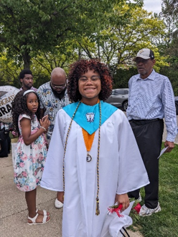
Averee Thomas – Beaumont School – Completed the 12th Grade.
Honors/Awards: *1st Honors all 4 years (7 Semesters) *, Math, Physics Awards,
Hyland Software Award, President’s Award for Outstanding Academic Excellence, Senior Scholar Athlete, National Honor Society, International Thespian Honor Society
Sports/Activities: Battle Robotics, Theater (sound), Academic Scholars, Soccer Team, Track Team Career Plans: Vanderbilt University – Bachelors of Engineering: Electrical/Computer Engineering

Katelyn Anderson – Panther Creek High School – Frisco, TX – Completed the 12th Grade.
Honors/Awards: Cum Laude, Superior Rating for Visual Art.
Sports/Activities: Art Club President, Audio/Video Team at Church.
Carrer Plans: GAP Year to work on Art Commission Projects.

Promotions
Kadira Gulley – John Hay School of Science and Medicine – Promoted to the 12th Grade. Honors/Awards: Honor/Merit Roll, Successful Passage of All OST’s
Sports/Activities: Cheer, Dance

Kyra Jackson – MC2 Steam – Promoted to the 12th Grade. I will be attending East Tech. High School my senior year. Honors/Awards: Science Certificate

Jamale Kee – Garfield High School – Promoted to the 11th Grade.
Sports/Activities: Football & Basketball

Kalilah Williams-McDaniel – John Hay Early College – Promoted to the 11th Grade.
Honors/Awards: 1) High Honor Roll all 4 Quarters, 2) All A’s 2nd Qtr., & 4th Qtr., 3) GPA 4.3, 4) Perfect Attendance 1st Qtr., & 4th Qtr. Sports/Activities: Tri-C Creative Arts Academy

ZaNiya Conner – Cleveland Heights High School – Promoted to the 10th Grade
Honors/Awards: Attendance, Honor Roll. Sports/Awards: TV Club, Leading Ladies

Ja′Vae Williams-Hunt – St. Martin De Porres – Promoted to the 10th Grade.
Honors/Awards: Merit Roll, Letter from President of St. Martin De Porres acknowledging my great start in the 9th grade of having a GPA of 3.5 or better.

Kiana Jackson – Solon Middle School – Promoted to the 9th Grade.
Honors/Awards: Merit Roll (Maintained a 3.2 or above GPA all school year), Voted Cheerleader with the highest, sharpest, and most powerful toe touch as well as best leadership qualities. Sports/Activities: Football Cheer, Basketball Cheer, and Track.

Zyaire Smith – Adlai Steveson – Promoted to the 9th Grade.
Sports/Activities: Football
Andre Brooks, Jr. – Charles Dickens – Promoted to the 8th Grade.
Sports/Activities: Track Team

Ke′Mari Gilbert – Richmond Heights Upper School – Promoted to the 8th Grade.
Sports/Activities: Basketball

Wakil Gulley – Campus International – Promoted to the 8th Grade.
Honors/Awards: Honor Roll. Sports/Activities: Basketball

Dylan Williams – Euclid Middle School – Promoted to the 8th Grade.
Honors/Awards: Jr. Honor Society, Merit Roll. Sports/Activities: Track and Field

Jeremy Williams, Jr. – Roxboro Middle School – Promoted to the 8th Grade.
Honors/Awards: Merit Roll. Sports/Activities: Track and Field

Ja′el Finley – Richmond Heights Middle School – Promoted to the 7th Grade.
Honors/Awards: Honor Roll All Year. Sports/Activities: Volleyball, Cross Country, Indoor & Outdoor Track & Field. State Champion 200 Meter Dash.

JaMaya Kee – Garfield Middle School – Promoted to the 7th Grade.
Sports/Activities: Dance Team

Tristyn Lane – Campus International – Promoted to the 7th Grade.
Honors/Awards: Risk Taker, Balance Award. Sports/Activities: Majorette Dance Team

James Taylor, III – Dover Intermediate School – Promoted to the 7th Grade.
Honors/Awards: Positive Referral. Activities: 1) Link after School Program 2) North Olmsted Student Success Center 3) Saturday Tutoring Program
Galel Gulley – Campus International – Promoted to the 6th Grade.
Honors/Awards: Honor Roll (Straight A’s)/Merit Roll (3rd Quarter)
Sports/Activities: Rugby, Basketball and Football

Camron Kee – Promoted to the 6th Grade.

Jaidah Kee – Miles School – Promoted to the 6th Grade.
Sports/Activities: Dance Team
Dallas Taylor – Dover Intermediate School – Promoted to the 6th Grade.
Activities: 1) Link After School Program 2) North Olmsted Student Success Center 3) Saturday Tutoring Program.
Jaxon Williams – Franklin D. Roosevelt – Promoted to the 6th Grade.
Sports/Activities: Soccer

Kacie Payne – Promoted to the 5th Grade.

Steven Rush, Jr. – Charles Dickens – Promoted to the 5th Grade.

Zuri Britt – 4th Grade.

Royal Brooks-Griffin – Charles Dickens – Promoted to the 3rd Grade.

Gabriella Deane – Northeast Ohio College Preparatory School – Promoted to the 3rd Grade.
Honors/Awards: Mathematics Award for Excellence in Math Skills.

Izabella Deane – Northeast Ohio College Preparatory School – Promoted to the 3rd Grade.
Honors/Awards: Fun Loving Award – Finding fun in every activity and situation.

Carson Kee – Promoted to the 3rd Grade.

Phoenix Breeding – Maple Elementary – Promoted to the 2nd Grade.

Elijah White – Roxbury Elementary – Promoted to the 2nd Grade.

Alyse Breeding – Maple Elementary – Promoted to the 1st Grade.

Jurnei Kee – Citizens Academy – Promoted to the 1st Grade.
Sports/Activities: Dance Team

Parker L. Pride – Ohio Virtual Academy – Promoted to the 1st Grade.

Arianna Sanders – Promoted to 1st Grade.

Luna Armstrong – Maplehurst Elementary – Promoted to Kindergarten.

Ja′le Kullum – Richmond Heights Elementary – Promoted to Kindergarten.
Awards/Activities: Math, Reading & Citizenship. Sports/Activities: Track

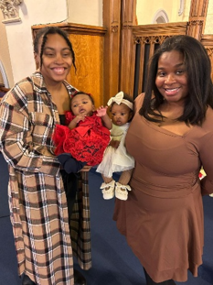
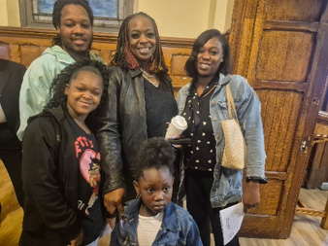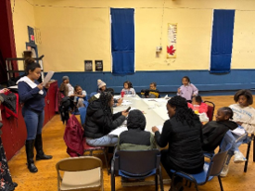
“In their hearts humans plan their course, but the Lord establishes their steps.” – Proverbs 16:9
Graduates:
Marcello Chapman, Jayden Hendrix, Amari Rouse, Averee Thomas, Monesha Townsend, Melody (Joy) Williams

Youth Ministry at New Life At Calvary

Youth Church Choir-
Dakari Avery
Alyse Breeding
Phoenix Breeding
Harmony Brown
ZaNiya Conner
Gabriella Deane
Izabella Deane
Ke’Mari Gilbert
Nylah Hill
Neveah Hill
London Huff
Regan Huff
Ja’lé Kullum
Tristyn Lane
Jace McClain
Javion McClain
Jequrri McClain
Amari Rouse
Dallas Taylor
James Taylor, III

Youth Liturgical Dancers-
Dakari Avery
Alyse Breeding
Phoenix Breeding
ZaNiya Conner
Gabriella Deane
Izabella Deane
Ke’mari Gilbert
Kadira Gulley
Tristyn Lane
Amari Rouse
Dallas Taylor
James Taylor, III
Kalilah Williams

Youth Church Assistants
Andre Brooks, Jr.
ZaNiya Conner
Ke’Mari Gilbert
Zyaire Kee-Smith
Tristyn Lane
Averee Thomas
Dylan Williams
Ja’Vae Williams-Hunt

Youth Media Team
Jayden Hendrix
Amari Rouse
Averee Thomas
Dallas Taylor
James Taylor, III

Security
Jayden Hendrix

Youth Church Participants-
Nursery:
Raeshawn Abercrombie
Ashtyn Abner
Ulani Avery
Melodie Burton
Khloe Jackson
Laila Jackson
Ja’lé Kullum
Marley Jenkins
Rainey Jones
Taytum Rhodes
Noelle Robinson
Ella Scott
Harlowe Sullivan
Zuri Thomas
DeVaughn Weeks
Nova Weeks
Gabriella White

Grades 1-6: (45)
Kailyn Abner
Kaiden Adams
Dakari Avery
Isaiah Bell
Alyse Breeding
Phoenix Breeding
Zuri Britt
Harmony Brown
Jayvair Burton
Gabriella Deane
Izabella Deane
Easton Goodwin
Royal Brooks-Griffin
Galel Gulley
Wakil Gulley
Jamario Hall
Maddisyn Hall
My’shon Hall
Nylah Hill
Neveah Hill
Atreus Huey
Sora Huey
Ashlynn James
Christian James
Amir Jenkins
Santana Jenkins
Ja’lé Kullum
Jai’dah Kee
Jace McClain
Javion McClain
Jequrri McClain
Kasie Payne
Miu Ray
Anaiyah Robinson
Brooklyn Robinson
London Robinson
Steven Rush, Jr.
Dallas Taylor
James Taylor, III
King Walker
Hailey White
Mychael White, Jr.
Dylan Williams
Jaxon Williams
Jeremy Williams, Jr.
Kailyn Williams

Youth Life-Connect Participants
Pre-K- Kindergarten:
Nasir Campbell
Serenity Cunningham
Grace Hunter
Ja’lé Kullum
Harlowe Sullivan

Grades 1-3:
Dakari Avery
Alyse Breeding
Phoenix Breeding
Anaiyah Robinson

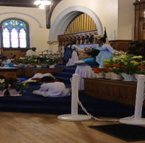
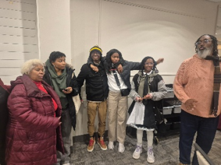
Grades 4-6:
Malik Garrett
Galel Gulley
Wakil Gulley
Tristyn Lane
Dallas Taylor
James Taylor, III
Dylan Williams
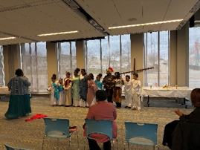
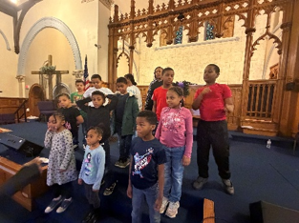
Jaxon Williams

Middle School/High School Class:
ZaNiya Conner
Kadira Gulley
Ke’Mari Gilbert

"Let the little children come to me, and do not hinder them, for the kingdom of heaven belongs to such as these." (Matthew 19:14)

