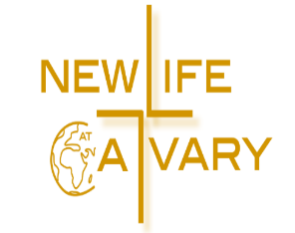

**Sunday, June 4, 2023**

**Communion**

**10:00am**

**Celebration Service**

**New Life At Calvary**

**2020 East 79th Street,**

**Cleveland, OH 44103**

**216-391-8448**

**Email:** [**officenlac@yahoo.com**](mailto:officenlac@yahoo.com)

**Website: NLAC.tv**

Wi-Fi—Life-Guest Password is Joinus2020

**Pastors:**

**Rev. Kellie C. Sullivan**

**Rev. Antonia Martin**

***Rev. Dr. Toby Gillespie-Mobley (Pastor Emeritus)***

***Rev. Dr. Rick Gillespie-Mobley (Pastor Emeritus)***

**Pastoral Ministry Staff: Elder Sylvia Fields**

**Music Ministry: Mr. Kerry Holland**

**Ms. Susan Gillespie**

**Mr. Marvin Rogers**

Welcome To Our Guests! May The Love Of Christ Fill Your Heart Today. Please fill out one of our Guest Cards so that we can thank you for being with us today. Let us know how we can serve you.

(New Life At Calvary CCLI#346464)

**Worship Service**

**Prelude….……..…...............Kerry Holland**

**Opening Prayer…………….……… Pastors**

**Welcome………………………….…Pastors**

**PRAYER…………………….….….…Pastors**

**O The Blood of Jesus**

O the blood of Jesus, O the blood of Jesus,

O the blood of Jesus, it washes white as snow.

It washes white as snow.

O the blood of Jesus, O the blood of Jesus,

O the blood of Jesus, it washes white as snow.

It washes white as snow.

There is power, Power wonderful working

power in the blood of the lamb.

There is power, Power wonderful working

power in the blood of the lamb.

There is power, Power wonderful working

power in the precious blood of the lamb.

The precious blood of the lamb.

There is power, Power wonderful working

power in the blood of the lamb. There is power,

Power wonderful working power in the blood of the lamb.

There is power, Power wonderful working

power in the precious blood of the lamb.

The precious blood of the lamb.

O the blood of Jesus, O the blood of Jesus,

O the blood of Jesus, it washes white as snow.

It washes white as snow.

O the blood of Jesus, O the blood of Jesus,

O the blood of Jesus, it washes white as snow.

It washes white as snow.

There is power, Power wonderful working

power in the blood of the lamb.

There is power, Power wonderful working

power in the blood of the lamb.

There is power, Power wonderful working

power in the precious blood of the lamb.

The precious blood of the lamb.

Vamp

There is power, power in the blood.

In the precious blood of the lamb.

The precious blood of the lamb.

**Take Up Your Cross**

Chorus:  
Take up your cross and follow Jesus  
Take up your cross every day  
Don’t be ashamed to say that you know Him  
Count the cost, take up your cross and follow Him

Take up your cross and follow Jesus  
Take up your cross every day  
Don’t be ashamed to say that you know Him  
Count the cost, take up your cross and follow Him

What are you doing for the King  
Have you really given everything  
For the One who gave His all for you  
Don’t you be satisfied just to know  
That the Lord has saved your soul  
Have you forgotten what you need to do  
  
(Chorus)

Take up your cross and follow Jesus  
Take up your cross every day  
Don’t be ashamed to say that you know Him  
Count the cost, take up your cross and follow Him

Don’t be ashamed to say that you know Him  
Count the cost, take up your cross and follow Him

I know sometimes the road is long  
And I know sometimes you feel like you can’t go on But you can make it, you just  
  
(chorus)

Take up your cross and follow Jesus  
Take up your cross every day  
Don’t be ashamed to say that you know Him  
Count the cost, take up your cross and follow him

Take up your cross and follow Jesus  
Take up your cross every day  
Don’t be ashamed to say that you know Him  
Count the cost, take up your cross

Count the cost, take up your cross

Count the cost, take up your cross and follow Him

**Prayer**

**Church Purpose Statement**

In Response to God’s love, Our purpose is to love others, Teach the Word of God, and Reach the World for Christ. Therefore, as a Covenant Partner, I will invite others to come and join me in worship. I will be a part of a small group bible fellowship to grow in Christ. I will serve in the ministry with my gifts and talents. I will do my part in faithfully giving my tithes and offerings to keep the ministry of Jesus Christ alive in the World. I will love all those who enter our doors and accept them in our midst.

**Belated Memorial Day Tribute**

**Scriptures……….……….…...Andrea Billups**

*Old Testament: Proverbs 22:9*

*New Testament: Luke 7:36-50*

**Offering…………………………….…Pastors**

***Scan here if you want to give online***



**Special Music………….…….…Praise Team**

*“I’m Grateful” Hezekiah Walker*

**Sermon……………….………Pastor Antonia**

*Love Has A Name: “Love Adores Extravagantly”*

**This I Believe**

CHORUS

I believe in God our Father

I believe in Christ the Son

I believe in the Holy Spirit

Our God is three in one

I believe in the resurrection

That we will rise again

For I believe in the Name of Jesus

**\*Affirmation of Faith**

**\*THE APOSTLES’ CREED (Ecumenical)**

**I believe in God, the Father almighty, creator of heaven and earth. I believe in Jesus Christ, His only Son, our Lord, who was conceived by the Holy Spirit, born of the Virgin Mary, suffered under Pontius Pilate, was crucified, died, and was buried; he descended to the dead. On the third day he rose again; He ascended into heaven, and he is seated at the right hand of the Father, Almighty, from thence He will come to judge the living and the dead.**

**I believe in the Holy Spirit, the holy Christian Church, the communion of saints, the forgiveness of sins, the resurrection of the body, and the life everlasting. Amen**

**Examination of our Hearts:**

L. Here what Jesus Christ promises: Happy are those who hunger and thirst for what is right. They shall be satisfied.

**P. Jesus said, “I am the bread of life. The one who comes to Me will never be hungry. The one who believes in Me will never thirst.**

L. This is also the word of the Lord: “All those whom I love, I correct and discipline. Therefore, shake off your complacency and repent. See I stand knocking at the door

If anyone listens to My voice and opens the door, I will go in and dine.”

**P. Let us open our hearts to the Lord. Let us open every door of our lives to God.**

L. Lift up your hearts.

**P. We lift them to the Lord.**

L. Holy God: We praise You for Your Son Jesus, who shared our weakness, and was tempted in every way as we are; Who obeyed You by suffering and dying for us. You have raised Him to rule The world and have given Jesus a name above every name, Lord And Christ. We praise Him, and we glorify You. Great God our Creator.

**P. Now give us Your Spirit in the breaking of bread and sharing of the cup, So that by Your power, we may be drawn together and made one with Jesus, Who is the Way, the Truth, and the Life.**

**Unison:** Our Father, who art in heaven, hallowed be Thy Name. Thy kingdom come. Thy will be done on earth as it is in heaven. Give us this day, our daily bread. And forgive us our debts, as we forgive our debtors; and lead us not into temptation. But deliver us from evil. For thine is the kingdom and the power and the glory forever. **Amen.**

**The Words of Institution ~ The Distribution**

**Prayer of Thanksgiving: (Unison)**

Bountiful God, we give you thanks that you have refreshed us at your table by granting us the presence of Christ. Strengthen our faith, increase our love for one another, and send us forth into the world in courage and peace, rejoicing in the power of the Holy Spirit. **Amen**

**Thank You Lord**

Thank You, Lord, thank You, Lord,

Thank You Lord,

I just want to thank You, Lord.

Been so good, been so good,

Been so good,

I just want to thank You, Lord

**Good News………………….…………Pastors**

**Benediction………….………..….……Pastors**

**WELCOME!** To our visitors, friends, members

and supporters: a warm greeting and God’s Blessings are extended to you. **VISITORS**, if you are passing through, we pray that your journey may be safe. If you live in the community, do worship with us again and share in the mission and ministry of this congregation. **Here’s your opportunity to help us grow. Please take a card out of the pew slots and pass out as you are out and about in the community.** If you need further information, call us at (216) 391-8448 / (440) 315-2791. Thanks for coming to worship with us, and please come again!

**Special Offerings**

1st Sunday – Deacon’s Offerings

2nd Sunday – Prison Ministry

3rd Sunday – Rotolu Orphanage Nigeria

4th Sunday – Two Cents A Meal

5th Sunday – Above & Beyond

**Scripture Readers:**

June 4th Andrea Billups

June 11th Youth Sunday

June 18th Ruby Turner

June 25th Sharon Thomas

**Birthdays the Week of June 4th**

Melvin Simmons 8th

Terrence Sullivan 8th

Demeshia Darmond 9th enH

**Anniversaries the Week of June 4th**

Terrencce & Kellie Sullivan 8th

**Announcements**

Youth Choir Rehearsal Sunday, June 4th after worship service. Following rehearsals will be announced.

Youth Sunday is next Sunday, June 11th. Please see Pastor Antonia if you want to participate or need any information. Graduation promotion forms are now due.

All Youth Ushers please arrive around 9:30am on Sunday, June 11th.

Session Meeting Thursday, June 8th at 6:00pm. On Zoom.

Hanna House Baby Bottle Fundraiser begin the week of May 14th thru June 18th, 2023.



On June 25, 2023. Are you interested in becoming a full Covenant Partner here at New Life At Calvary. Please let Sylvia Fields Know.

Refreshments served during New Members class!

**The Women’s Guild is on Summer Break until September, 2023.**

**Men’s Ministry Golf Outing Friday, August 11, 2023 Highland Park Golf Course. Flyer & entry form on the information rack in the foyer.**

**Youth Church Teachers**

1st Sunday- Whitney upper, Dacia lower, Susan nursery

2nd Sunday- Kamilah upper, Kim lower, Susan nursery

3rd Sunday- Joy upper, Susan lower, Whitney nursery

4th Sunday- Mrs. Beach upper, Kimili lower, Susan nursery

5th Sunday- Yvonne Sims upper, Trinity lower, Susan nursery

**Mental Health Resources Crisis Text Line:**

**Dial or Text – *988**from anywhere in the United States, anytime.  Crisis Text Line is here for any crisis.  A live, trained Crisis Counselor receives the text and responds. **Hotline For Mental Health Emergencies**

**GriefShare** has resumed at New Life At Calvary. Have you gone through a loss and are having a difficult time with grief? You are not alone! Find relief today through sharing with others and guidance from the Holy Spirit. Classes meet weekly on zoom.   To join the **Grief Share** class or a one-on-one session please see Pastor Antonia to sign up or send an email to [lovemusic1114@gmail.com](mailto:lovemusic1114@gmail.com).

**Youth Church Teachers**

1st Sunday- Whitney upper, Dacia lower, Susan nursery

2nd Sunday- Kamilah upper, Kim lower, Susan nursery

3rd Sunday- Joy upper, Susan lower, Whitney nursery

4th Sunday- Mrs. Beach upper, Kimili lower, Susan nursery

5th Sunday- Yvonne Sims upper, Trinity lower, Susan nursery

**Life Connect Classes**

**Youth Zoom Classes on Mondays Class Resumes this week.**

**Teacher (Pastor Antonia Martin)**

2-5 years (6:00-6:30pm)

6-8 years (6:30-7:30pm)

9-12 years (7:30-8:30pm)

13-17 years (8:30-9:30pm.)

Zoom ID: 832 7903 1773 PC: 092683

**Monday 6:00 pm (Adult Class)**

Teachers: Marvin Rogers and Andrea Billups

Zoom Meeting 891-1091-7393/2020 Zoom Call In 1-312-626-6799 891-1091-7393 # # 2020#

**2nd Tuesday 7:30pm (Women) Monthly**

Teacher: Helen Britt (Women with a Heart Bent Toward God) Zoom Meeting 879-0241-3084/2020

**Grief Share with Pastor Antonia – Wednesday 5pm** (Same code as her Life Connect Class)

**Wednesday 7:30 pm (Adult Class)**

Teacher: Pastor Antonia **(Break Week)**

Zoom Meeting 829-8003-5837/2020

Zoom Call In 1-312-626-6799 829-8003-5837 # # 2020# **No Class This Week**

**Wednesday 7:30 pm (Adult Class)**

Sylvia Fields – (**Jesus Calls Us**)

Zoom Meeting 865-9998-5439/12345

Zoom Call In 1-301-715-8592 ID: 865-9998-5439

PW: 12345

**Wednesdays 7:30 pm (Adult Class)**

Teachers: Reginald Woods

Fellowship Hall: (The Chosen Season 3)

**Wednesday 7:00 pm (Adult Class)**

Teachers: Pastor Toby Emeritus **(A Faith That Will Not Fail) Zoom** Meeting 334-158-729/2020

Zoom Call In 1-312-626-6799 334-158-729 # # 2020#

**New Life At Calvary**

**Join us on our social media pages**

**Facebook: New Life At Calvary**

**Facebook: Newlife At Calvary**

**Instagram: _NLAC_**

**Twitter: @2NLAC**

**Tic Tok: Newlifeatcalvary**

**You Tube: New Life At Calvary**

**You can check your attendance online** by sending us a chat on the webpage, make a comment on the Facebook page, send a text saying present with your name(s) at 440-315-2791 or clicking of the bar at the top of the app page, choosing About Links, clicking on the Guest/Prayer card and filling it out. This helps us to know who is a part of the worship service and who we need to make sure we are checking in on.

If you download our church app from either the

App Store or Google Play Store, you can 1)

give your offering through the App, 2) fill out a

Guest Information Card, 3) contact us with a

prayer request, or 4) go to the church website. One you have the app touch it on your phone, touch the

three lines in front of New Life At Calvary. Touch "About & Links". Touch and push the phone screen upwards to choose the action you want to do. Once the page comes up, touch the side of the screen, and push upwards and fill out the information. Don't forget to push submit for guests and for messages or prayer requests.  You can still watch recorded services, bulletins, life-sharing lessons and sermons as before with the app.

GIVING OPTIONS

​**Did You Know There Are 8 Different Ways for You To Give Financially For The Work Of Christ At New Life At Calvary?**

**​**​

1. You can set up an account online at and

have your offering sent directly to the

church’s bank account.  You can designate which accounts to give to. You can also set up an automatic deduction from your account and give one time, weekly, bi-weekly, monthly, or yearly and not have to worry about falling behind on your giving.   You can use a bank account, debit card, or credit card to do this. Once signed in, you will be taken to a secured site. Click on the Donations and Offerings above to do this.

1. ​If you have Cash App you can send your offering to $2NLAC Phone # 216-854-4853.

3.  You can**give cash, checks, or money orders during the regular worship** service. Or drop it off at the church.

​

4.  You can **have us set up an account for you in the office** and we can automatically have your offering sent to your church’s bank account on whatever basis you want. It can be one time, weekly, bi-weekly, monthly, or yearly. You can use a bank account, a debit card, or a credit card to do this.

5. You can do your **online banking** and set up the church as one of your bill payments. The bank will mail the church your check automatically as often as you want it to be sent, weekly, bi-weekly or monthly. You need a checking account or savings account to do this and do online banking. The mailing address is 2020 E. 79th Street, Cleveland, OH 44103

 ​

6.   You can **mail in your offering**through the mail at New Life At Calvary, 2020 E. 79th Street, Cleveland, OH 44103.

​*We encourage you to only use your credit card when you are paying for items at the church such as tickets or t shirts. Never place a large offering on a credit card.

​

** Your offering goes the furthest when you either place it directly in the offering plate or when you have your bank mail your offering to the church under the online bill pay plan.

**Sick & Recuperating Shut In**

**Jennie Brown** (1783 East 227th St, Euclid, OH 44117 216.785.9295)

**Stanette (Brown) Israel** (19205 Lanbury Ave, Warrensville, OH 44122) 216-798-6223 cell: 216.941.5211)

**Bessie Bryant** (Jennings Rehab Center, 10204 Granger Rd, Rm 115 Garfield Hts 44125 216-246-3453)

**Minnie Doaty** (12005 Ablewhite Ave, Clev., OH 44108)

**Natalie Franklin** (daughter of Julie Wright cards only) 6615 Kennedy Ave, Cincinnati, OH 45213

**Alfred Haywood** (St. Augustine 7801 Detroit Ave, Rm 421, Cleveland, OH 44102)

**Robin Hill** (Falling Water Healthcare Center, RM 241D, 18840 Falling Water Rd. Strongsville, OH 44136)

**Glynn Jackson** (13717 Southview Clev., OH 44120 216-921-3788)

**LaDonna Jessup** (Home 216-255-7693)

**Kent Kelton** (9308 Empire, Cleveland, OH 44108 216-287-0469)

**Mildred Little** (1344 East 90th St., Cleve., OH 44106)

**Margaret Mallory** (7829 Euclid Ave #809, Clev, OH 44103)

**Madelin Martin** (12812 Forrest Hills Ave, East Clevv., OH 44112)

**Georgia Naylor (**661 East 103rd St #301 Clev., OH 44108 216.451.6057)

**Elosie Payne** (Jennings Rehab Center, 10204 Granger Road, Rm 110 Garfield Hts 44125)

**Martha Robinson** (Alpine Nursing Home Rm. 218, 5500 Northfield Rd., Maple Heights, OH 44137 216-834-9673)

**Fannie Ruffin** (8164 Dartmoor Rd, Mentor, OH 44060)

**Edna Swoope** (27100 Cedar Rd Rm B115, Beachwood, OH 44122)

**Brenda White** (West Park Commons 4106 Rocky River Dr, Apt 207, Clev., OH 44135 216-377-7314)

**Janet Williams** (10516 Elgin Ave., Clev., OH 44108)

**The White pillars candle in the chancel is a reminder for us to pray for the safety of all the men and women serving in the military. It reminds us to pray for peace in our land and all lands.**

**Women's Schedule:**

**1. Saturday, June 10th @ 10 00**

**2. Wednesday, June 14th @ 6 00**

**3.  Saturday, June 17th @ 10 00...**

**THIS Choir is for ALL Women ❤️**

**Any Questions call Gwen Coats 216 598 4936**

***Sermon Series: Love Has A Name***

**Love Adores Extravagantly**

Week 1: Sunday May 21, 2023

**Love Starts With A Name**

Week 2: Sunday May 28, 2023

**Love Is More Than A Theory**

Week 3: Sunday June 4, 2023

**Building On Faith Restoration Project**

**Fund Raisers**

These are the fundraisers that have been scheduled so far for the Building On Faith Restoration Project. More fundraisers will be added. All proceeds from these fundraisers will go to the building projects. Please check with your ministry and plan your fundraiser. Please let Ruth Yarbrough or Pastor Kellie know of any fundraising plans so we can add your fundraiser to this list. If you would like to help with a fundraiser, please speak to the above-listed people as well. Thank you!

**May:**

* Juneteenth 50/50 Raffle: Dates May 1, 2023, to June 18, 2023
  + 1st Place: 50% of the cash prize
  + 2nd Place: $100.00 Gift Card
  + 3rd Place: Women Gift Bag with assorted gift items
  + 4th Place: Silver Keepsake Box with Cross & Elegant High Heeled Ring Holder
  + 5th Place Prize: Men’s gift bag with assorted gift items
* Mothers Paint and Praise: Date May 12, 2023, at 7:00 pm
  + Paint a beautiful flower for your mother or mother figure.
  + Cost $25.00 or 2 for $40.00

**June:**

* **Sunday June 4th:  Prayer Walk seven times around the church after service.**
* Juneteenth 50/50 Raffle: Dates May 1, 2023 to June 18, 2023
  + 1st Place: 50% of the cash prize
  + 2nd Place: $100.00 Gift Card
  + 3rd Place: Women Gift Bag with assorted gift items
  + 4th Place: Silver Keepsake Box with Cross & Elegant High Heeled Ring Holder
  + 5th Place Prize: Men’s gift bag with assorted gift items
* Health Fair Coin Collection Bring your change, change a Life: Date June 24, 2023, 12:00 pm to 3:00 pm
  + Bring your coins and donate them to change a life.
  + Coins will be collected during the NLAC Health Fair

**July**

**August**

Possible Gospel Skate

* Education and Resource Fair Coin Collection Bring your change, change a Life: Date August 19, 2023, 12:00 pm to 3:00 pm
  + Bring your coins and donate them to change a life.
  + Coins will be collected during the NLAC Education and Resource Fair

**September**

Popcorn fundraiser & Scratch off cards Fundraiser (Dates TBA)



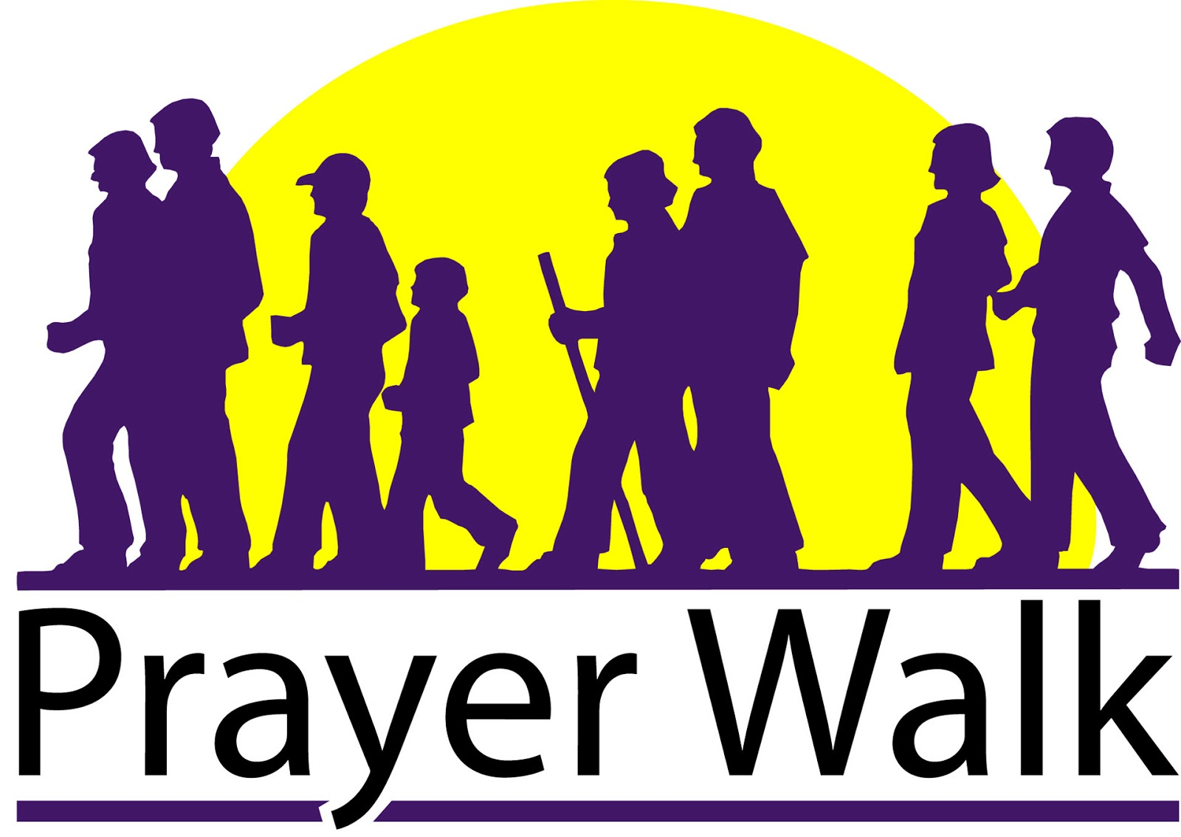

**WE WILL START IN THE SANCTUARY WITH PRAYER**

**AND END IN THE SANCTUARY WITH PRAYER**

1. Make sure you have your bracelet
2. Dismiss slowly watch our seniors & children
3. Walk at your own pace. GO AROUND SEVEN (7) TIMES.
4. Refreshments will be in Fellowship Hall, must have a bracelet.
5. Pray as you walk. Be sincere in your prayer.



**SAVE THE DATE**

**ANNUAL CHURCH PICNIC**

**JULY 8TH AT 12:00PM**

**FOREST HILL PARK 2A & 2B**

**2370 LEE BLVD CLEVELAND HEIGHTS, OH 44118**

**SET UP AT NLAC 10AM – 12PM**



There are still some spaces

Left to sign up for summer camp.

Spaces are limited.

SUMMER CAMP

WE NEED HELP SPONSORING

SCHOLARSHIPS

Contributions Of Any Amount May

Be Given In Offering Use “Other” On Envelope, Write “Summer Camp”

You may also sign up to be a volunteer,

A driver for field trips.

THANKS SO MUCH FOR GIVING!