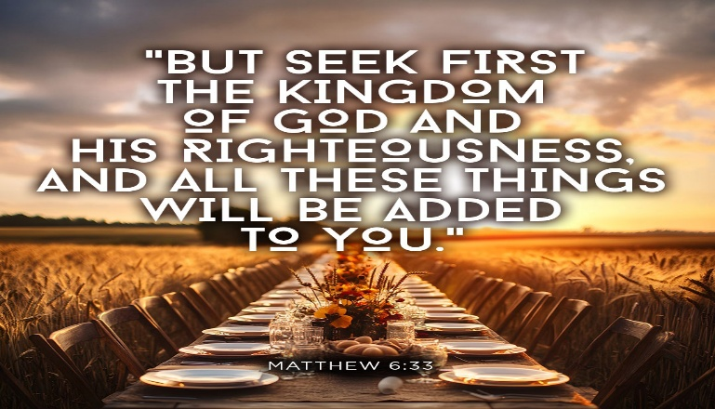New Life At Calvary
November 1, 2026
Communion Sunday

9:55 Prelude: Kerry Holland

10:00 Worship Service

Welcome/Opening Prayer:

Selection: Praise Team/Band
“Wonderful God”

Scripture: Andrea Billups
OT: Joshua 11:6
NT: Matthew 6:25-34, Philippians 4:19

Offering:

Special Music: Youth Liturgical Dancers
“Mighty Name of Jesus”
by The Belonging Co. & Hope Darst

Messages: Pastor Antonia
“The God Who Provides”

Selection: “This I Believe”

*Affirmation of Faith

The Sacrament of Holy Communion

Announcements:

Benediction:

Wonderful God
We serve a great big wonderful God
We serve a great big wonderful God
Always victorious
Always watching over us
No matter what we’re going through
We serve a great big wonderful God
Great big wonderful God
Great big wonderful God

This I Believe
I believe in God our Father
I believe in Christ the Son
I believe in the Holy Spirit
Our God is three in one
I believe in the resurrection
That we will rise again
For I believe in the Name of Jesus

*Affirmation of Faith
*THE APOSTLES’ CREED (Ecumenical)
I believe in God, the Father almighty, creator of heaven and earth. I believe in Jesus Christ, His only Son, our Lord, who was conceived by the Holy Spirit, born of the Virgin Mary, suffered under Pontius Pilate, was crucified, died, and was buried; he descended to the dead. On the third day he rose again; He ascended into heaven, and he is seated at the right hand of the Father, Almighty, from thence He will come to judge the living and the dead.

I believe in the Holy Spirit, the holy Christian Church, the communion of saints, the forgiveness of sins, the resurrection of the body, and the life everlasting. Amen


Communion Service

(Examination of our Hearts)

L. Here what Jesus Christ promises: Happy are those who hunger and thirst for what is right. They shall be satisfied.

P. Jesus said, “I am the bread of life. The one who comes to Me will never be hungry. The one who believes in Me will never thirst.
L. This is also the word of the Lord: “All those whom I love, I correct and discipline. Therefore, shake off your complacency and repent. See I stand knocking at the door
If anyone listens to My voice and opens the door, I will go in and dine.”

P. Let us open our hearts to the Lord. Let us open every door of our lives to God.

L. Lift up your hearts.
P. We lift them to the Lord.
L. Holy God: We praise You for Your Son Jesus, who shared our weakness, and was tempted in every way as we are; Who obeyed You by suffering and dying for us. You have raised Him to rule The world and have given Jesus a name above every name, Lord And Christ. We praise Him, and we glorify You. Great God our Creator.

P. Now give us Your Spirit in the breaking of bread and sharing of the cup, So that by Your power, we may be drawn together and made one with Jesus, Who is the Way, the Truth, and the Life.

Unison: Our Father, who art in heaven, hallowed be Thy Name. Thy kingdom come. Thy will be done on earth as it is in heaven. Give us this day, our daily bread. And forgive us our debts, as we forgive our debtors; and lead us not into temptation. But deliver us from evil. For thine is the kingdom and the power and the glory forever. Amen.

The Words of Institution ~ The Distribution

Prayer of Thanksgiving: (Unison)
Bountiful God, we give you thanks that you have refreshed us at your table by granting us the presence of Christ. Strengthen our faith, increase our love for one another, and send us forth into the world in courage and peace, rejoicing in the power of the Holy Spirit. Amen

Thank You, Lord
Thank You, Lord, thank You, Lord,
Thank You, Lord,
I just want to thank You, Lord.

Been so good, been so good,
Been so good,
I just want to thank You, Lord

Announcements
Attention: Please refrain from walking during these times: Prayer, Soloist, Scripture and Sermon. Thank you.

There is a called Session meeting, Thursday, November 5th on Zoom at 6PM. Re: The Emmaus Project and The Lily Endowment Grant. Look for an email with follow-up information.

Thanks to everyone that supported the Elbert Arnwine Family, at his Memorial Service and Repast this past Wednesday. Continue to keep his wife Pat and the entire family in your prayers.

Thanks to everyone who supported the Katy Glenn Family, at Bridge City Church, this past Saturday. Please continue to keep Walter, Gail, Marvin and the entire family in your prayers.

Thanks to everyone who donated candy and the use of their vehicles for Trunk or Treat.

NLAC Men’s Association
Raffle Fundraiser
October 11, 2026 to November 15, 2026
All proceeds will benefit the Men’s Association
1st Place $200 Cash
2nd Place $125 Value Gift Card
3rd Place $ 75 Value Gift Card
For tickets, please see Lenny Gray, Terrence Sullivan and Glenn Hendrix. 6 Tickets $5.00

Parking Lot Security: Due to the rash of car break-ins now targeting churchgoers, as part of a broader crime wave. We are asking for help in monitoring the church parking lot. Currently, Joseph Stewart monitors the parking lot. Attention: Due to the rash of car break-ins, please do not leave anything valuable visible for others to see.

Birthdays The Week of November 1, 2026
Mychael White, Jr 4th
Esther Banaci 5th

Scripture Readers November
Andrea Billups Nov. 1st
Shannon Hendrix Nov 8th
Men’s Association Nov. 15th
Ruby Turner Nov 22nd
Ruth Yarbrough Nov 29th

Special Offering
1st Sunday – Deacon’s Offerings
2nd Sunday – Prison Ministry
3rd Sunday – Rotolu Orphanage Nigeria
4th Sunday – Ten Cents A Meal
5th Sunday – Above & Beyond

November Sermon Series



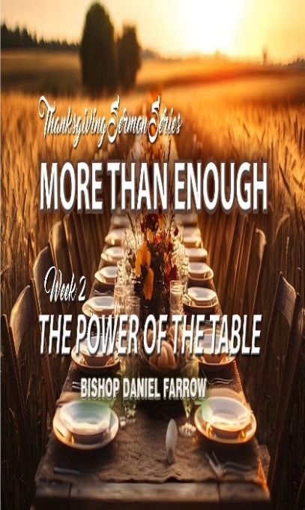

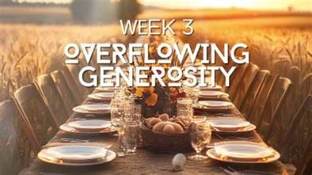

GIVING OPTIONS
www.NLAC.tv Website Giving:



If you have Cash App you can send your offer to $2NLAC




Go into your mobile banking app Click on pay with Zelle. Once inside your Zelle app it will give you the option to scan the QR code below or type in the church email address: officenlac@gmail.com

You can mail in your offerings through the mail at
New Life At Calvary
2020 East 79th Street
Cleveland, OH 44103


DON’T FORGET TO TURN IN YOUR HONORING OUR VETERNS FORM WITH YOUR MILITARY INFORMATION BY TUESDAY, NOVEMBER 10, 2026.

MEN’S MINISTRY PROGRAM
NOVEMBER 15, 2026

PLEASE DON’T FORGET TO VOTE!!!!

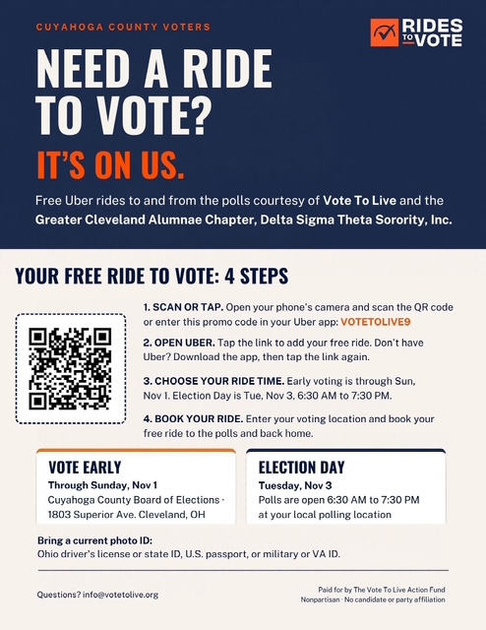

Register for the General Election by: October 5, 2026

To register online, you must provide your Ohio driver's license or ID card number, your name, date of birth, address and the last four digits of your Social Security number. Visit the state elections site for more information

Ohio's early in-person voting dates: October 6–November 1, 2026 (Ohio law bars in-person early voting on the Monday immediately before Election Day; the final day, Sunday November 1, has reduced hours 1–5 p.m.)

Starting the day after the close of voter registration (October 6, 2026), registered voters may cast an early in-person ballot at their county board of elections. Check with your specific county location for hours.

Ohio's absentee ballot by mail request deadline: received by October 27, 2026, 8:30 p.m.
Any qualified Ohio voter may request an absentee ballot without stating a reason. To apply, complete an absentee ballot request form and return it to your county board of elections by October 27, 2026. Completed ballots must be received by the county board by 7:30 p.m. on Election Day.

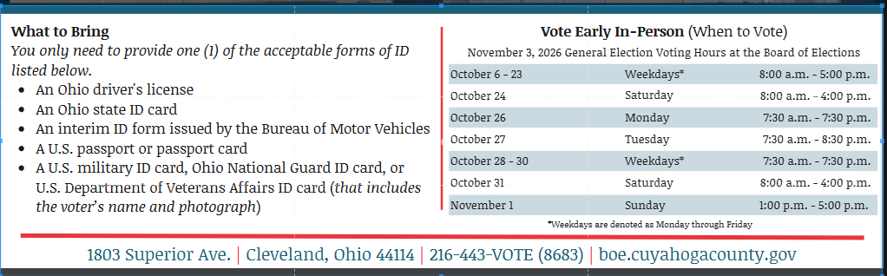

JUDICIAL RATINGS AND RECOMMENDATIONS OF THE
NORMAN S. MINOR BAR ASSOCIATION FOR THE 2026 ELECTIONS.

OHIO SUPREME COURT: JENNIFER BRUNNER

MARILYN ZAYAS

CUYAHOGA COUNTY COMMON
PLEAS COUR GENERAL DIVISION: DARYL DENNIE

TIMOTHY CLARY

ANTONIO NICHOLSON

CUYAHOGA COUNTY DOMESTIC
RELATIONS COURT: PAMELA HAWKINS

EIGHT DISTRICT COURT OF
APPEALS: ANITA LASTER MAYS

REQUIRES A PHOTO IDENTIFICATION FROM A GOVERNMENTAL AGENCY.

AN OUT OF STATE DRIVER’S LICENSE IS NOT VALID IDENTIFICATION.

EVERY VOTE MATTERS.

THANK YOU FOR VOTING

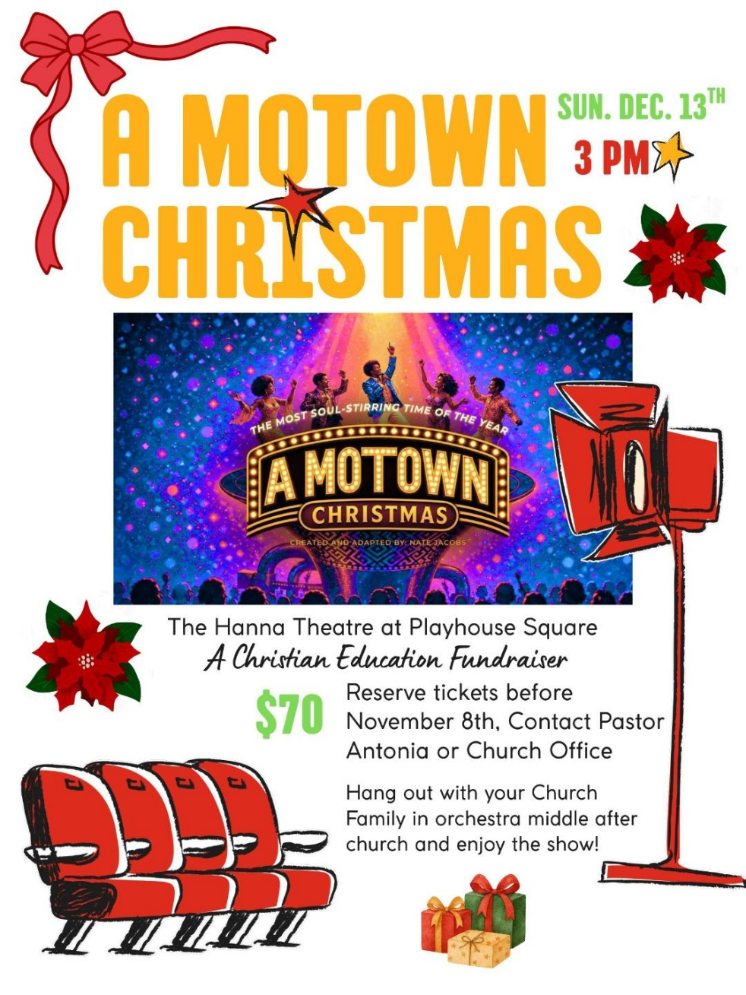

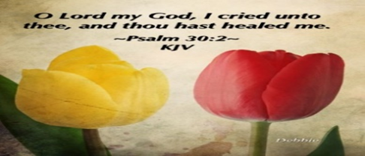
Please send a card, call, pray for, and support our Sick and Shut ins and recuperating brothers and sisters in Christ. Thank you.

Jennie Brown (1783 East 227th St, Euclid, OH 44117 216.785.9295)
Natalie Franklin (daughter of Julie Wright cards only) c/o Donnese Franklin, 4216 Colby Ave, Columbus, OH 43227)
Alfred Haywood (St. Augustine 7801 Detroit Ave, Rm 237, Cleveland, OH 44102)
Savannah (Robin) Hill (Grande Pointer Healthcare Center, 3 Merit Dr, #323, Richmond Heights, OH 44143, 216-609-6920)
Kent Kelton (Longmeadow Care Center, 565 Bryn Mawr St., Room 22, Ravenna, OH 44266, 216-672-2763))
Mildred Little (1344 East 90th St., Cleve., OH 44106)
Joseph McIntosh (O’Neil Healthcare, 13900 Detroit Ave, Room 112, Lakewood, OH 44107)
June Phillips (Forest Hills Place 3151 Mayfield Rd., Cleveland Hts., OH 44118)
Fannie Ruffin (8164 Dartmoor Rd, Mentor, OH 44060)
Edna Swoope (27100 Cedar Rd, Beachwood, OH 44122)
Brenda White (West Park Commons 4106 Rocky River Dr, Apt 207, Clev., OH 44135 216-377-7352)
Janet Williams (10516 Elgin Ave., Clevland, OH 44108)


The White pillars candle in the chancel is
a reminder for us to pray for the safety of all
the men and women serving in the military.
It reminds us to pray for peace in our land
and all lands.

LIFE CONNECT CLASSES

Youth Life Connect on Zoom Classes on Mondays: Teacher Pastor Antonia
Grades PK- 6th. Be on the lookout for bible study bags. Zoom ID: 832 7903 1773 Password: 092683
Grades PK-K (2-5 years old) 6 pm- 6:30 pm
Grades 1-3 (6-8 years old) 6:30 pm- 7:30 pm
Grades 4-6 (9-12 years old) 7:30 pm- 8:30 pm

Monday 6:30 pm (Adult Class)
Teachers: Andrea Billups Hallelujah Anyhow
Zoom Meeting 891-1091-7393 PW: 2020 Zoom Call In 1-312-626-6799 891-1091-7373 ##2020#

Reading Through The Bible - 7:30 pm: We will be using the NIV Version – Teacher: Pastor Kellie
Meetings 1st, 3rd, 4th, & 5th Tuesday of the month Meeting ID: 820-9791-8709 PW: 605886
Phone# 1-312-626-6799 ID: 820-9791-8709 ##605886#

Karen ‘s Prayer Shawl Ministry: Tuesday, November 10th. meets once a month on Tuesdays 6pm-7:30pm Susan Gellispie Leader.

Women with a Heart Bent Toward God. November 10th. Meets once a month on Tuesdays at -7:30 pm: Teacher: Helen Britt - Zoom ID: 895-0072-4832 PW: 709557# Zoom Call In: 1-301-715-8592 Code: 709557#

Wednesday 6:00 pm (Adult Class) In Person
Teacher: Clemon Walker & LaTonya Deane In Fellowship Hall. Acts by Francis Chan

Wednesdays 7:00 pm (Adult Class)
Teacher: Pastor Emeritus Toby
Chosen
Zoom Meeting 334-158-729/2020 Zoom Call In 1-312-626-6799 334-158-729## 2020#

Wednesday 7:30pm (Adult Class)
Teacher: Pastor Antonia The Book of Jeremiah
Zoom Meeting 872 5812 7559/2020 Call In 1-305-224-1968,,87258127559#,,,,*2020#

Wednesday 7:30 pm (Adult Class)
Teacher: Sylvia Fields The Soul of a Nation
Zoom Meeting 865-9998-5439/54321 Zoom Call In 1-301-715-8592 TD: 865-9998-5439## PW: 54321

