New Life At Calvary
Sunday
January 18, 2026

Prelude: Kerry Holland

Welcome/Opening Prayer:

Selection: “Lift Every Voice And Sing”

Scripture: Yvonne Sims
OT: Deuteronomy 6:4-12
NT: John 21:5-13

Offering:

Special Music: “Spiritual Medley”
Praise Team

Video “I Have A Dream”

Message: “Renewed Love”
Pastor Antonia

Selection: “Just A Closer Walk With Thee”

Announcements:

Benediction:

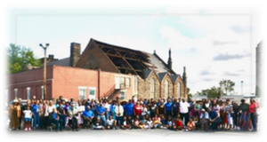
Church Purpose
In Response to God’s love, Our purpose is to love others, Teach the Word of God, and Reach the world for Christ. Therefore, as a Covenant Partner, I will be a part of a small group bible fellowship to grow in Christ. I will serve in the ministry with my gifts and talents. I will do my part in faithfully giving my tithes and offerings to keep the ministry of Jesus Christ alive in the World. I will love all those who enter our doors and accept them in our midst.
Lift Every Voice And Sing
Lift ev’ry voice and sing
Till earth and heaven ring
Ring with the harmonies of liberty
Let our rejoicing rise High
as the list’ning skies
Let it resound loud as the rolling sea
Sing a song full of the faith that
the dare past has taught us
Sing a song full of the hope
that the resent has brought us
Facing the rising sun Of our new day begun
Let us march on till victory is won.

Stony the road we trod
Bitter the chast’ning rod
Felt in the days when hope unborn had died
Yet with a steady beat Have
not our weary feet
Come to the place for which our fathers sighed?
We have come over a way
that with tears has been watered
We have come treading our path through the blood of the slaughtered
Out from the gloomy past
Till now we stand at last
Where the bright gleam of our bright star is cast.

God of our weary years
God of our silent tears
Thou who hast brought us thus far on the way
Thou who hast by Thy might
Led us into the light
Keep us forever in the path we pray
Lest our feet stray from the places our God, where we met Thee
Lest our hearts drunk with the wine of the world we forget Thee
Shadowed beneath Thy hand May
we forever stand
True to our God, true to our native land.

Just A Closer Walk With Thee
I am weak, but Thou art strong;
Jesus, keep me from all wrong;
I'll be satisfied as long
As I walk, let me walk close to Thee.
Refrain
Just a closer walk with Thee,
Grant it, Jesus, is my plea,
Daily walking close to Thee,
Let it be, dear Lord, let it be.
Through this world of toil and snares,
If I falter, Lord, who cares?
Who with me my burden shares?
None but Thee, dear Lord, none but Thee.
Refrain
Just a closer walk with Thee,
Grant it, Jesus, is my plea,
Daily walking close to Thee,
Let it be, dear Lord, let it be.
When my feeble life is o'er,
Time for me will be no more;
Guide me gently, safely o'er
To Thy kingdom shore, to Thy shore.
Refrain
Just a closer walk with Thee,
Grant it, Jesus, is my plea,
Daily walking close to Thee,
Let it be, dear Lord, let it be. (repeat)

Announcements
Attention: Please refrain from walking during these times: Prayer, Soloist, Scripture and Sermon. Thank you.

Youth Bible Study on Break Monday January 19th – MLK Holiday

Congregation Meeting and Electing of officers has been rescheduled for Sunday, February 15, 2026. If you have not turned in your committee reports, please do so by January 20, 2026.

MLK – Rehearsal today after worship.

Ushers: All current and past Ushers there will be a meeting Sunday, January 18, 2026 after worship in the class room off Fellowship Hall. If you are interested in joining this ministry, please plan on attending. Thanks

Women’s Association will meet Sunday, January 25, 2026 after worship in the Sanctuary.

Men’s Association will meet Sunday, January 25, 2026 after worship in the classroom off the Fellowship Hall.

Parking Lot Security: Due to the rash of car break-ins now targeting churchgoers, as part of a broader crime wave. We are asking for help in monitoring the church parking lot. Currently, Joseph Stewart monitors the parking lot until around 10:40am. We need someone to monitor from 10:40am until service is over.

Attention: Due to the rash of car break-ins, please do not leave anything valuable visible for others to see.

MLK - Celebration – “She Kept Marching” – Honoring the Legacy of “Coretta Scott-King”
Monday, January 19th - 10:00 am – Live Stream of the Beloved Community Commemorative Service by the King Center. Lunch following program.
12 Noon – 1:00pm after “She Kept Marching” Program from 1:00pm – 2:00pm. If anyone is interested in participating as an actor or singer, please speak to Pastor Kellie or Kacie.

Per Capita: The 1st Sunday in January, your Per Capita for 2026 is due in the amount of $30. Thanks

Birthdays The Week of January 18, 2026

Kent Kelton 18th
Olivera Perkins 22nd

Scripture Readers January 2026
Melvin Simmons 4th
Andrea Billups 11th
Yvonne Sims 18th
Terrence Sullivan 25th

Special Offering
1st Sunday – Deacon’s Offerings
2nd Sunday – Prison Ministry
3rd Sunday – Rotolu Orphanage Nigeria
4th Sunday – Ten Cents A Meal
5th Sunday – Above & Beyond

GIVING OPTIONS
www.NLAC.tv Website Giving:



If you have Cash App you can send your offer to $2NLAC


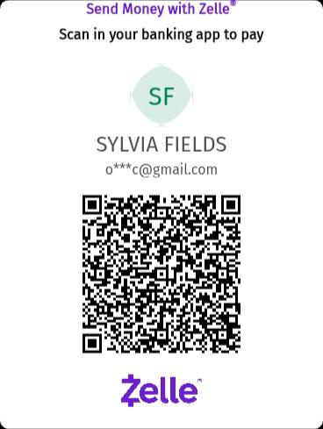

Go into your mobile banking app Click on pay with Zelle. Once inside your Zelle app it will give you the option to scan the QR code below or type in the church email address: officenlac@gmail.com

You can mail in your offerings through the mail at
New Life At Calvary
2020 E. 79th Street
Cleveland, OH 44103

Please registrar on line at www.euclidpubliclibrary.org to receive the Coretta Scott King Book.

Life Connect Classes

Youth Life Connect on Zoom Classes on Mondays
On Break
6:00pm-9:30pm, Teacher Pastor Antonia
Grades PK -K (3-5 years) 6:00-6:30
Grades 1-3 (6-8 years) 6:30 – 7:30pm
Grades 4-6 (9-12 years) 7:30-8:30pm
Grades 7-12 (13-17 years) 8:30-9:30pm
Zoom Meeting ID: 832-7903-1773 PW: 092683
Monday 6:30 pm (Adult Class)
Teachers: Andrea Billups (On Break)
Zoom Meeting 891-1091-7393 PW: 2020 Zoom Call In 1-312-626-6799 891-1091-7373 ##2020#

Read The Bible in One Year/52 weeks/365 days - 7:30 pm: We will be using the NIV Version – Teacher: Pastor Kellie
Meetings 1st, 3rd, 4th, & 5th Tuesday of the month Meeting ID: 820-9791-8709 PW: 605886
Phone# 1-312-626-6799 ID: 820-9791-8709 ##605886#

Women with a Heart Bent Toward God. Teacher: Helen Britt (Return 2/10/26)
Zoom ID: 891-6849-5855 PW: 751319
Zoom Call In: 1-301-715-8592 Zoom Meeting ID: 896-0072-4832 Zoom Code: 709557#

Wednesday 7:00 pm (Adult Class) In Person
Teacher: Clemon Walker, In Fellowship Hall.

Wednesdays 7:00 pm (Adult Class)
Teacher: Pastor Toby Emeritus (The Chosen)
Zoom Meeting 334-158-729/2020 Zoom Call In 1-312-626-6799 334-158-729## 2020#

Wednesday 7:30pm (Adult Class)
Teacher: Pastor Antonia – Five Postures of a Global Christian
Zoom Meeting 872 5812 7559/2020 Call In 1-305-224-1968,,87258127559#,,,,*2020#

Wednesday 7:30 pm (Adult Class)
Teacher: Sylvia Fields – Enduring Belief of Looking Back The Christian Faith Looking Forward.
Zoom Meeting 865-9998-5439/54321 Zoom Call In 1-301-715-8592 TD: 865-9998-5439## PW: 54321

Please send a card, call, pray for, and support our Sick and Shut ins and recuperating brothers and sisters in Christ. Thank you.

Jennie Brown (1783 East 227th St, Euclid, OH 44117 216.785.9295)
Minnie Doaty (12005 Ablewhite Ave, Cleve., OH 44108)
Natalie Franklin (daughter of Julie Wright cards only) (c/o Donnese Franklin, 4216 Colby Ave, Columbus, OH 43227)
Marvin Hayes (1817 Marloes Rd, East Cleveland, OH 44112 216.541.6314)
Alfred Haywood (St. Augustine 7801 Detroit Ave, Rm 237, Cleveland, OH 44102)
Mary James (497 East 108th Street, Cleveland, OH 44108, 216-541-4114)
Savannah (Robin) Hill (Grande Pointe Healthcare Center, 3 Merit Dr, #323, Richmond Heights, OH 44143, 216-440-3440)
Kent Kelton (Longmeadow Care Center, 565 Bryn Mawr St, Room 57, Ravenna, OH 44266, 216-672-2763)
Mildred Little (1344 East 90th St., Cleve., OH 44106)
Fannie Ruffin (8164 Dartmoor Rd, Mentor, OH 44060)
Edna Swoope (27100 Cedar Rd, Beachwood, OH 44122)
Brenda White (West Park Commons 4106 Rocky River Dr, Apt 207, Cleve., OH 44135 216-377-7352)
Janet Williams (10516 Elgin Ave., Cleveland, OH 44108)
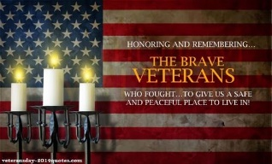

Sermon Series - January
Week 1: Renewed Spirit
Week 2: Renewed Purpose
Week 3: Renewed Love
Week 4: Renewed Community

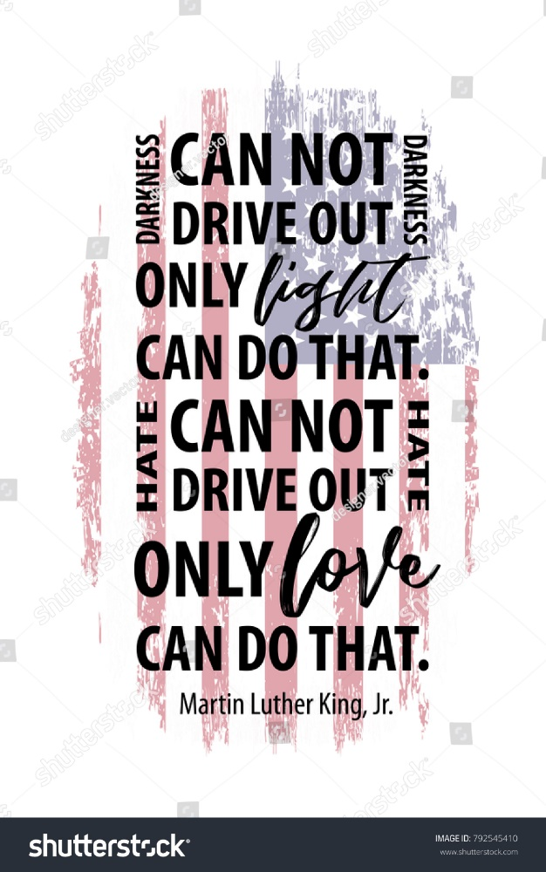
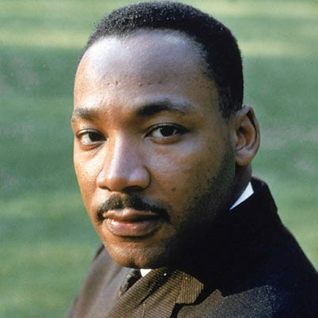
REMEMBERING REV. DR. MARTIN LUTHER KING, JR.
During the less than 13 years of Dr. Martin Luther King, Jr.’s leadership of the modern American Civil Rights Movement, from December 1955 until April 4, 1968. African Americans achieved more genuine progress toward racial equality in America than the previous 350 years had produced. Dr. King is widely regarded as America’s pre-eminent advocate of nonviolence and one of the greatest nonviolent leaders in world history.

Drawing inspiration from both his Christian faith and the peaceful teachings of Mahatma Gandhi, Dr. King led a nonviolent movement in the late 1950s and ‘60s to achieve legal equality for African-Americans in the United States. While others were advocating for freedom by “any means necessary,” including violence, Martin Luther King, Jr. used the power of words and acts of nonviolent resistance, such as protests, grassroots organizing, and civil disobedience to achieve seemingly-impossible goals. He went on to lead similar campaigns against poverty and international conflict, always maintaining fidelity to his principles that men and women everywhere, regardless of color or creed, are equal members of the human family.
Dr. King’s “I Have a Dream” speech, Nobel Peace Prize lecture and “Letter from a Birmingham Jail” are among the most revered orations and writings in the English language. His accomplishments are now taught to American children of all races, and his teachings are studied by scholars and students worldwide. He is the only non-president to have a national holiday dedicated in his honor and is the only non-president memorialized on the Great Mall in the nation’s capital. He is memorialized in hundreds of statues, parks, streets, squares, churches and other public facilities around the world as a leader whose teachings are increasingly-relevant to the progress of humankind.
In 1955, he was recruited to serve as spokesman for the Montgomery Bus Boycott, which was a campaign by the African-American population of Montgomery, Alabama to force integration of the city’s bus lines. After 381 days of nearly universal participation by citizens of the black community, many of whom had to walk miles to work each day as a result, the U.S. Supreme Court ruled that racial segregation in transportation was unconstitutional.
In 1957, Dr. King was elected president of the Southern Christian Leadership Conference (SCLC), an organization designed to provide new leadership for the now burgeoning civil rights movement. He would serve as head of the SCLC until his assassination in 1968, a period during which he would emerge as the most important social leader of the modern American civil rights movement.
In 1963, he led a coalition of numerous civil rights groups in a nonviolent campaign aimed at Birmingham, Alabama, which at the time was described as the “most segregated city in America.” The subsequent brutality of the city’s police, illustrated most vividly by television images of young blacks being assaulted by dogs and water hoses, led to a national outrage resulting in a push for unprecedented civil rights legislation. It was during this campaign that Dr. King drafted the “Letter from a Birmingham Jail,” the manifesto of Dr. King’s philosophy and tactics, which is today required-reading in universities worldwide.
Later in 1963, Dr. King was one of the driving forces behind the March for Jobs and Freedom, more commonly known as the “March on Washington,” which drew over a quarter-million people to the national mall. It was at this march that Dr. King delivered his famous “I Have a Dream” speech, which cemented his status as a social change leader and helped inspire the nation to act on civil rights. Dr. King was later named Time magazine’s “Man of the Year.”


Pledge Card for support of the 2nd Milestone of the
Building On Faith Capital Campaign of
New Life At Calvary Cleveland, OH
A Capital Campaign is how we fund the future of New Life At Calvary. It challenges us to reach higher and dig deeper in order to meet the immediate and long-term needs of the church and the community. Like annual giving, giving to a Capital Campaign enhances the mission and ministry of the church through renovation and improvement of our church building.
Giving to the Capital Campaign is considered sacrificial giving. It does not come from our daily living expenses. Capital Campaign giving can be spread out over a three-year period to allow donors to manage their gifts according to their needs.
_____________________________________________________________________________
I/We pledge in faith to support the 2nd Milestone of the Capital Campaign of New Life At Calvary listed by making the financial contribution listed below:
Total Amount of Pledge $_________________ (for those renewing the pledge see reverse side of this form)

One-time Payment Date: ___________ Payments Over-Time
Regular Payment Schedule expected:

$_____________ each week/month/quarter/year
Method(s) of Payment
- Cash or Check Enclosed
- Online Giving through New Life At Calvary
- (set up on the www.nlac.tv website)
- Gift of Securities (see other side for more ways to give)
Start date: ______________ End Date: ______________
-or-

Other Payment Schedule described below:
__________________________________________________
__________________________________________________

__________________________________________________

Names: _____________________________________________________________________________________________________

Address: ____________________________________________________________________________________________________

City: _______________________________________________ State: __________________ Zip: ____________________________
Phone: ______________________________________________ Email: _________________________________________________

Signature Date of Pledge

____________________________________________________________________________________________________________
Signature Date of Pledge

Methods of Giving to New Life At Calvary Capital Campaign, Building on Faith Restoration
Cash or Checks- Checks payable to New Life At Calvary, sent to 2020 E. 79th Street, Cleveland, Ohio 44103
Online Giving- One time or Recurring payment directly from a bank account. This is set up and managed from the Online Giving tab on the New Life At Calvary website (nlac.tv).
Gifts of Securities- Gifts of stocks, bonds, and other financial instruments can be arranged by contacting the NLAC steering Committee: Pastor Kellie C. Sullivan, Sylvia Y. Fields, Ruby Turner and Ella Thomas. When giving gifts of securities, please contact the Steering Committee with the donor’s name, the type of security name, and the number of shares, no later than the day the gift is made.
Matching gifts- Many employers will match charitable donations made by their employees. By using your company’s Matching Gift benefit, you may be able to multiply the amount of your donation. If you are affiliated with a company that matches gifts, please send the Matching Gift Form (usually attained by contacting your Human Resources Department), along with your donation to New Life At Calvary. The church will complete the form and return it to the company.
Information pertaining to my companies matching gift program:
___ I/We work for a Company that has a Matching Gifts Program.
___ The Matching Gifts Form is enclosed with this Pledge Card.
___The Matching Gifts form will be forwarded in the near future.

------------------------------------------------------------------------------------------------------------------------------------------
I/We pledge in faith to support the Building on Faith Restoration Campaign of New Life At Calvary by making the financial contribution listed on the reverse side of this form. My/Our contact information is on the reverse side. I/We have also signed indicating our commitment to complete this pledge. I understand that if we are a couple making this pledge both parties must sign this pledge.

I/We made a pledge to the 1st Milestone. For the 2nd Milestone please do one of the following: (Check One)
- __________ Keep my/our pledge the same.

- . _________ Increase my/our pledge to $________________.

  - I/We plan on giving monthly, weekly, bi-weekly (please circle one).

- I /We want to discuss giving a Gift of Securities.
- I/We want to discuss doing a matching gift with my job.
1st Milestone givers please complete the contact information on the other side of this form. Thank you for your continued support.

