New Life At Calvary
April 28, 2024

Prelude: Kerry Holland

Welcome /Opening prayer

Selection: “Take Up Your Cross”

Scripture: Amari Rouse
OT: Proverbs 16:
NT: Matthew 28:16-20

Offering:

Special Selection: “Oh Give Thanks”
Praise Team/Praise Band

Message: All In: “Live The Commission”
Pastor Kellie

Selection: “Blessed Quietness”

Brief Announcements

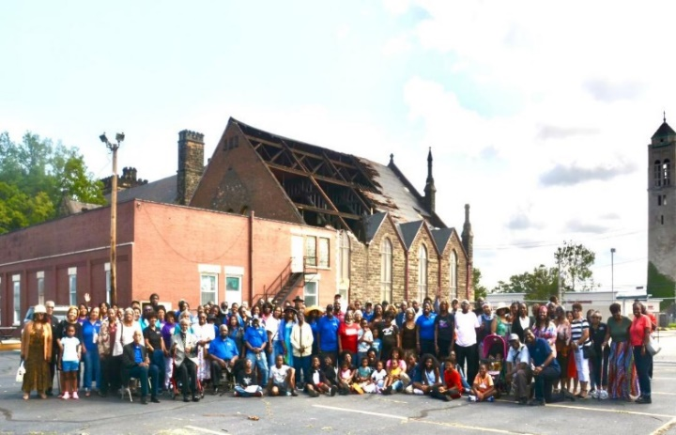
Benediction

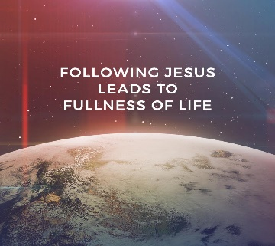
Church Purpose Statement.
In Response to God’s love, Our purpose is to love others, Teach the Word of God, and Reach 19720 World for Christ. Therefore, as a Covenant Partner, I will invite others to come and join me in worship. I will be a part of a small group bible fellowship to grow in Christ. I will serve in the ministry with my gifts and talents. I will do my part in faithfully giving my tithes and offerings to keep the ministry of Jesus Christ alive in the World. I will love all those who enter our doors and accept them in our midst.

Take Up Your Cross
Chorus:
Take up your cross and follow Jesus
Take up your cross every day
Don’t be ashamed to say that you know Him
Count the cost, take up your cross and follow Him x2
What are you doing for the King
Have you really given everything
For the One who gave His all for you
Don’t you be satisfied just to know
That the Lord has saved your soul
Have you forgotten what you need to do
(chorus)
Take up your cross and follow Jesus
Take up your cross every day
Don’t be ashamed to say that you know Him
Count the cost, take up your cross and follow Him
Don’t be ashamed to say that you know Him
Count the cost, take up your cross and follow Him
I know sometimes the road is long
And I know sometimes you feel like you can’t go on But you can make it, you just
(chorus)
Take up your cross and follow Jesus
Take up your cross every day
Don’t be ashamed to say that you know Him
Count the cost, take up your cross and follow him

Take up your cross and follow Jesus
Take up your cross every day
Don’t be ashamed to say that you know Him
Count the cost, take up your cross
Count the cost, take up your cross
Count the cost, take up your cross and
follow Him

Blessed Quietness
Joys are flowing like a river
Since the comforter has come;
He abides with us forever,
Makes the trusting heart His home.

Blessed quietness, Holy quietness,
What assurance in my soul;
On the stormy sea, Jesus speaks
To me, and the billows cease to roll.

Like the rain that falls from heaven,
Like the sun-light from the sky,
So the Holy Spirits given,
Coming on us from on high.

Blessed quietness, Holy quietness,
What assurance in my soul;
On the stormy sea, Jesus speaks
To me, and the billows cease to roll.

What a wonderful salvation,
When we always see His face,
What a perfect habitation,
What a quiet resting place.

Blessed quietness, Holy quietness,
What assurance in my soul;
On the stormy sea, Jesus speaks
To me, and the billows cease to roll.

Altos) Blessed quietness, Holy quietness, (x2)
Sop) Blessed quietness, Holy quietness, (x2)
Tenors) Blessed quietness, Holy quietness, (x2)
On the stormy sea, Jesus speaks
To me, and the billows cease to roll.
Announcements
Diane Owens-Hall has tickets for MJ The Musical, Wednesday, August 7, 2024 at 7:30pm. at the State Theater. All tickets are $87.50, payment is due to Diane by May 12, 2024. NO EXCEPTION.

R. T. A. Career Opportunity
Ambassadors - Starting Pay: $19 per hour
Full-Time Only!

We are Back: NLAC Hot Meals: Tuesday, April 30, 2024. From 5-6pm. Volunteers please arrive around 4:30pm. Thanks

Calling All Men and Young Men: We would like to do a special tribute for Mother’s Day. If you are available to sing, please see Kerry today after worship service.

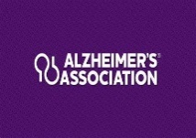
The Third Annual NE Ohio Purple Sunday: Stewardship of the mind through Alzheimer’s and Dementia awareness. Today!

Come Join Us
August 9-10, 2024
Lancaster County Pennsylvania
Price Includes: Roundtrip Barons Motor Coach Transportation
Outstanding Live Stage Production
Sight & Sound Theater
“DANIEL”
Fairfield Inn & Suites
One Night Hotel Accommodations
(Breakfast included)
DINNER: Miller’s Smorgasbord
Shopping: Kitchen Kettle Village,
Tanger Outlets Mall
Lunch: Bird-in-Hand Smorgasbord
Shopping: Hershey’s Chocolate World
$365
Deposit of $85.00 due ASAP
Make checks or money orders payable to “TRAVEL by YOU”
See Laureen Beach 216-526-8511
or Margaret Board 216-320-2928

Happy Birthday and Happy Anniversary

This Week April 28th _ May 4th, 2024
Stephaie Simmons 2nd
Patricia Townsend 2nd
Jasmine Banes 3rd
Raffia Billups 3rd
Elijah Dowdell 3rd
Mildred Little 3rd
Estelle Milan 4th

Scripture Readers Month of Apr./May
Amari Rouse 28th
Jasmine Banes May 5th
Gail H. Banes May 12th

Life Connect Classes
Youth Zoom Classes on Mondays
Faith, Hope and Love
Teacher (Pastor Antonia Martin)
(Grades PK-K) 2-5 years (6:00-6:30 pm)
(Grades 1-3) 6-8 years (6:30-7:30 pm)
(Grades 4-6) 9-12 years (7:30-8:30 pm)
(Grades 7-12) 13-17 years (8:30-9:30 pm.)
Zoom ID: 832 7903 1773 PC: 092683

Monday 6:30 pm (Adult Class)
Getting Unstuck by Nona Jones
Teachers: Marvin Rogers and Andrea Billups
Zoom Meeting 891-1091-7393/2020 Zoom Call In 1-312-626-6799 891-1091-7393 # # 2020#

2nd Tuesday 7:30 pm (Women) Monthly
May 14th
Teacher: Helen Britt (Women with a Heart Bent Toward God) Zoom Meeting 891-6849-5855 PC: 751319

Wednesday 7:30 pm (Adult Class)
Book of Ruth Teacher: Pastor Antonia
Upcoming Wellness Events...

Mentally Mangled Mental Health Conference, Wednesday, May 22, 2024, at Mt. Sinai Friendship United Church,
7510 Woodland Ave., Cleveland 44104.
https://mentallymangled.com/event/2024-mentally-mangled-mental-health-conference/ (https://mentallymangled.com/event/2024-mentally-mangled-mental-health-conference/)

Mt. Pleasant Health and Wellness Event/Mammogram Clinic, Saturday, June 08, 2024, 9:30 AM - 2:00PM
at Zion Hill Baptist Church, 11115 Kinsman Rd, Cleveland, OH 44104 - Contact: Angela Anderson, 440-409-7139

2024 Cleveland Black Men's Wellness Day, Saturday, August 24, 2024, a day of FREE Health Screenings, Vendors, Live Entertainment & Family-Friendly Fun,
at Wade Oval, 10820 East Boulevard, Cleveland, 44106

https://aawellness.org/cleveland-ohio/ (https://aawellness.org/cleveland-ohio/)

(Zoom Meeting 829-8003-5837/2020
Zoom Call In 1-312-626-6799 829-8003-5837 # # 2020#

Wednesday 7:30 pm (Adult Class)
Faith Hope and Love – Examining Our Faith
Teacher: Sylvia Fields
Zoom Meeting 865-9998-5439/54321
Zoom Call In 1-301-715-8592 ID: 865-9998-5439 # # PW: 54321 #
Wednesday 7:00 pm (Adult Class)
Teachers: Reginald Woods – Philippians
In person in the gym.

Wednesdays 7:00 pm (Adult Class)
Teacher: Pastor Toby Emeritus (The Chosen Epoxides 7 & 8) Zoom Meeting 334-158-729/2020
Zoom Call In 1-312-626-6799 334-158-729# #
2020#

Read The Bible in One Year/52 weeks/365 days
Return April 16th - 7:00 pm
Special Offerings
1st Sunday – Deacon’s Offerings
2nd Sunday – Prison Ministry
3rd Sunday – Rotolu Orphanage Nigeria
4th Sunday – Two Cents A Meal
5th Sunday – Above & Beyond

We will be using the NIV Version
Teacher: Pastor Kellie
Meetings 1st, 3rd, 4th & 5th Tuesday of the month
Meeting ID: 82097918709 PW: 605886
Phone # 13126266799 82097918709 # # 605886 #

Mildred Ramsey Little
We’re celebrating the 91st birthday of Mildred Little.

Mildred was born May 3, 1933 in Scooba, MS, to Liddie and Freeman Ramsey. she is currently the matriarch in her family. Mildred has two sisters, Rita is her younger sister and Emma was her older sister, who passed away. She went to school in the south and came to Cleveland as an adult in her early 20’s. Mildred’s father who was in Cleveland working returned to Mississippi to bring Mildred back to Cleveland with him.
Her first job was at the Majestic Hotel. Mildred enjoys cooking. She cooked 30 years for the Cleveland City Schools. She worked at Addison Jr. High School for 8 years, 19 years at Empire, and her last 3 years were at Whitney Young. She retired in 1995.

Mildred became a member of Calvary Presbyterian Church, November 9, 1958. She served in the Youth Ministry and wherever she was asked to help. On September 8, 2013, she became a Charter Member of the newly merged church, New Life At Calvary and has continued to serve faithfully.

Mildred has five children: Willis, Elizabeth, Eva, Pearlie and Anna-Jean. Willis passed away on April 28, 2019 and Anna Jean passed away in infancy. She also, adopted two children, Elizabeth and Shonda. Mildred loved being a mom. Wherever her children went she went and whatever they did she did, including jumping rope and skating with them at the playground. Mildred so enjoyed being around children, she served for 36 years as a foster mother to over 60 children. Many of her foster children keep in touch with her to this day. She is a grandmother and a great and great-great grandmother. She enjoys fishing.

We say Happy 91st Birthday to Mildred, May God continue to bless you.

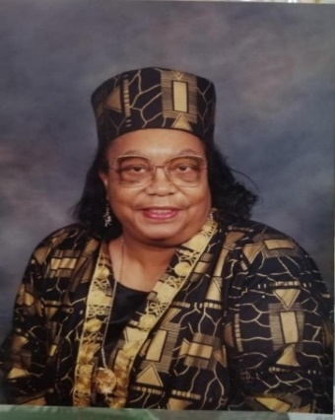

SERMON SERIES FOR
APRIL
Week 1: Deny Yourself
Week 2: Take Up Your Cross
Week 3: Faithfully Follow Jesus
Week 4: Live The Commission

Sick & Recuperating Shut In
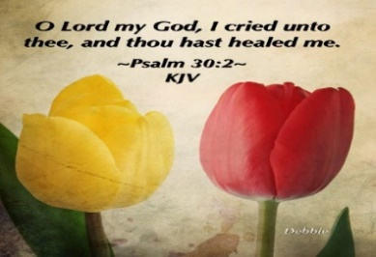

Please send a card, call, pray for, and support our Sick and Shut ins and recuperating brothers and sisters in Christ. Thank you.

Rev. Joseph Banaci (12007 Chesterfield, Cleveland, OH 44108 216-396-8078)
Jennie Brown (1783 East 227th St, Euclid, OH 44117 216.785.9295)
Stanette (Brown) Israel (19205 Lanbury Ave, Warrensville, OH 44122) 216-798-6223 cell: 216.941.5211)
Bessie Bryant (Jennings Rehab Center, 10210 Granger Rd, #367 Garfield Hts 44125 216-246-3453)
Minnie Doaty (12005 Ablewhite Ave, Clev., OH 44108)
Natalie Franklin (daughter of Julie Wright cards only) 6615 Kennedy Ave, Cincinnati, OH 45213
Alfred Haywood (St. Augustine 7801 Detroit Ave, Rm 421, Cleveland, OH 44102)
Savannah (Robin) Hill (Falling Water Healthcare Center, RM 241D, 18840 Falling Water Rd. Strongsville, OH 44136)
Glynn Jackson (13717 Southview Clev., OH 44120 216-921-3788)
LaDonna Jessup (Home 216-255-7693)
Kent Kelton (9308 Empire, Cleveland, OH 44108 216-287-0469)
Mildred Little (1344 East 90th St., Cleve., OH 44106)
Georgia Naylor (Mount St. Joseph Nursing Home, 21800 Chardon Road #505, Cleveland, OH 44117)
Elosie Payne (Jennings Rehab Center, 10204 Granger Road, Rm 110 Garfield Hts 44125)
Martha Robinson (LECOM at Elmwood Gardens, 2628 Elmwood Ave., Erie, PA 16508)
Fannie Ruffin (8164 Dartmoor Rd, Mentor, OH 44060)
Anna Sharp (Home 216- 593-2211)
Edna Swoope (27100 Cedar Rd, Beachwood, OH 44122)
Brenda White (West Park Commons 4106 Rocky River Dr, Apt 207, Clev., OH 44135 216-377-7314)
Delois Williams (1007 East Blvd, Cleveland, OH 44108)
Janet Williams (10516 Elgin Ave., Clevland, OH 44108)
Kathlyn (Benita) Williams (1007 East Blvd, Cleveland, OH 44108)

The White pillars candle in the chancel is a reminder for us to pray for the safety of all the men and women serving in the military. It reminds us to pray for peace in our land and all lands.

